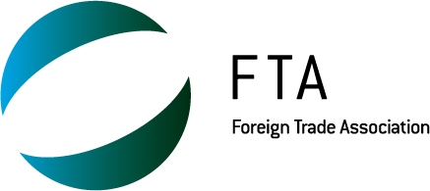

SESSION 17: CONSEQUENCES OF A FAILED DOHA ROUND

Organized by: EUROCHAMBRES and the Foreign Trade Association

Sub-theme 1: Challenges and Opportunities facing the WTO

Date: Thursday 25th of September 9:00 - 11:00

Meeting Room: W

Abstract

In the final two weeks of July all efforts were made in Geneva to try to achieve an agreement on the Doha Development Agenda (DDA) round of multilateral trade negotiations. Unfortunately, officials were not able to reach a consensus and no deal was possible. What will be the consequences of such a failure?

This session will discuss the macroeconomic implications that the failed Doha round could have on the global trade agenda and on the existing acquis of the GATT/WTO. Moreover, the panellists will address the advantages and drawbacks of the multilateral approach in global rule-making and will try to define what could be improved in this approach. The panel will also look at the microeconomic impacts of the DDA collapse, through concrete and practical experiences from companies.

Moderators:
- Dirk VANTYGHEM, Eurochambres, Director International Affairs
- Stuart NEWMAN, FTA, Legal Advisor.

Speakers:
- Munir AHMED, International Textiles & Clothing Bureau (ITCB), Secretary General
- Jacques H.J. BOURGEOIS, Professor at the College of Europe (Bruges)
- Stefano MINGAIA, Fan Gioielli SPA, Director
- Elmer SCHIALER, Permanent Mission of Peru to the United Nations and other International Organizations at Geneva, Minister.

Eurochambres - The Association of European Chambers of Commerce and Industry represents over 19.9 million enterprises in Europe through 45 national associations of Chambers of Commerce and Industry and a European network of 2000 regional and local Chambers.

Foreign Trade Association - The Foreign Trade Association (FTA) is the association for European commerce specialised in international trade issues. Their members are national trade associations and companies from all over Europe.

______________

