MEMO

Pascal Kerneis – Managing Director

European Services Forum – ESF

Mr. Pascal Kerneis
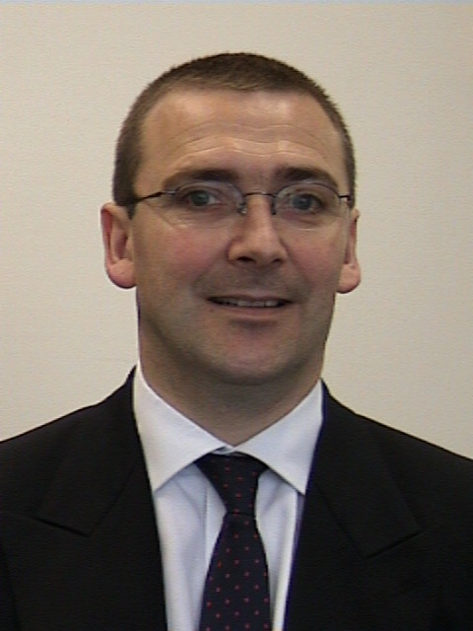
Managing Director
European Services Forum

Born on 13 April 1962
French Nationality
Married – 2 children

Mr Kerneis studied Law in France. He got his Master degree in 1984. He was lecturer in European law in the Law University of Rennes from 1985 to 1987. He was Legal Expert in the European Commission in Brussels (Belgium) from 1988 to 1990. In the meantime, he achieved his Ph. D. in European Law in 1990. The thesis, dealing in particular with the international trade and the European law, was awarded and financed by a European Commission grant.

Mr Kerneis joined the European Banking Federation (Brussels, Belgium) in 1990 as Assistant. He became then Adviser in International Affairs in 1992. During his stay at the Banking Federation, Mr Kerneis was closely involved in the WTO negotiations on financial services, in the framework of the GATS (General Agreement on Trade in Services). He participated to the effort of the private financial services industry to help the negotiators to obtain a comprehensive agreement in December 1997 in Geneva, with substantial commitments for the banking sector. Mr Kerneis was also closely involved in the work of the Financial Leaders Group (FLG), gathering European, American and also Japanese bankers and insurers at the highest level.

Mr Kerneis was appointed Managing Director of ESF (European Services Forum) at the launching meeting of the organisation in January 1999. ESF is a network of representatives from the European services sector committed to promoting actively the interests of European services and the liberalisation of services markets throughout the world in connection with the GATS 2000 negotiations. ESF comprises 40 major European service companies and 40 European service federations, representing 20 different services sectors.

As member of the European Commission Contact Group, Mr. Kerneis participated at the three last WTO Ministerial Conferences (Seattle - 1999, Doha – 2001, Cancun - 2003) as Advisor to Trade Commissioner Lamy in the European Commission official delegations and also attended the Hong Kong WTO Ministerial as adviser to Commissioner Peter Mandelson.

___________________

