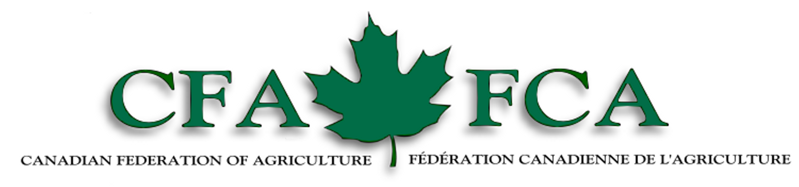
2006 WTO Public Forum, Geneva, Switzerland
Canadian Federation of Agriculture Session on Agriculture
September 26th, 15:00 – 16:30
Room: W

Theme: The Doha Round, where do we go from here and what are the implications?

The World Trade Organization will be working vigorously to put a revised negotiating agreement forth during this Doha Round. As members of the agriculture community we have a considerable stake in the outcome of this Round and must take opportunities to voice our ideas and opinions regarding the future of agricultural trade. The Canadian Federation of Agriculture has put forth three excellent speakers to present in the areas of market access development, myths surrounding domestic support and overall trade policy. The presentations and discussion to follow will result in a better understanding of how we as a global agricultural community can move from where we are, to where we want to be.

2006 WTO Public Forum, Geneva, Switzerland
Canadian Federation of Agriculture Session on Agriculture
September 26th, 15:00 – 16:30
Room: W

Theme: The Doha Round, where do we go from here and what are the implications?

Moderator: Laurent Pellerin – 1st Vice President of the Canadian Federation of Agriculture and President of l’Union des producteurs agricoles (UPA)

15:00 – 15:05
Opening Remarks – Laurent Pellerin

15:05 – 15:25
The “Myths of Decoupling”
Mr. Peter Clark – Grey, Clark, Shih and Associates, Limited

15:25 – 15:45
The Importance of the WTO for Agri-Food Exporters
Mr. Martin Rice – Executive Director of the Canadian Pork Council

15:45 – 16:05
The Doha Round – Where to go from here?
Mr. Bob Friesen – President of the Canadian Federation of Agriculture

16:05 – 16:30
Questions to speakers

*Documents that have been provided by speakers are available at our website, www.cfa-fca.ca.

