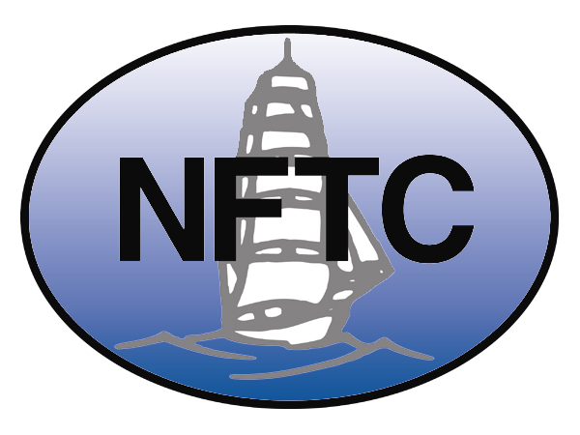

WTO Public Forum 2006

National Foreign Trade Council Session:
To remain relevant and viable in the XXIst Century,
what will the WTO need to deliver?
Tuesday, 26 September, 10:00 – 13:00
The National Foreign Trade Council (NFTC) has assembled a panel to debate the question of what the WTO will need to deliver in order to remain relevant and viable in the XXIst Century. The recent suspension of the Doha Round negotiations adds significance to the question. Speakers will not only address how they believe a revived Doha Development Agenda could contribute to the WTO, but also their longer term, post-Doha Round vision, describing where they believe the WTO should be going and what needs to be done to make that happen. Globalization and the trend to regional and bilateral free trade agreements form part of the backdrop, but the focus will be on the WTO. The NFTC believes that a good discussion will be generated by bringing together speakers who approach the subject from different vantage points.
Panelists:
Mary Irace  Vice-President,  Trade and Export Finance, and  Co-Chair of the NFTC Doha Round  Working Group  National Foreign Trade Council,  Washington, D.C. | Dr. Magdi Farahat (Invited)  Chief  Office for Africa  Division of Technical  Cooperation Coordination  International Trade Centre  Geneva
Celine Charveriat  Head of Advocacy Office in Geneva, and  Head of Make Trade Fair Campaign  Oxfam  Geneva | John Vassallo  Senior Counsel and  Director of European Affairs  GE  Brussels
Fredrik Erixon  Director  European Centre for  International Political Economy  Brussels | T.S. Vishwanath  Head of International Trade Policy  Confederation of Indian Industry  New Delhi
Moderator:
John M. Weekes
Senior Policy Adviser
Sidley Austin LLP
Geneva

