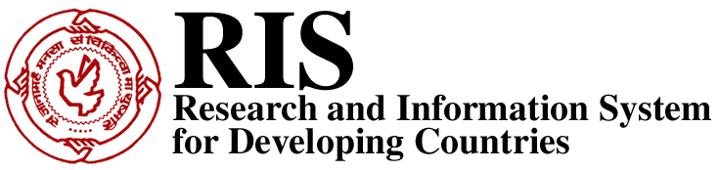

Launch and Presentation of
RIS Report
World Trade and Development Report 2006
Building a Development Friendly World Trading System

At the
WTO Public Forum 2006
Room F, WTO Secretariat, Geneva
26 September 2006: 1500-1630hrs

Agenda
Moderator: Mr Faizel Ismail, Head of the South African Delegation to the WTO
Presentation of Report’s Highlights: Dr Nagesh Kumar, Director-General, RIS
Panelists:
Dr Yash Tandon, Executive Director, South Centre
Dr Sam Laird, Spl. Adviser, Office of Secretary-General, UNCTAD
Dr Martin Khor, Director, Third World Network
Open Discussion

This Panel will be devoted to the presentation and discussion of the World Trade and Development Report 2006: Building a Development Friendly World Trading System, just prepared by RIS. After a presentation of the highlights of the Report by Dr Nagesh Kumar, the Panelists will discuss the issues raised in the Report followed by open discussion.

Although the Doha Round was launched with the promise to address their development concerns so much so to call it a ‘Development Round’, the emerging patterns in the ongoing negotiations over the past five years suggest that development was just the rhetoric to get developing countries around to agree to launch of the new round. The spirit of Doha is hardly visible in the ongoing negotiations and as per the modalities being discussed developing countries are being pushed to accept commitments to provide market access in agriculture and non-agricultural products in more than full reciprocity basis. There has been little progress if at all on the development issues such as making the special and differential treatment ‘precise, operational and effective’. The multilateral trading system that is not able to address the concerns of the majority of its membership cannot be sustainable in the long run. Against that background, the World Trade and Development Report 2006 (WTDR06), second in the series launched by RIS, examines the emerging trends and patterns in the global trading system overall and in select important areas, highlights the growing asymmetries especially from a development perspective and puts together an agenda for reform.

WTDR06 has been partially supported by the UNDP, New York and the Commonwealth Secretariat, London

RIS
RIS is an autonomous publicly-funded, not-for-profit policy think-tank, based in New Delhi, specialized in trade and development issues. Its work programme focuses on multilateral trade negotiations, regional economic cooperation in Asia, South-South cooperation, new technologies and development, among other issues. The work of RIS is published in the form of research Reports, books, discussion papers and journals. For more information about RIS and its work programme, please visit its website: www.ris.org.in.
Contact information: Dr Nagesh Kumar, nkumar@ris.org.in; +91-9811099655.
*tbc

