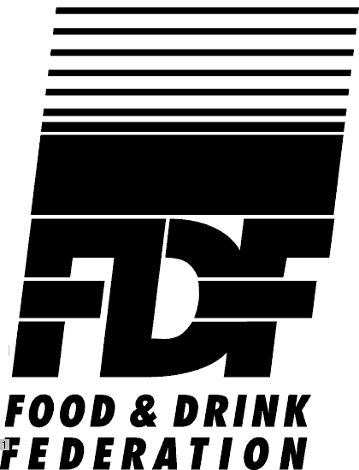

PRIORITIES FOR WTO AGRICULTURE NEGOTIATIONS

FDF looks to the forthcoming WTO agriculture negotiations to:

- Fulfil Article 20 of the Marrakesh Agreement of 1994, which looked to these new negotiations “correcting and preventing restrictions and distortions in world agricultural markets (in order to) establish a fair and market-oriented agricultural trading system”.
- Fulfil the strategic approach set out by Article 20, to include “long-term objectives of substantial progressive reduction in support and protection resulting in fundamental reform in an ongoing process”

In particular FDF looks to the forthcoming negotiations to result in a fairer and clearer set of trading rules, treating agricultural products and value-added processed food and drink products in balance, and providing a coherent approach to the three key areas – market access, export competition and internal support.

Market access: FDF looks to the EU to push for improvements in market access for processed food products – and ensure that other trading partners make equivalent moves, while maintaining the competitiveness of the EU food and drink industry.

Since the GATT Uruguay Round world trade has grown by some 20-25%. Value-added, processed food and drink exports (estimated by the EC at some €15bn pa) are one of the EU’s fastest growing exports – the UK’s share of these at £3.26bn (exports outside the EU in 1999– source FFB) is significantly high.

Exports increasingly offer new sources of growth for food and beverage companies:
Growth in value of EU 12 exports 1988 – 1997

Agricultural commodities: +70%
Processed food products: +140%

Source: European Commission

Increased trade in added value processed food is expected to reach 75% of global agricultural trade in 2000.

In the decade to 1996, the global market for these products grew as an additional 500 million people moved up to enjoy disposable income. Source: FAO/OECD

A key objective for these Article 20 negotiations must be further reductions in tariff protection for value added food products. If the cost of reducing barriers to exports to third country markets is to reduce the barriers against imports from third countries, the outcome must ensure that the incentive to process food and therefore add value within the EU is maintained.
EU tariff reductions must be in line with internal price support cuts.

Export competition and internal support:

FDF continues to support equitable liberalisation of world trade. There must be close relationships between raw materials (from either inside or outside the EU) and value added food products, thus ensuring that the EU food industry remains competitive both inside and out. So long as EU prices for agricultural commodities are above the world level, restitutions are essential to achieve competitively priced exports. The EU should not therefore accept any further commitment to cut export refund expenditure for Non-Annex I products, either before there is a correlated reduction in the price of raw materials internally (through further CAP reform), or externally before the use of measures having an equivalent effect to export refunds (such as export credits, Food Aid or STE practices) have been controlled. FDF therefore welcomes the Commission’s clear WTO statement to this effect in September 2000.

Reaching agreement:

The EU must make every reasonable effort to enable agreement in these Article 20 negotiations to be reached within a fair timeframe, in particular by December 2003:

- Whether or not a wider WTO Round of trade negotiations is achieved
- To enable EU enlargement negotiations to proceed with equal speed – each set of negotiations to inform and be mutually compatible with the other
- To coincide and be co-ordinated with the foreseen next round of CAP reforms (currently anticipated in 2002/03)
- To avoid any complications arising from the expiry of the Peace Clause

Sound standards underpinning world trade:

- FDF believes that the SPS clause (which should not be re-opened) should in time (eg. as part of a wider WTO Round) be strengthened by making the required underpinning of “sound science” more explicit and clarifying the links between the WTO, Codex Alimentarius, Zoonotics and Plant Protection bodies. Any use of the Precautionary Principle must be proportionate to the risk, applied in a non-discriminatory way and must not give rise to disguised restrictions to trade
- WTO members should agree to respect environmental, animal welfare and social standards, seeking comparable conditions of production.

The food and drink manufacturing industry is the largest manufacturing sector in the UK, employing over 500,000 people. Its annual turnover is some £66bn. The industry purchases some two thirds of UK agricultural produce.. In 1999 UK food and drinks exports totalled some £8.8bn, of which more than £3.26bn go to non-EU countries. Based on separate EC figures this would appear to represent about one third of all EU food and drink exports

For further information contact FDF’s European and International Policy Director, Jonathan Peel (jpeel@fdf.org.uk) or Senior Executive, Agriculture & Trade, Katharine Anderson (kanderson@fdf.org.uk) on: Tel: +44-1207-420-7103 Fax: +44-207-379-4674

November 2000

