





ACHIEVING FREE AND FAIR TRADE IN FOREST AND PAPER PRODUCTS
A STATEMENT BY LEADING GLOBAL FOREST AND PAPER INDUSTRIES

GENEVA, SWITZERLAND
JULY 2003

This statement expresses strong industry support for accelerated trade liberalization in wood and paper products through the World Trade Organization (WTO) Doha Development Agenda (“the Doha negotiations”).

This statement reflects the views of forest and paper products industries in Canada, Chile, New Zealand and the United States as well as the forest industry in Australia and the paper industry in South Africa1. Between them these industries represent 34 percent of world trade in wood products, 54 percent of world trade in wood pulp and 25 percent of world trade in paper.

Representatives of these industries met in Oaxaca, Mexico, in May 2003 to discuss the progress in the Doha negotiations and to consider options for furthering the interests of the global forest and paper industries in these critical negotiations.

These industry representatives are united in their belief that accelerated trade liberalization of forest and paper products, particularly through the WTO, provides a means of expanding output, employment and economic growth and alleviating poverty. The Doha negotiations offer an unparalleled opportunity to eliminate trade barriers, put in place more effective trade rules and address the specific concerns of developing countries. A successful and robust outcome from the Doha negotiations is critical to ensuring the future expansion of the world’s forest and paper industries.

This statement reflects the views of the following organizations:
Australia: National Association of Forest Industries (NAFI)
Canada: Forest Products Association of Canada (FPAC)
Chile: Corporación Chilena de la Madera (CORMA)
New Zealand: New Zealand Forest Industries Council (NZFIC)
South Africa: Paper Manufacturers Association of South Africa (PAMSA)
United States: American Forest & Paper Association (AF&PA)

Reviewing progress in the Doha negotiations, industry representatives agreed that:

- WTO members should move with the greatest possible speed towards the goal of eliminating all tariffs on forest and paper products, whether by an ambitious formula approach to tariff elimination, an expansion of current zero for zero deals, or a combination of these approaches, taking account of established WTO provisions in respect of developing countries;
- the goal of eliminating non tariff barriers should also be pursued with speed given their increasing prevalence and effect in blocking trade expansion;
- greater clarification, refinement and more disciplined application of anti-dumping provisions is required; and
- they will seek more effective rules and disciplines to address the use of subsidies.

Industry representatives called on their respective national governments and all member countries of the WTO to ensure:

- that effective modalities for non-agricultural market access were identified as soon as possible, but before the WTO Ministerial in Cancun, Mexico, in September 2003; and
- that Trade Ministers meeting in Cancun resolve to keep the Doha negotiation to its original timeframe for conclusion by 1 January 2005.

Industry representatives further agreed:

- to convey the views in this statement to their respective national governments and to industry stakeholders and the general public in their countries;
- to consult regularly amongst themselves with a view to co-ordinating their respective positions and strategy in respect to the Doha negotiations; and
- to explore opportunities to present these views and any subsequent considerations to WTO officials and national delegations in Geneva and as appropriate at the WTO Ministerial Meeting in Cancun, Mexico, in September 2003.

Signed by the following representatives of industry organizations:

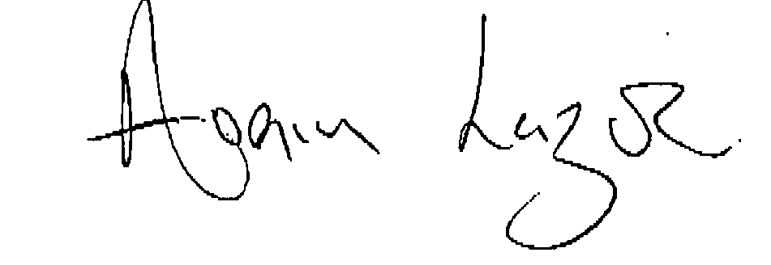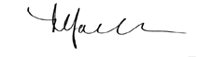
Avrim Lazar Stephen Jacobi
President and Chief Executive Chief Executive
Forest Products Association of Canada New Zealand Forest Industries Council
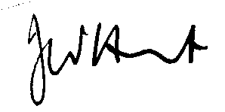
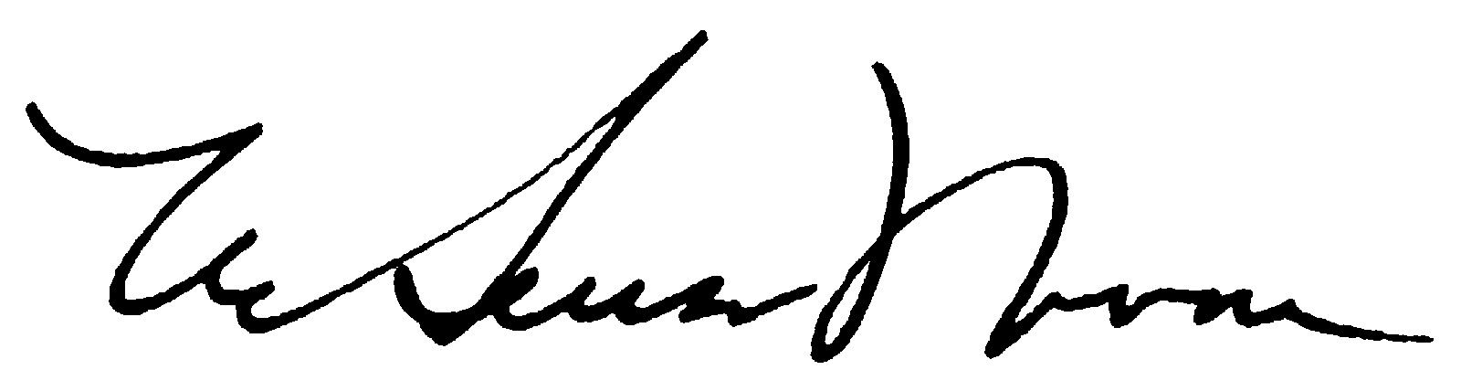
John Hunt W. Henson Moore
Executive Director President and Chief Executive Officer
Paper Manufacturers Association of American Forest & Paper Association
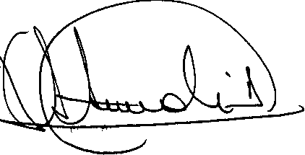
South Africa
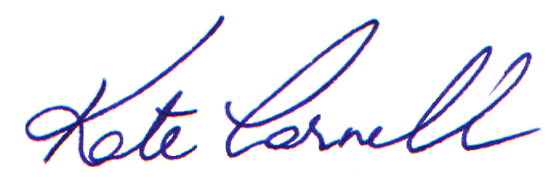Kate Carnell José Ignacio Letamendi Arregui
Executive Director Chairman
National Association of Forest Industries Corporación Chilena de la Madera
(Australia) (Chile)

