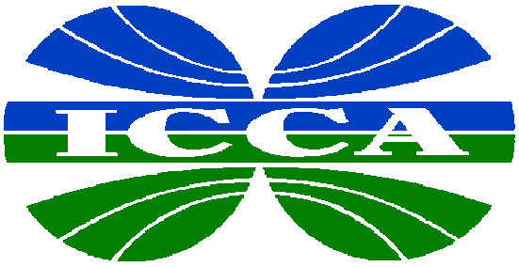

INTERNATIONAL
COUNCIL OF
CHEMICAL
ASSOCIATIONS

Position on

WTO Dispute Settlement

June 2001

The International Council of Chemical Associations (ICCA) is an organization of leading trade associations representing almost 80% of chemical manufacturers worldwide. World chemical industry production exceeds US$1.7 trillion annually, and nearly one-third of this production is traded internationally.
Conselho das Associações da Indústria Quimica do Mercosul
(CIQUIM)
Argentina, Brazil, Paraguay and Uruguay

European Chemical Industry Council (CEFIC)

Japan Chemical Industry Association (JCIA)

Asociácion Nacional de la Industria Quimica
(ANIQ)
Mexico

Canadian Chemical Producers' Association (CCPA)

American Chemistry Council
(ACC)

New Zealand Chemical Industry Council
(NZCIC)

Plastics and Chemical Industry Association (PACIA)
Australia

Chemical and Allied Industries Association
South Africa

Introduction

ICCA considers the WTO Dispute Settlement Understanding (DSU) to be one of the major achievements of the Uruguay Round. For the first time, WTO members have subscribed to a set of rules and procedures for settling trade disputes. The DSU is the central element in providing security and predictability to the multilateral system and is key to preserving the rights and obligations of WTO members. ICCA believes that the WTO dispute settlement system is a success and that, by enforcing rules and commitments, it has ensured real market opening worldwide.

Position

To maintain the strength and success of the WTO dispute settlement system, ICCA believes that the WTO must pursue the following:

Faithful implementation of WTO rulings
ICCA calls on all WTO members to fully and faithfully implement WTO dispute settlement rulings. The WTO dispute settlement system has teeth. If a country does not implement a dispute settlement ruling, the WTO can authorize the withdrawal of concessions, generally called sanctions. Retaliation inevitably injures innocent third parties, and ultimately the business community has to pay the price for non-implementation. Effective compliance with the obligations embodied in the WTO agreements is essential to increasing the overall gains from reciprocal trade liberalization.

Full use of settlement possibilities
The central aim of the DSU is the search for compromise and the re-establishment of the balance of concessions, before legal procedures take effect. ICCA recommends that WTO members place more emphasis on using all the options of the DSU to settle disputes bilaterally, including the good offices of the Director General, conciliation and mediation. A bilateral solution or compromise will often be preferable and less trade disruptive than starting down a path that risks retaliatory sanctions. Governments should

consider carefully whether to launch a dispute settlement case and risk setting into motion a process of retaliatory sanctions.

Compensation rather than sanctions
If no amicable solution can be found, compensatory measures such as lowering tariffs or some other form of trade-liberalizing measures should be preferred over sanctions. Compensatory measures at least have the benefit of reducing the overall level of protection and act as a temporary offset to a continuing WTO violation. But compensatory measures are not an alternative to implementation since, like sanctions, they affect areas that are unrelated to the subject of the dispute.

While ICCA accepts that a remedy needs to be available that eventually puts pressure on WTO members to comply with their WTO obligations, it is convinced that sanctions should only be applied as a last resort and not as an automatic consequence. Sanctions increase trade protection and as such contradict the WTO goal of trade liberalization.

Dispute prevention and early warning
ICCA encourages the WTO to establish an early warning system as part of the DSU with the authority to review and comment on draft national legislation at the request of a member to ensure WTO compatibility and to avoid trade disputes from arising. If a draft law is considered WTO-incompatible, it should be amended. An early warning system, by affording an opportunity to amend measures before they become law, can help to prevent trade disputes from escalating.

Improvements to the DSU
Sequencing: While the DSU has correctly addressed the problems of the past (blockades in response to the establishment of a panel or the adoption of a panel report), new issues have arisen. ICCA believes that the dispute settlement review should lead to a re-assessment of all those rules with which the WTO membership had no previous experience, particularly the rules relating to implementation of panel reports and the sequence of steps involved.

Legal uncertainty has arisen regarding the correct sequence of steps to be taken when a member disagrees that another member’s remedial actions are adequate to achieve compliance with WTO rules. ICCA calls for a clarification of the agreement that retaliatory action can only be taken if it has been established that the national measure is not in compliance with the WTO obligations. A competent panel should first rule expeditiously on compliance, followed by arbitration on the amount of the retaliatory action due.

Transparency: Transparency should be improved throughout the dispute settlement system. Greater public insight and awareness of the issues surrounding dispute settlement cases might generate incentives for governments to accelerate compliance, and efforts to allow interested parties more and efficient access to the information on disputes should be welcomed.

ICCA supports allowing third parties to file amicus curiae briefs at the appellate stage of dispute settlement proceedings and suggests that the DSU be amended to explicitly provide for this. In addition, appellate stage proceedings should be made public, and interested parties should be allowed to observe, but not participate in, appellate stage proceedings.

For an electronic version of this and other ICCA positions on trade, please visit the ICCA web site at www.icca-chem.org

