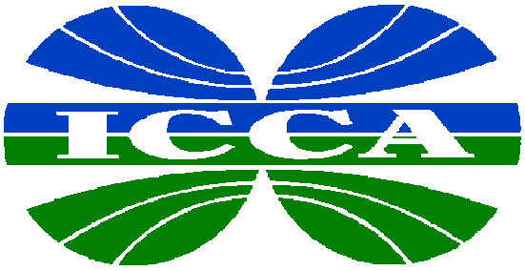

INTERNATIONAL
COUNCIL OF
CHEMICAL
ASSOCIATIONS

Position on

Market Access

June 2001

The International Council of Chemical Associations (ICCA) is an organization of leading trade associations representing almost 80% of chemical manufacturers worldwide. World chemical industry production exceeds US$1.7 trillion annually, and nearly one-third of this production is traded internationally.
Conselho das Associações da Indústria Quimica do Mercosul
(CIQUIM)
Argentina, Brazil, Paraguay and Uruguay

European Chemical Industry Council (CEFIC)

Japan Chemical Industry Association (JCIA)

Asociácion Nacional de la Industria Quimica
(ANIQ)
Mexico

Canadian Chemical Producers' Association (CCPA)

American Chemistry Council
(ACC)
United States

New Zealand Chemical Industry Council
(NZCIC)

Plastics and Chemical Industry Association (PACIA)
Australia

Chemical and Allied Industries Association
South Africa

Introduction

The ICCA supports the launch of a new multilateral round of trade negotiations at the WTO Ministerial Conference in Qatar that is sufficiently broad and flexible to allow for meaningful requests and concessions across a wide range of sectors. The ICCA believes that bilateral and regional trade agreements should be designed to advance broad, multilateral trade liberalization.

ICCA believes in the principle of a single undertaking at the end of the round, which should not preclude the possibility of plurilateral agreements under the aegis of the WTO.

Statement of Principle on Tariffs Negotiations

ICCA is committed to the elimination of chemical tariffs in the WTO and supports a proposal whereby all countries with a viable chemical industry (or the potential to create such an industry) agree to eliminate all chemical tariffs by 2010, dismantle all identified non-tariff measures (NTMs) and prevent the formation of new NTMs in the future.

ICCA believes that chemical tariff elimination can be achieved either by participating in such an agreement or through other mechanisms leading to the same results.

ICCA recognizes that developing countries may need a slightly longer transition period, i.e. beyond 2010, to implement these objectives and supports provisions for longer phasing periods for developing countries.

ICCA’s Market Access Criteria

ICCA’s objective for a new round is the elimination of chemicals tariffs and NTMs as outlined above.
ICCA believes that this objective can be achieved with the following criteria:

Full elimination of all chemical tariffs
ICCA calls for the elimination of all tariffs in Harmonized System Chapters 28-39 as covered by the CTHA as well as in those select line items in other chapters that are considered to be products of the chemicals or allied industries.

Tariff elimination should begin from currently applied rates, not bound rates. Overall tariff reductions below CTHA levels would only commence if all WTO members with a viable chemical industry commit to tariff elimination. For current CTHA signatories, phasing of tariff elimination should not exceed five years, with the last reduction step in 2010.

For WTO members that are not CTHA signatories, one example of a phasing schedule for tariff elimination could be:

- 5 equal steps, over a maximum of 5 years with the last reduction step in 2010, for tariffs of 6.5% or less;
- 7 equal steps, over a maximum of 7 years, for tariffs over 6.5%, up to and including 15%; and,
- 10 equal steps, over a maximum of 10 years, for tariffs over 15%.

There must be no exception to product coverage for final tariff elimination; however, for developing countries, phasing periods longer than 10 years may be negotiated, as long as tariff reductions are in equal annual stages.

Staging and Binding of Tariffs Reductions
The ICCA recognizes that WTO members whose currently applied tariff rates are high may need time to phase them out in stages. We endorse reasonable flexible phasing regimes for tariff harmonization that will take dissimilar tariff rates into account. Similarly, in moving to full tariff elimination, longer phasing may be necessary for import-sensitive products and, as stated above, for developing countries. All members must agree to bind their tariff commitments resulting from the new round.

Non-tariff Measures (NTMs)
The ICCA recognizes that identified NTMs and actionable subsidies can seriously undermine the market access benefits of tariff elimination. These should be eliminated as part of the overall trade liberalization process and further agreement needs to be reached to prevent the formation of further NTMs. Examples of non-tariff measures that are of concern to the chemical industry include, but are not limited to, import licensing, quotas, trigger price mechanisms and discriminatory standards.

Future WTO Accessions
Countries wishing to accede to the WTO following the conclusion of the new round of negotiations, as well as those that accede during the round, should be required to adopt all agreements reached during those negotiations, including agreements reached regarding chemical tariffs and NTMs.

For an electronic version of this and other ICCA positions on trade, please visit the ICCA web site at www.icca-chem.org

