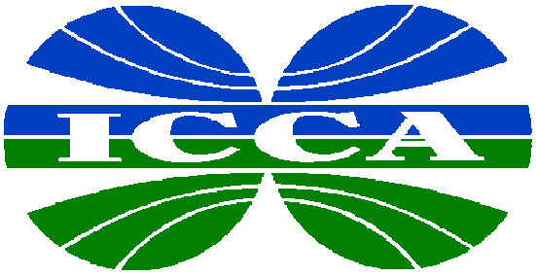

INTERNATIONAL
COUNCIL OF
CHEMICAL
ASSOCIATIONS

Global Chemical Industry Concerned About a New WTO Round

Geneva, July 11 - At the ICCA Trade Policy Group meeting today in Geneva, Chairman Gerry Finn expressed strong concern that there has not been sufficient progress to allow for a launch of a new trade round this year. While noting that the mood in Geneva has markedly improved recently, Finn said, “There is still much work to be done to bring about an agreed upon agenda that is sufficiently broad to get all countries on board – developed, developing and least developed.”
Conselho das Associações da Indústria Quimica do Mercosul
(CIQUIM)
Argentina, Brazil and Uruguay

European Chemical Industry Council (Cefic)

Japan Chemical Industry Association (JCIA)

Asociácion Nacional de la Industria Quimica
(ANIQ)
Mexico

Canadian Chemical Producers' Association (CCPA)

American Chemistry Council
(ACC)

New Zealand Chemical Industry Council
(NZCIC)

Plastics and Chemical Industry Association (PACIA)
Australia

“WTO members should get beyond expressing their differences and difficulties with each other’s proposals and come to closure on a sufficiently broad agenda to allow all WTO members the opportunity to support a launch,” added Gerry Finn. The ICCA is meeting in Geneva with WTO members to voice its support for the launch of a WTO Round.

ICCA reiterated its support for a new round of multilateral trade negotiations in the World Trade Organization (WTO). ICCA’s key priorities for a new Round include:

- elimination of chemical tariffs by 2010;
- establishment of a set of basic rules on trade and investment;
- clarification of the relationship between trade and environment;
- harmonization of antidumping practices;
- simplification of customs procedures (trade facilitation); and,
- full implementation of the TRIPs Agreement.

ICCA is an organization of leading trade associations representing almost 80% of chemical manufacturing worldwide. World chemical industry production exceeds US$1.7 trillion annually, and nearly one-third of this production is traded internationally.

A strong and effective WTO is essential for achieving the goal of increased living standards and sustainable development around the world. ICCA supports the WTO in its vital mission of ensuring that international trade is fair and as free from restrictions as possible in order to stimulate economic growth. ICCA believes that increased international trade, trade liberalization, and investment are preconditions for further economic growth and sustainable development.

Media contacts: René van Sloten +32 486 511284 (until July 12)
+32 2 676 72 20 (after July 12)
Kathleen Ambrose +41 22 906 66 6 6 (until July 12)
+1 703 741 5920 (after July 12)

