International Agriculture and Food Sectors
Call for Renewed Negotiations at the WTO

With this declaration, the undersigned, representing 46 organizations and companies from 13 countries, urge Ministers of WTO member countries to re-state their commitment to the Doha Mandate for WTO agriculture negotiations, and to immediately return to the negotiating table to reach an agreement that fulfills the mandate.

Agriculture and food trade is valued at over US$450 billion annually. More than 50% of agricultural trade (about 49% of exports and 52% of imports) is by developing countries. Yet international markets continue to be distorted by tariffs, tariff rate quotas, non-tariff barriers and trade distorting subsidies. The average world tariff is still over 60%, and total support provided to agriculture in the world’s richest countries is over $US 318 billion.

The ability to compete in an international marketplace that is not distorted by protectionism and subsidies is critical to many countries around the world, particularly to the world’s developing nations. It is estimated that if the world’s wealthiest nations provided access to their agricultural markets, developing countries would benefit by more than US$ 100 billion annually - twice the amount they currently receive from wealthy countries in development assistance.

WTO member countries have had time to reflect on the events of the 5th WTO Ministerial meeting in Cancun, Mexico. There has been ample time to consider new positions, proposals and strategies. We call on member countries to abandon rhetoric and entrenched positions, and promptly return to the negotiating table in Geneva with constructive and practical proposals to reach the goals to which we all committed in launching the Doha Round.

Specifically, negotiators must reach agreement to:

- Substantially increase market access for all agricultural products - with deep cuts to all tariffs, maximum expansions in tariff quota volumes, and sectoral free trade initiatives wherever possible.
- Substantially reduce trade-distorting support – through reductions in spending.
- Reduce, with a view to phasing out, all forms of export subsidies – by specifying annual reductions on the basis of expenditures and volumes, and a clear end date for the total elimination of all export subsidies
- Implement Special provisions for developing countries – a combination of trade concessions and development assistance for countries that are in true need of special treatment to assist them to fully capture the opportunities presented by the international marketplace.
The costs of protectionism and the benefits of liberalization for the agriculture and food industries and for consumers in developed and developing nations, have been identified by research bodies and academics around the world. These benefits can only be achieved through the implementation of global rules and commitments that apply equally to all countries. With this declaration, we urge countries to work towards agreement on a framework for agriculture negotiations at the December 15 session of the WTO General Council.

-30-

This Declaration is supported by:
  AAPRESID  Argentina |   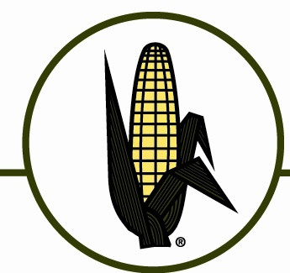  Canadian Sugar Beet Producers Association | 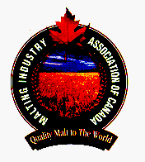  Malting Industry Association of Canada
  Agricore United (Canada) |   Canadian Sugar Institute | National Corn Growers Association (USA)
  American Farm Bureau Federation |  |   National Farmers Federation (Australia)
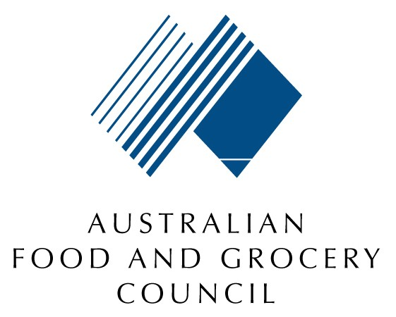 |   Cargill Limited | 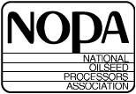  National Oilseed Processors Association (USA)
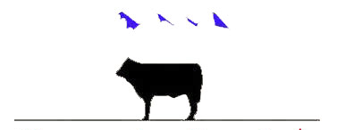  Canada Beef Export Federation | 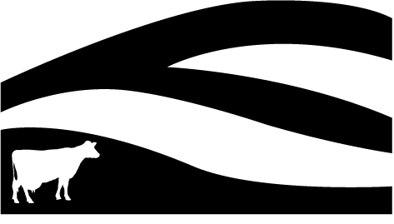  Dairy Farmers of New Zealand | 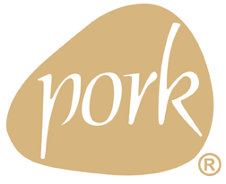  National Pork Producers Association (USA)
  Canadian Agri-Food Trade Alliance |   Federated Farmers of New Zealand |   New Zealand Food and Grocery Council
    Canadian Cattlemen’s Association | 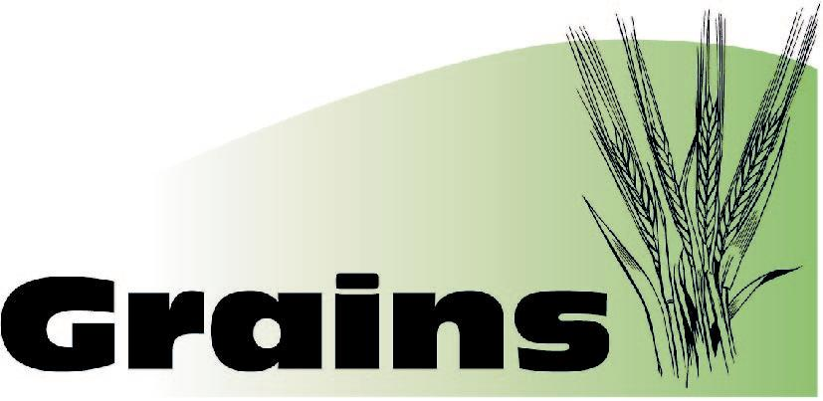  (New Zealand) | New Zealand Grains Council
  Canadian Meat Council |   Food and Consumer Products Manufacturers of Canada | New Zealand Meat and Fibre Producers Council
  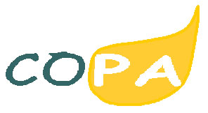  Canadian Oilseed Processors Association | 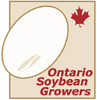  Global Sugar Alliance* | Ontario Soybean Growers (Canada)
  Canadian Restaurant and Food Services Association |   Grain Growers of Canada | 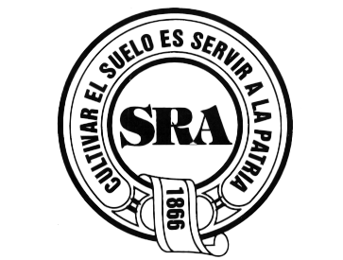  Sociedad Rural Argentina

* Members of the Global Sugar Alliance are:

Australia - Canegrowers, Australian Sugar Milling Council, Queensland Sugar, Australian Cane Farmer's Association

Brazil - UNICA, Crystalsev, Cosan, Copersucar

Canada - Canadian Sugar Institute, Canadian Sugar Beet Producers
Chile - Empresas Iansa S.A.
Colombia - Asocana
Guatemala - AICA
Honduras - APAH
India - Indian Sugar Millers Association, National Federation of Co-operative Factories Ltd
South Africa - South African Sugar Association
Thailand - Thai Sugar Manufacturing Association, Thai Cane and Sugar Corporation, Federation of Thai Sugarcane Planters

