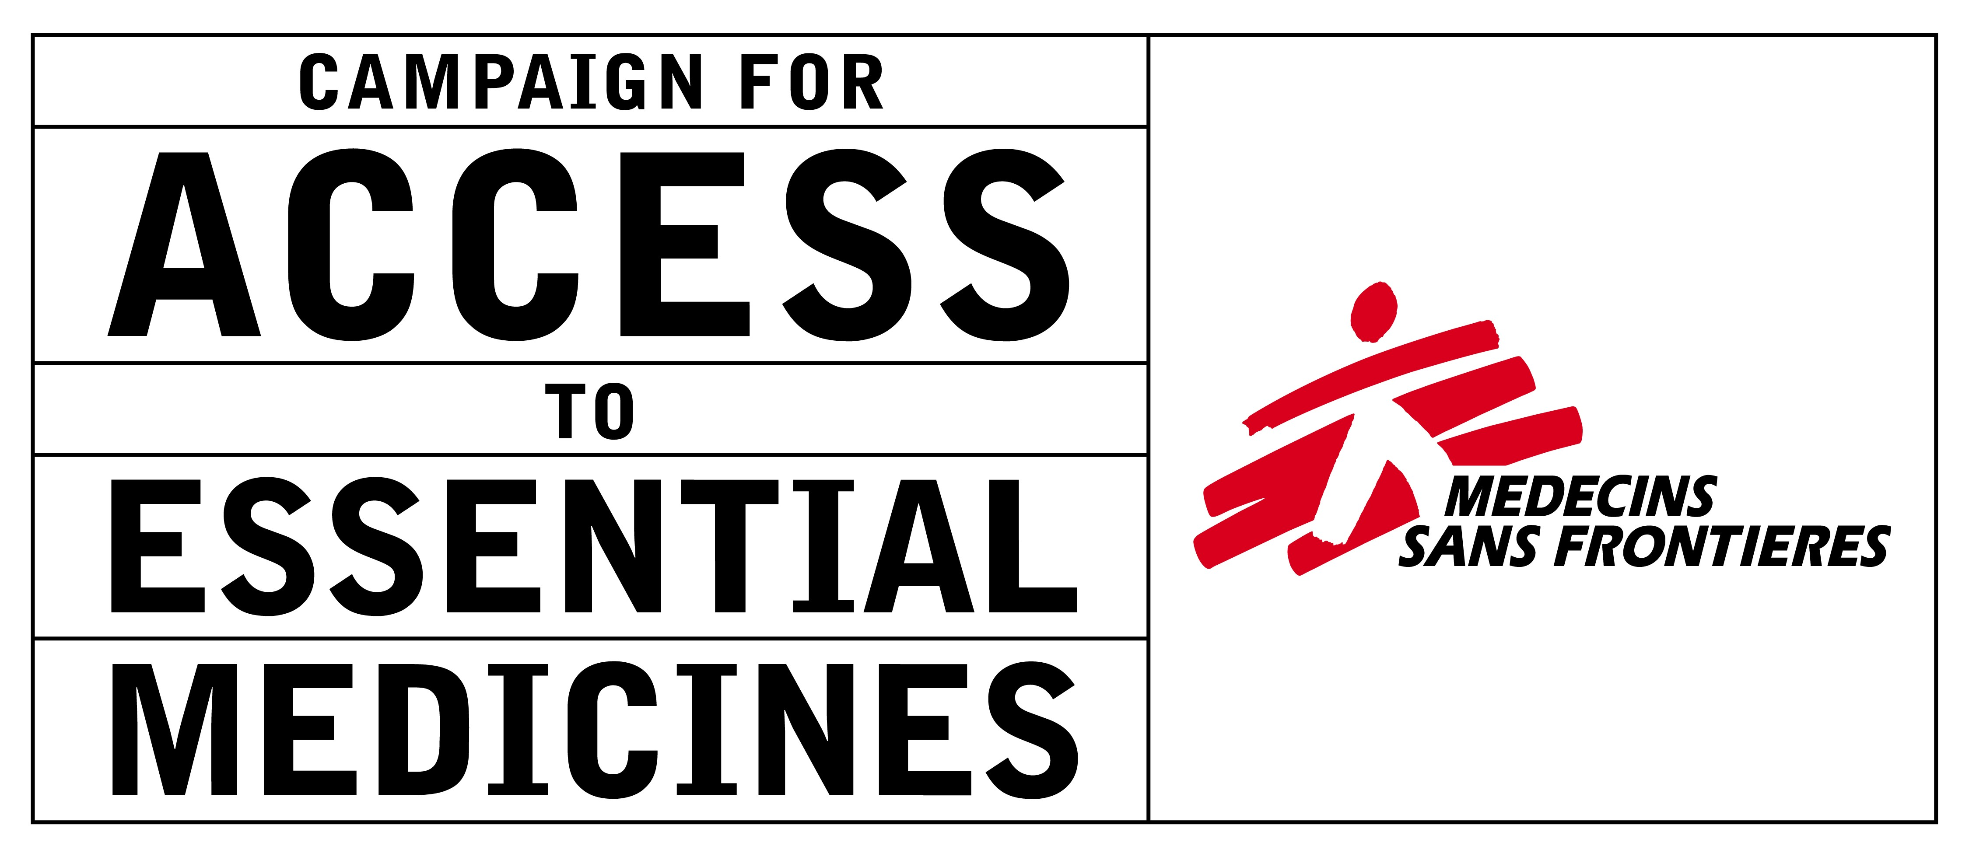



Essential
Action

28 January 2002

Dear Members of the TRIPS council,

We are writing to present our views on the issue of exports of medical technologies under the WTO TRIPS rules for patents. Paragraph 6 of the Doha Declaration on the TRIPS Agreement and Public Health instructed the Council for TRIPS to find a "solution" to difficulties in using compulsory licenses when countries have insufficient or no manufacturing capacity.

“6. We recognize that WTO Members with insufficient or no manufacturing capacities in the pharmaceutical sector could face difficulties in making effective use of compulsory licensing under the TRIPS Agreement. We instruct the Council for TRIPS to find an expeditious solution to this problem and to report to the General Council before the end of 2002.”

Paragraph 6 of the Doha Declaration addresses one particular concern with the TRIPS agreement, namely the case where a country that has a patent on a medicine cannot find an efficient, affordable and reliable source of medicines, due to TRIPS restrictions on production and export of medicines. Of course the same problem exists also for countries where there is no patent on a medicine or other health care technology, including the least developed countries that avail themselves of the automatic extended transition period (until 2016) recently agreed at Doha. We urge the members of the WTO to find solutions that address both cases, in order to ensure that poor persons, wherever they live, will have opportunities to obtain better access to health care.

The Doha Declaration on TRIPS contains both a promise and an obligation to interpret and implement the TRIPS Agreement in a manner supportive of a WTO members right to protect public health and promote access to medicines for all. Now that the Doha meeting has been concluded, it is the duty of the TRIPS council to implement the entire Doha Declaration in good faith, ensuring that the safeguards of the TRIPS work for both rich and poor countries, for countries with large or small domestic markets, and for countries with different levels of technological development.

Of particular interest are proposals that Article 30 of the TRIPS Agreement be interpreted to permit countries to export medicines and other inventions to address health needs. This approach was endorsed by public health groups in the 1999 "Amsterdam Statement" on trade and public health, in several resolutions adopted by the Trans Atlantic Consumer Dialogue (TACD is a US/EU trade consultation group), by a group of public health groups engaged in recent European Commission (EC) consultations on trade policy and access to medicines, and in a developing countries proposal submitted prior to the Doha meeting.

We urge the WTO to consider an interpretation of Article 30 that is similar to that proposed in Paragraph 9 of the October 4, 2001 communication by the developing countries, perhaps with modifications to ensure that it is broader than medicines, and does not raise concerns regarding Article 27.1 restrictions on discrimination by field of technology. One possible statement would be:

Under Article 30 of the TRIPS agreement, Members may provide an exception to the exclusive rights conferred by a relevant patent to permit all acts associated with the production for export to a third country of a patented product or a product produced by a patented process; where the export addresses health needs in the third country; and the product and/or process is either (a) not patented; or (b) a compulsory license has been granted or government use made of the relevant patent in the third country.

The Article 30 approach to addressing the issue of exports of medicines (and other health care inventions) is not the only possible solution to this problem, but it has many advantages, including for example:

- It is the most direct, administratively simple, and least contentious approach to addressing the need to permit exports, in that an activity falling within a 'classic' Article 30 exception is not an infringement of the patent and does not therefore need permission from the patent holder (or even that notice be given to the patent holder) or compensation to the patent holder. In addition, it could be limited to only the health problems the Doha declaration seeks to solve.

- It would permit a mechanism where the patent owner is compensated in the country where the product is consumed, according to the norms for compensation in that country. This approach would avoid problems of double compensation where patents exist in both the producing and exporting countries, and would only fail to provide compensation when consumption took place in countries where the inventor did not have a patent (typically in smaller markets of marginal economic importance). This ensures that the inventor benefits when the product is used in countries where the inventor obtained a patent, while permitting patients to seek the most efficient suppliers of medicines and other medical technologies.

- It would also permit exports to countries that lack the capacity for local production including those that have granted a patent, countries where the patent has not been filed or granted, or countries that do not issue patents. In contrast, some proposals from the EC would restrict exports to those countries that have patents and have issued a compulsory license.

- It would permit exports from the widest number of countries, including those, for example, that could not under domestic law implement some of the alternative approaches.

- Unlike an Article 31 approach, it would not imply that the necessary conditions for the grant of a compulsory license be determined in the exporting countries, which would result in tying the problems of the exporting and importing countries together.

We also urge the WTO to reject proposals to tie Article 30 export exemptions to overly restrictive or complex conditions, such as those proposed in the 2001 UK/French non-proposal, that would require, inter alia, importing countries to justify their rejection of various tiered pricing schemes. The WTO does not have the competence to regulate price negotiations, and we are very wary of any measures that add additional uncertainly and complexity to the TRIPS framework.

While we support a strong Article 30 approach to the export issue, we also urge the WTO to ensure that other solutions to the export issue are available to developing countries, thus making good the promise in Doha that the WTO will seek to implement the TRIPS in a manner consistent with seeking to promote access to medicines for all. Anything less would be a failure to implement the Doha Declaration in good faith, and would undermine future trust in the fairness of the trading system.

Yours sincerely,

Ellen ’t Hoen
Coordinator Globalisation Project
Access to Essential Medicines Campaign
Médecins Sans Frontières
Email : ellen.t.hoen@paris.msf.org

James Love
Director
Consumer Project on Technology
Email: love@cptech.org

Michael Bailey
Oxfam International
Email: mbailey@oxfam.org.uk

Asia Russell
Coordinator, International Advocacy
Health Gap Coalition
Email: asia@CritPath.Org

Cecilia Oh
Third World Network
Email: ceciliaoh@yahoo.com

Robert Weissman
Co-director
Essential Action
Email: rob@essential.org

“9. Under Article 30 of the TRIPS Agreement, Members may, among others, authorize the production and export of medicines by persons other than holders of patents on those medicines to address public health needs in importing Members”. (WTO, IP/C/W/312, WT/GC/W/450, 4 October 2001, (01-4803), Council for Trade-Related Aspects of Intellectual Property Rights, General Council, Proposal by the African group, Bangladesh, Barbados, Bolivia, Brazil, Cuba, Dominican Republic, Ecuador, Haiti, Honduras, India, Indonesia, Jamaica, Pakistan, Paraguay, Philippines, Peru, Sri Lanka, Thailand and Venezuela.)
For example, legal traditions vary on such topics as exhaustion of patent rights or in accepting a foreign country decision to issue a compulsory license, two of the alternative approaches considered in recent TRIPS council discussions.
In a typical Article 31 approach, the producing country would have to make the determination regarding the grounds for issuing a compulsory license.
Developing countries have explored a number of options for addressing the export issue, including those mentioned in the October 4, 2001 communication to the TRIPS council, the EC consultations have considered such issues as permitting exports within trade unions, and there are opportunities to export under Article 31.k of the TRIPS when the use is authorized to remedy anticompetitive practices.

