AEFJN Africa-Europe Faith and Justice Network
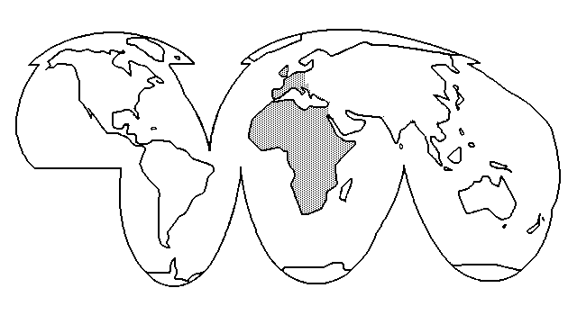
RFJAE Réseau Foi et Justice Afrique-Europe
ANTENNE SUISSE
Position paper
Why should WTO be reformed (reconstitutionalised) into a tripartite organisation like ILO ?

It is unbearable that States (governments) alone decide of world trade in on a political, social, cultural and ecological development model of nations and populations. The WTO creates an ideological antagonism between States and Civil Society. All commercial actors should be integrated into WTO, because it is a question of survival for many and of development. As M. Pascal Lamy put it : the structure of WTO is medieval

- States are powerless to manage all commercial questions.
- "Participative democracy" of Civil Society questions today's "representative democracy". It does not accept anymore the sole representativity of States at international level which are not able to manage commercial situations.
- Decisions taken by States'representatives create growing unhappiness in Civil Society which impedes a peaceful ongoing of democratic decisions, especially among young people.

In the frame of a new reform (reconstitutionalisation) of WTO, we propose that all commercial actors be included in WTO constitution with equal rights as States' representatives. This means :

- States' representatives
- Representatives of Consummers' associations legaly recognised at national level.
- Representatives of Producers' associations legaly recognised at
national level.
WTO would be a tripartite organisation like ILO. The WTO structures remaining as they are, the decisions taken would always be contested by broad parts of the Civil Society concerned.
This new reformed WTO should be under control of UN General Assembly. It would enable a better coordination of its work with other organisations of UN (WHO, ILO, UNCTAD, FAO,etc.) and Commissions on sustainable Development, of Human Rights, of Disarmement, etc. It would then be necessary to create a new ECOSOC with equal power and mandates, but related to the Security Council, both being coordinated by General Assembly. This new organisation means a modification of UN Charta.

Christine von Garnier, Exec. Secretary Swiss Antenna AEFJN, June 2005

