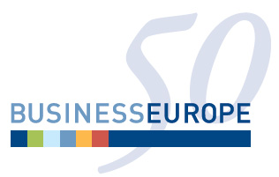

Session 9: Markets for Raw Materials and Energy – What role for the WTO?

Organized by: BUSINESSEUROPE, the Confederation of European Business

Sub-theme 3: Ways forward for the multilateral trading system

Date: Wednesday 24th of September 14:00 - 16:00

Meeting Room: F

Abstract

Various raw materials (including most industrial raw materials) have seen price increases in recent years. One main factor behind these increases is the growing demand from emerging economies. At the same time, trade and investment restrictions (export taxes, export licences and dual pricing schemes) are on the rise around the world.

Due to this global rise in demand and growing protectionism, the competition for and costs of raw materials and energy have been increasing over the past years. However, whereas securing a level playing field for access to fossil, mineral and renewable raw materials and energy is an essential precondition for the competitiveness of WTO members’ economies, this has become increasingly troublesome.

Therefore access to raw materials and energy will be a major issue in the years to come – for business and consumers alike. However, instruments or policies that create trade distortions in the market for raw materials and energy are currently very difficult to address under existing WTO provisions. Trading these materials will have to be organised in a multilateral way. This session will therefore set out to answer the question: What is the role for the WTO in the markets for raw materials and energy? What are the possibilities for the WTO to reduce trade distortions in the markets for raw materials and energy?

The panel will be composed of representatives from raw material exporting and importing countries, who will provide a mix of views that will allow a balanced discussion of the issues from all angles. It will be moderated by Prof. Reinhard Quick, Vice-Chairman of the BUSINESSEUROPE WTO Working Group.

_____________________

