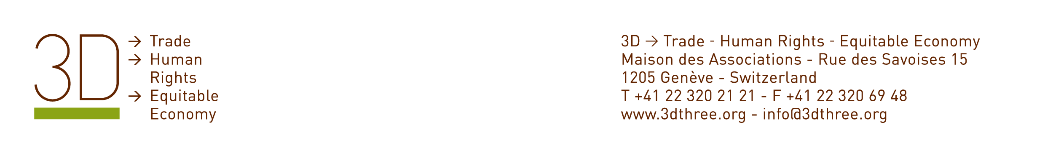

Session 10: The new ‘Geneva Consensus’ Defining People-Centred and Development-Oriented Trade Policy: Can a Human Rights Approach Help?

Organized by:
3D -> Trade - Human Rights - Equitable Economy
and
Office of the High Commissioner for Human Rights

Sub-theme 2: Challenges and Opportunities facing the Main Actors & Stakeholders of the Multilateral Trading System

Date: Wednesday 24th of September 16:15 – 18:15

Meeting Room: F

Abstract

The objective of this session is to explore what tools are available to ensure that trade and other – social, environmental, cultural – policies can work in a mutually-supportive way to improve standards of living and sustainable development for all.

In particular, speakers in this session will explore how human rights can contribute. Indeed, human rights provide a framework for responding to the challenges and opportunities that the WTO faces today, including that of ensuring that trade and globalization do not leave some countries or some people behind.

During the session, speakers will describe how human rights tools can help us think about how to design trade policy in a way that takes account of the needs of all, including the most vulnerable and marginalized countries and people within all countries. Issues covered might include how human rights help us think about in what circumstances and how to provide social safety nets for those who bear the costs of adjustment to globalization and liberalization, how to assess existing or proposed ‘development partnerships’ including new and planned trade agreements. Human rights can offer new ways of thinking about how and why to carry out forward-looking impact assessments of planned trade policies and reforms and these will also be presented.

Speakers will also describe some of the ways that human rights have been applied to promote more equitable trade rules. In this way, the session will dispel misunderstandings about human rights. It will seek particularly to explain that human rights are not tools for disguising restrictions on trade, nor call for trade sanctions against countries who others may consider to have lower human rights standards.

Confirmed panellists for the session:

- Ambassador Mrs. Angélica Navarro Llanos, Ambassador of Bolivia to the UN and the WTO

- Mr Ibrahim Salama, Chief, Treaties and Council Division, Office of the High Commissioner for Human Rights, member of the Working Group on the Right to Development

- Professor Robert Howse, New York University School of Law

- Professor Olivier de Schutter (UN Special Rapporteur, on the Right to Food)

Moderator: Caroline Dommen, Director, 3D -> Trade - Human Rights - Equitable Economy

__________________

Term used by the UN Human Rights Council’s Working Group on the Right to Development, see http://www2.ohchr.org/english/issues/development/taskforce2008.htm

