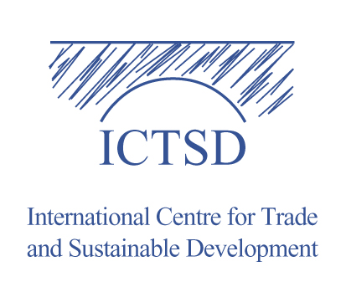

Session 15: Climate Change, Competitiveness and Trade Policy: Opportunities and Challenges for the Future of the Multilateral Trading System

Organized by: ICTSD, Global Platform on Trade, Climate Change and Sustainable Energy

Sub-theme 1: Challenges and Opportunities facing the WTO

Date: Thursday 25th of September 9:00 - 11:00

Meeting Room: CR II

Abstract

Brief abstract outlining the theme of the session and highlighting the main questions that the panel will address

The cross-cutting nature of the challenge of climate change requires action beyond the climate regime. Solutions are already being contemplated within the multilateral trading system, making it critical for the trade regime, as it evolves, to define parameters of responses possible within its mandate, while addressing calls for greater reform, in light of the needed action on climate change.

Several trade-related policies and instruments are likely to arise in the process of negotiating the architecture of the post-2012 regime and its implementation. These range from incentive-based instruments for a sustainable energy transition; the development, diffusion and transfer of clean technologies; the creation of markets for low carbon goods and technologies, to the use of border measures to address problems of carbon leakage and competitiveness.

As such, governing the use of trade-related tools and instruments in addressing climate change is poised to be a major challenge facing actors and stakeholders in the multilateral trading system in the years and decades to come. While some see trade policy as part of the solution, others are concerned about potential obstacles that trade rules may pose in the search for solutions to global warming, leading to calls, in some corners, for a fundamental reform of the international trade regime so that it is aligned with climate action objectives.

This session will bring together a group of leading experts and stakeholders from government, intergovernmental organisations and civil society with a view to critically reflect on future challenges facing actors and stakeholders of the multilateral trading system, from the perspective of climate change.
Panelists will address the following questions:

- How will the multilateral trading system contribute to responses to climate change in an effective manner while maintaining the integrity of the system and the core principles underlying its functioning (e.g. non-discrimination, national treatment, and open trade)?

- How will the system deal with the emerging, but rapidly developing trend of integrating a “carbon footprint” in virtually all aspects of economic activity, from production to consumption? How should long-term implications of bunker fuel costs be addressed?

- What new forms of systemic interaction may be warranted with other policy processes, both public and private, that impact on international trade?

- How will the multilateral trading system strengthen its arbitration function in a context of potentially growing disputes arising from the use of trade-related tools to achieve climate change objectives?

______________

