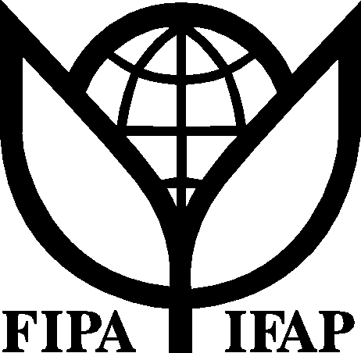
International Federation of
Agricultural Producers

Session 20: Should the Doha Agenda on Agriculture Be Revised in Light of New Challenges Facing Farmers?

Organized by: The International Federation of Agricultural Producers (IFAP)

Sub-theme 2: Challenges & Opportunities facing the main actors & stakeholders of the multilateral trading system

Date: Thursday 25th of September 11:15 - 13:15 hours

Meeting Room: D

Abstract

The Doha agenda for agriculture was set in 2001, seven years ago. Since that time, agriculture has been confronted by new challenges, including a world food crisis, a global energy crisis, and pressures of climate change. The international community is rallying around a new agenda that is focused on increasing investment in small-holder agriculture in developing countries and sustaining the productive capacity in developed countries, while taking into account new environmental considerations like conserving biodiversity and addressing climate change.

This session will explore whether the Doha agenda for agriculture should be revised in light of the new challenges facing agriculture.

Panellists invited include the ambassadors of the G-4 countries (Brazil, the EU, India, and the USA). Participants will include leaders from national farmers’ organisations worldwide.

In particular, this session will address the following questions:

- Would any new investments in small-holder agriculture to meet food security and climate targets be compromised by the draft deal that is currently on the table in the WTO?

- Should the Doha negotiating agenda for agriculture be revised in light of the new challenges facing farmers and governments?

