BIOGRAPHY

Pascal Kerneis – Managing Director

European Services Forum – ESF

Mr. Pascal Kerneis
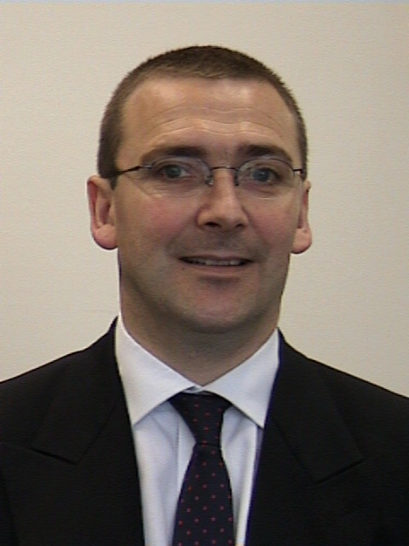
Managing Director
European Services Forum

Born on 13 April 1962
French Nationality
Married – 2 children

Mr Kerneis studied Law in France. He holds a Ph. D. in European Law. After two years as legal expert in the European Commission, Mr Kerneis joined the European Banking Federation (Brussels, Belgium) in 1990. During his stay at the Banking Federation, Mr Kerneis was closely involved in the WTO negotiations on financial services. Mr Kerneis was appointed Managing Director of ESF (European Services Forum) at the launching meeting of the organisation in January 1999. ESF is a network of representatives from the European services sector committed to promoting actively the interests of European services and the liberalisation of services markets throughout the world in connection with the GATS 2000 negotiations. ESF comprises now more than 30 major European service companies and 30 European service federations, representing 20 different services sectors. Mr. Kerneis is a member of the Civil Society Dialogue’s Contact Group of the Directorate General Trade of the European Commission.
___________________

