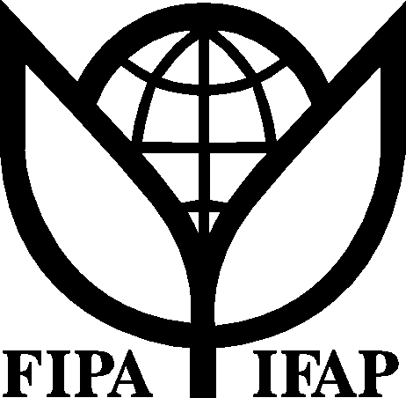
International Federation of
Agricultural Producers
_____________________________________________________________________________________

WTO Public Forum, Geneva
IFAP Session on Agriculture
5 October 2007, 11:15 – 13:15 hours
Room: CRII

Theme: An agreement on agriculture that promotes global development

PROGRAMME

In this session, leaders of the main negotiating groups (G-4 countries) will examine with participants and leaders from farmers’ organisations how the WTO negotiations on agriculture would promote global development.

Opening remarks by the President of IFAP, Jack Wilkinson

Panel of the leaders of the main negotiating groups:

- Brazil– WTO Ambassador H.E. Clodoaldo HUGUENEY

- European Communities – WTO Ambassador H.E. Eckart GUTH

- India - WTO Ambassador H.E. Ujal Singh Bhatia

- USA – WTO Ambassador H.E. Peter Allgeier

Closing remarks by the Deputy Director General of the WTO, Mr. Harsha Singh

Questions and discussion from the floor

