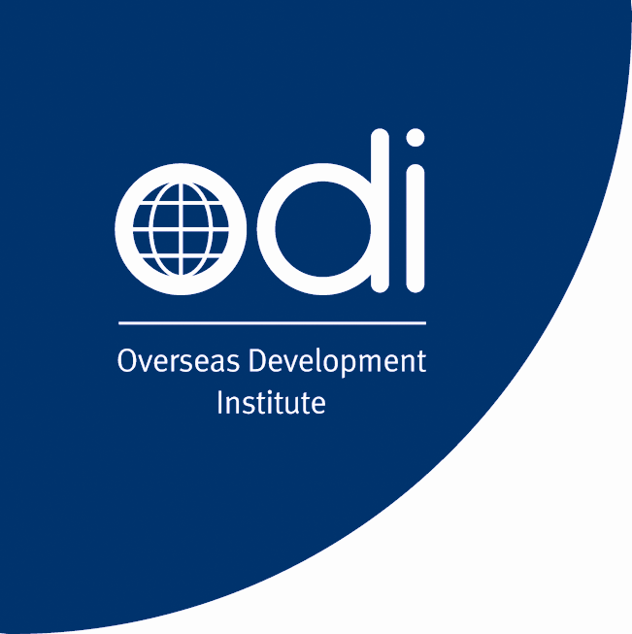

ODI organises a workshop at the WTO’s Public Forum:
“How can the WTO help harness globalization?”
Friday 5th October 2007, 9.00am - 11.00am
Room D, WTO, Geneva, Switzerland

Session 19: Economic Growth

The contribution of Services to Development
The role of regulation and trade liberalisation

The services sector plays a key role in the economy, but has received less attention than agriculture and industry as sources of growth. There is by now quite a bit of work explaining the role of agriculture in the development process, but developing country officials and donors have placed much less emphasis on the services sector, partly because there is less recognition of the contribution it makes to the economy, and partly because they are less clear about the types of measures – liberalisation, sequencing and regulation – that are needed to stimulate the service sector (and wider economy) onto a more dynamic growth path and how these relate to the trade liberalisation agenda. The ODI has been engaged in services and development and aim to present tentative findings of a study funded by the UK Department for International Development.

The objectives of the meeting are to:
- to highlight the importance of services in development,
- to highlight the role of regulatory reform and trade liberalisation in services and development, and how this might be done,
- to raise awareness with development actors of how regulatory reform and trade liberalisation can contribute to development and
- to bring services experts together to discuss the development effects of services.

There will be four speakers who will speak for 15 minutes each, after we expect to have a lively debate.

Chair: Sheila Page, Senior Research Associate, Overseas Development Institute

Speakers

Dirk Willem te Velde, Research Fellow, Overseas Development Institute
“The Contribution of Services to Development, the Role of Regulation and Trade Liberalisation”

Rudolf Adlung, Senior economist, Trade in Services Division, WTO Secretariat
“The Contribution of Services Liberalization to Poverty Reduction: What Role for the GATS”

Dominique Njinkeu, Executive Director, International Lawyers and Economists Against Poverty.

Rajesh Aggarwal, Senior Advisor-International Trading System, International Trade Centre

Overseas Development Institute  111 Westminster Bridge Road  London SE1 7JD  UK | Tel:+44 (0)20 7922 0300  Fax:+44 (0)20 7922 0399  Email: dw.tevelde@odi.org.uk
For further information, see www.odi.org.uk/iedg

