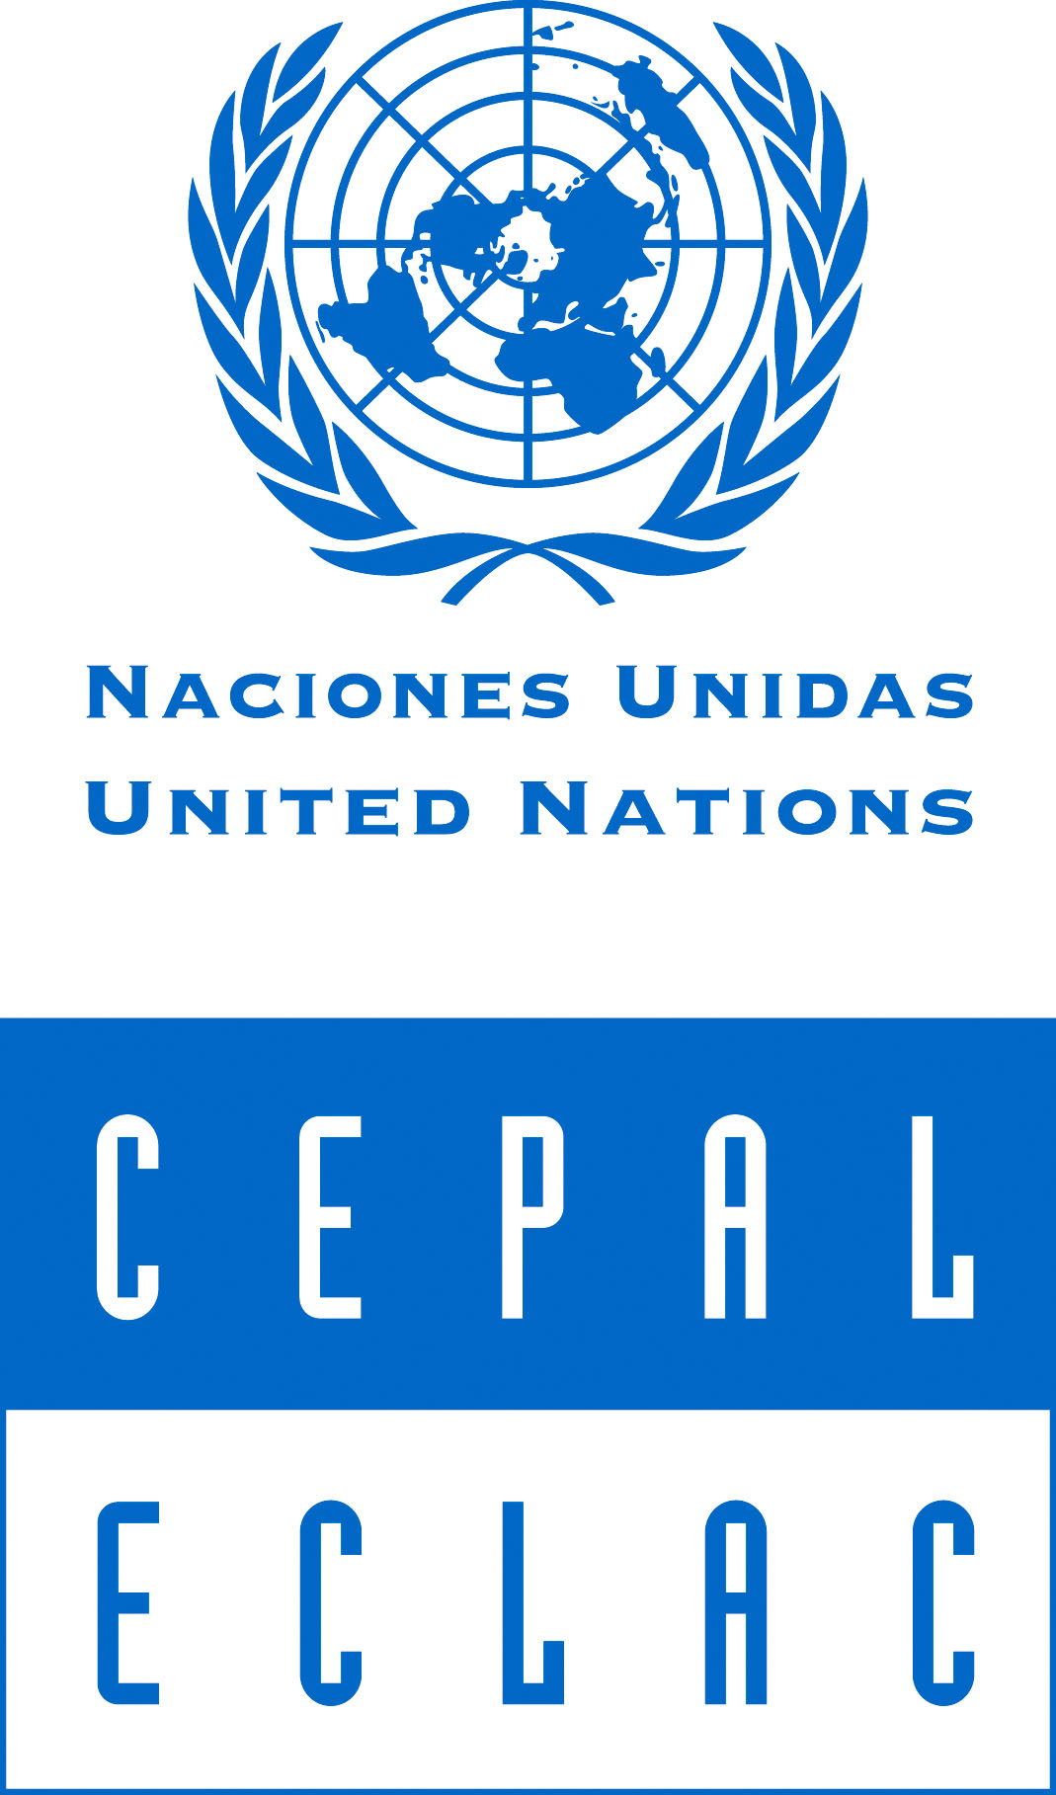

Session 38: Sustainable Development

WTO Public Forum 2007, Geneva
"How Can the WTO Help Harness Globalization?"
Session 39: Sustainable Development

Trade Rules for Sustainable Development in
Latin America and the Caribbean:
Understanding the Linkages

Organizer: Economic Commission for Latin America and the Caribbean
(ECLAC)
When: Friday, 5 October, 2007 at 14:15-16:15
Where: WTO Main building, Ground Floor, Room B

A number of changes occurring in the international environment, such as global environmental concerns, innovation, competitive pattern of growth and institutional governance are relevant for a progressive movement toward sustainable development objectives in Latin American and Caribbean countries and call for a more integral approach, recognizing the importance of trade rules in transmitting these changes. It is quite reasonable to expect that developments in areas like intellectual property rights, foreign investment and technological development are critical factors that generate important challenges for sustainable development in the countries of the region, explaining not only the kind of international trade pattern that has emerged in Latin American and Caribbean countries, but also the available options for addressing challenges related to competitiveness, equity, institutional development and environmental protection.
The session will address the issue of how international trade rules and provisions regarding investments and intellectual property rights impact the Latin American and Caribbean export pattern, and will discuss the specific conditions that these rules and provisions must fulfill in order to become effective instruments for achieving objectives in the economic, social and environmental dimensions of development

Moderator:
- Mr. Alejandro Jara, Deputy Director-General, WTO

Speakers:
- Mrs. Marianne Schaper, Senior Economic Affairs Officer, Sustainable Development and Human Settlements Division, ECLAC, Santiago
- Mr. Carlos de Miguel, Environmental Affairs Officer, Sustainable Development and Human Settlements Division, ECLAC, Santiago
- Mr. Sebastian Sáez, Expert, Division for International Trade and Integration, ECLAC, Santiago

Contact: Marianne Schaper (marianne.schaper@cepal.org)

