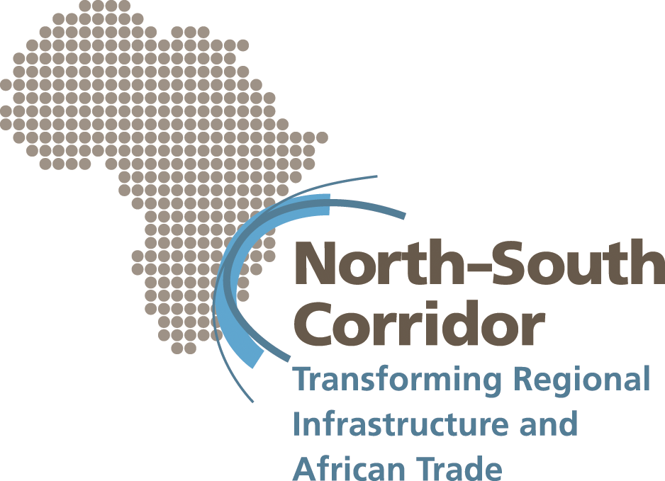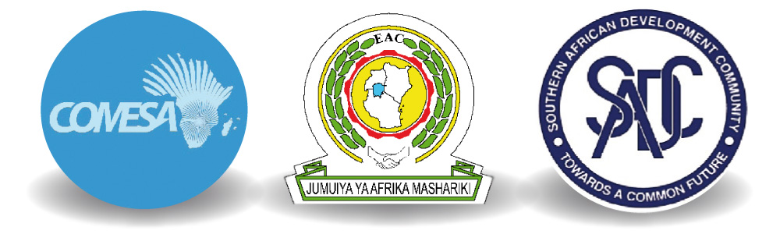

North-South Corridor Conference

Press Release
___________________________________________________________
Increasing Trade and Competitiveness in Africa
COMESA-EAC-SADC Tripartite agrees major regional infrastructure development and Aid for Trade Programme to increase regional competitiveness
Over $1bn of funding is committed by development partners to upgrade regional road, rail and port infrastructure, and to support trade facilitation measures
6th April 2009: Three regional economic communities - COMESA, EAC and SADC – under the Tripartite, have undertaken to implement an extensive Aid for Trade programme encompassing transport, power and trade facilitation projects along the North-South Corridor traversing eight countries in East and Southern Africa.
At a high level meeting hosted by President Rupiah Banda in Lusaka, Zambia, on 6th-7th April, President Mwai Kibaki, President Kgalema Mothlante and President Yoweri Museveni, who represented the three Regional Economic Communities at the conference, announced plans to implement critical reforms to facilitate cross-border trade, reduce transport delays and costs, and promote public and private sector investment. Development partners have agreed to over $1bn of funding to meet the costs of a comprehensive Aid for Trade and infrastructure programme to upgrade road, rail, port and energy infrastructure.
The North-South Corridor is a combination of two traditional corridors (Durban Corridor and the Dar es Salaam Corridor) linking the port of Durban and others in Southern Africa to the Eastern Port of Dar es Salaam. The Durban corridor also has direct links into the Beira, Maputo, Walvis Bay, Benguela and Lobito corridors. From the Port of Dar es Salaam the corridors link to the Central and from the border post of Tunduma the corridor links the Tunduma (Tanzania) – Moyale (Kenya) corridor and Northern Corridor linking the Port of Mombasa to Eastern DRC through Uganda and Rwanda thereby giving physical interconnectivity between Eastern and Southern Africa. The North-South Corridor was selected for the Aid for Trade pilot programme because it is the busiest corridor in the region in terms of values and volumes of freight. Poor road and rail infrastructure and long waiting times at borders and ports create significant costs and hamper regional producers’ ability to access regional and international markets.
The Aid for Trade pilot programme represents a new and innovative approach to supporting and developing regional infrastructure projects. For the first time at a regional level, investments in infrastructure are being made alongside measures to address trade facilitation and regulation. Another innovation is the holistic and regional approach the programme takes to transport system planning and maintenance, the aim of which is to give producers in the region access to a greater choice of road and rail networks.
The North-South Corridor programme includes the maintenance and upgrading of roads, establishing a system to more efficiently control axle loads, reduce border post delays and rehabilitate rail track along the corridor. Faster border crossings and improved port facilities, railways and highways will enable producers and traders, especially in landlocked countries, to transport their goods quickly and access more easily regional and international markets, stimulating economic growth and inward investment. The North-South Corridor is an example of Aid for Trade in action.
In addition to upgrading infrastructure, the initiative will also simplify regulatory processes to speed up cross border clearing procedures, harmonise transit and transport regulations, and simplify administrative requirements. Power supply and transmission in the region will also be improved to allow better management of peak loads and increased power trading, and will provide employment opportunities for large sections of the region’s populations that live in areas with inadequate power.
H.E. President Mwai Kibaki and COMESA Chairman said:
“If we are to successfully realise our vision of creating a vibrant and integrated free trade area, it is vital that we develop the region’s physical infrastructure and capacity to trade. That is why the North-South Corridor Pilot Aid for Trade Programme is so important to our progress, helping to unlock the significant economic potential that lies within, to attract greater levels of inward investment and ensure we can compete more effectively as a region in international markets.”
H.E. President Yoweri Museveni representing the EAC said:
“Through the North-South Corridor programme, we have a unique opportunity to create a modern regional transport network and trading environment that will increase trade and investment. By working collectively with public and private partners, we are implementing an innovative approach, which will simultaneously address both infrastructure and trade constraints. This approach and model should be replicated on other corridors in eastern and southern Africa.”
H.E. President Kgalema Mothlante of South Africa and SADC Chairman said:
“The challenging economic environment, which was brought in to sharper focus at last week’s G20 Summit, brings a greater level of urgency to the efforts of COMESA, EAC and SADC to bring together our respective regional integration programmes in order to further enlarge our markets, unlock our productive potential, increase levels of intra African trade and enhance our regional prospects. As we seek to expand regional markets in Africa, the North-South Corridor programme will place us in a stronger position to respond effectively to intensifying global challenges.”
At the Lusaka meeting, representatives of African governments, regional organisations, international donors, multilateral banks, the WTO, and the private sector, agreed to work collectively on an innovative Aid for Trade programme to enable producers, especially in landlocked countries, to access regional and international markets more quickly and cost effectively and so help unlock the region’s economic potential and boost competitiveness.
At the meeting, there was unequivocal agreement that electricity and transport costs need to be reduced as they are affecting competitiveness and the ability of businesses to trade internationally. This in turn limits job opportunities and investment, lowers living standards and holds back progress on poverty alleviation.
The range of planned projects include the financing of capital maintenance costs of over 8,000 km of road, the rehabilitation of 600 km of rail track, the upgrading of infrastructure at Dar es Salaam port and plans to significantly increase the ability of the region to generate and distribute electrical power both in the short and longer term.
Improvements to the North-South Corridor will be implemented sequentially and will lead to transport cost savings to African based businesses in the order of US$150 million per year by, among other things, greatly improving time taken to move goods around the region.

At the conference, the Presidents announced plans by the RECs they represent to deliver the following:
- More efficient and faster border crossings by completing, amongst other measures, at least three new One Stop Border Posts along the North-South Corridor
- The reform of rail concessions in Eastern and Southern Africa and establishing a well functioning regional rail network
- Improved infrastructure to make the port of Dar es Salaam more efficient
- Improved trade facilitation measures, including streamlining customs procedures and other border clearance facilities and vehicle control systems (such as axle load and vehicle dimension controls) along the corridor.
- Improved power supply and transmission in the region and establishing linkages between Southern and East African Power Pool Member Countries

World Trade Organisation Director General Pascal Lamy commented:
“Aid for Trade is essential to support Africa's own economic growth agenda. The North-South Corridor is an example of a highly innovative regional Aid for Trade approach that can transform competitiveness and enhance regional trade flows. The Corridor projects will promote development and poverty alleviation in the Southern African region and promote deeper regional integration. Such initiatives have never been more urgent than in the current global economic climate.”

African Union Vice Chairman, Erastus Mwencha, said:
“The African Union Commission is in full support of the North South-Corridor programme and looks forward to the lessons learned in this exercise so that these can be applied to other corridors and thus move towards the full linking up of Africa and so deepen integration”.
Development partners including the World Bank, AfDB, EC, UK, Japan, Netherlands, France and Finland, have come together behind the leadership of the RECs to work collaboratively in support of the initiative, delivering one coherent and harmonised solution to addressing trade and infrastructure issues along the corridor.

President of the African Development Bank, Donald Kaberuka commented: “Improving infrastructure and lowering the cost of trading and transport in the region is vital if we are to realise the vast economic potential of East and Southern Africa.
The Africa Development Bank views the North-South Corridor to be a very strategic investment.”

World Bank Vice President for the Africa Region, Obiageli K. Ezekwesili, commented: “Adequate power, good roads, and sound trade regimes are the hallmarks of well-functioning economies and for Africa could add 2% to GDP and increase productivity by 40%. The agreements reached today have the potential to unleash economic growth, facilitate trade, and benefit millions of people by building sustainable pathways out of poverty.”

EU Trade Commissioner Catherine Ashton commented:
“In this economic crisis we must do everything we can to facilitate trade as a source of growth and jobs. The North-South Corridor initiative is a perfect example of how targeted funding can remove barriers to trade caused by poor infrastructure and cumbersome regulation."

UK Minister for Trade and Development Gareth Thomas commented:
"I am delighted to support the North-South Corridor conference. This pioneering initiative will make a difference to millions of people's every day lives in Africa; enabling them to travel more easily, have better access to food, goods and services, and compete in the global market. In an economic downturn, it is vital that economies are kept moving and the North-South Corridor will play a vital role in opening up trade in Africa through improved transport infrastructure, more efficient borders and reliable energy supplies."

In an earlier statement supporting the North South-Corridor, Mr. Abdoulie Janneh, Executive Secretary of the Economic Commission for Africa said: “We at the United Nations Economic Commission for Africa consider efforts to address the missing links and non-physical barriers along African transit corridors as critical to the achievements of the continent’s regional integration agenda which is key to the attainment of sustainable development and poverty reduction. That is why we welcome the idea of using the North-South Corridor as a pilot Aid for Trade programme in Africa.”

These donors undertook to work with the RECs and member states to ensure available financing is matched to implementation plans.

The Chamber of Mines, representing mining companies operating in DR Congo and Zambia, that are reliant on the North-South Corridor for the export of minerals and concentrates, commented:
“With the falling price of metals on the international markets it is essential that the costs of transport to and from international markets are reduced if we are to stay in business. We, therefore, are in full support of the North South Corridor initiative and will work with the Regional Organisations to ensure the Programme’s successful roll-out”.
The conference brought together many key players and stakeholders working on Aid for Trade globally to discuss broader needs for Aid for Trade in East and Southern Africa and share examples of best practice in the region.
For further information, please contact:
Dianna Games:
Mobile: +27 (0) 82 331 4225 ; Landline: +2711 880-4868
Email: diannagames@mweb.co.za;
NOTES TO EDITORS

Donor Commitments

Specific commitments made at the conference include:
- World Bank commits US$500m to projects along the North-South Corridor, with an additional US$500m committed to investing in projects that are significantly complementary to the North-South Corridor.
- EC commits to €115m / $150m.
- ADB commits to $380m for projects on the North-South Corridor. In addition, the bank will invest $160m in sections of the Ncala Corridor, which is complementary to the North-South Corridor and provides an alternative route to the sea.
- UK’s Department for International Development commits to £100 million over the next five years for projects on the North-South Corridor, aligned to the priorities of the RECs.

Special Advisor to the Minister for Foreign Affairs of Japan, Keitaro Sato
commented: “Japan is determined to faithfully carry out its commitments made at TICAD IV, including those on infrastructure development. Japan will actively mobilize the concessional loans of up to 4 billion US dollars over five-years and expeditiously implement 2 billion US dollars of grant aid and technical cooperation during this difficult period of financial crisis.”

Mr. David White, Head of Regional Representation for Southern Africa, European Investment Bank commented: “We are committed to a proactive approach to funding North-South Corridor investments and also linked corridors such as the Beira Corridor for which we have committed €94m (including €29m from the EU-Africa Infrastructure Trust Fund). We attach high priority to these types of regional projects”.

The Netherlands’ Minister for development cooperation, Bert Koenders, invited the countries in the region to make optimal use of existing cooperation arrangements, including the new untied Dutch ORIO instrument for public infrastructure development.

Ms. Patricia Francis, Executive Director, said that ITC commits itself to contribute to private sector soft infrastructure solutions for the North-South Corridor.

Information about the North-South Corridor

Context and challenge
- The Southern and East African regions have vast untapped potential in the form of rich mineral deposits and a strong agricultural base. The cost of trading and transportation in the region, however, are significantly higher than the rest of the world. Inefficient and poor quality infrastructure is a major constraint to the ability to trade between countries and internationally, inward investment and economic growth.

- For example, transporting a single cargo of copper from the Copperbelt to port currently takes, on average, two to three weeks. In Europe, the same distance would take 48 hours. It is estimated that the lost income in terms of interest alone on a trainload of copper is about US$16,000 per week of delay.

- The volume of goods moving along the corridor is expected to increase in the coming years and the infrastructure will further deteriorate, adding additional transport costs, without remedial action being taken. The World Bank estimates that for every $1 spent on preventative road maintenance, $4 is saved on rehabilitation.

- The programme will also address bottlenecks caused by inefficient regulatory and administrative procedures at key points.

- Aid for Trade is a global initiative which aims to help developing countries, particularly least-developed countries, develop the trade-related skills and infrastructure that is needed to implement and benefit from WTO agreements and to expand their trade. At the G20 meeting in London on 2 April, leaders reaffirmed their commitments on Aid for Trade.

Expected outcomes from improvements along the Corridor include:

- Overall reduction of the transport costs and transit times for traffic between Dar es Salaam and Lusaka of at least 25%;
- A reduction in travelling times by road from Lusaka to Durban of at least 10 per cent;
- A reduction in transit times at the Chirundu border post (between Zimbabwe and Zambia) of at least 20 percent;
- Latent reduction of transit costs and times for traffic between East Africa and southern Africa; and
- An increase in generation and transmission of electricity in the region, particularly hydro-electric generation

