Please check against delivery
BANGLADESH
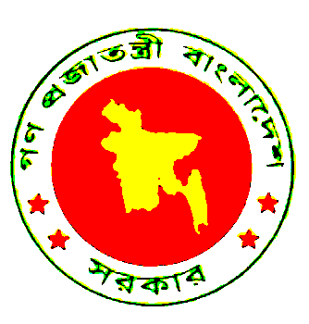
Statement of H.E. Mr. Muhammad Faruk Khan
Honourable Minister for Commerce

Mr. Chairman
Ladies and Gentlemen

Bangladesh fully endorses the statement by Tanzania, made on behalf of LDCs.

Mr. Chairman,

We have gathered here at a very critical juncture of the world economy and perhaps the worst of time since the 1930s. The global financial crisis coupled with the impact of climate change threatens our existence more than ever. While the scenario is common to all WTO members in varying degrees, it is distinctly scaring for LDCs like Bangladesh where the challenges are extremely daunting. Our exports in the last quarter have experienced a slump of around 12%, export of textile and apparels which constitutes 80% of our total export has declined by 27% in the month of September than that of the same period last year. Number of workers going abroad have declined by a drastic 40%. All these are manifestations of a gloom that looms heavily on us.

We do not have the necessary resources to cope with the paramount challenges facing us. Therefore, we need the sincere support and cooperation of our development partners. They must deliver on their commitments made at various international fora, including G20 Summit.

We observe with deep frustration that delay in DDA outcome is denying the LDCs of DFQF market access. We continue to face significantly high tariff for our major exports to some developed countries. Therefore, we call upon Members to sincerely engage for an early conclusion of Doha Round.

Undoubtedly Bangladesh is one of the most disproportionately affected countries. Therefore, we urge WTO Members to work towards a balanced outcome in addressing DAC issue while respecting the development dimension which is the centrepiece of the current round.

Further, in terms of human exposure, Bangladesh is most vulnerable to floods, third most to tsunami and sixth most in terms of cyclone. Therefore, Bangladesh is a doubly disproportionately affected country. We must be compensated through trade as well for adaptation to and mitigation of climate change.

We urge Members for an early adoption and operationalisation of the LDC Services waiver decision.
Restrictions imposed by many countries on export of food items have caused great suffering to millions of food-insecure people in the LDCs during the recent food crisis. In order to ensure food security of the LDCs, restrictions should not be imposed on export of food grains to LDCs.

Mr. Chairman,

LDC Ministers agreed on the following principles in Dar-es-Salaam. We call upon all WTO Members to adopt them:

First, to operationalise the core principle of S&D Treatment and the development dimension of Doha by granting all LDCs more preferential treatment than non-LDCs.

And, to address the issues of concern to LDCs on a priority basis and to have an "early harvest" on DFQF market access, services waiver and cotton issue.

In this regard, there must be clarity on DFQF both on product coverage of 97 per cent and the phasing in of the remaining 3 per cent well before the conclusion of the Round. DDA outcome must not backtrack on its development commitments.

Mr. Chairman,

We can not afford the stalemate on DDA. All of us, particularly the major trading Members must be forthcoming. They can not absolve themselves of the moral responsibility they have towards the teeming millions across the world.

I thank you.

