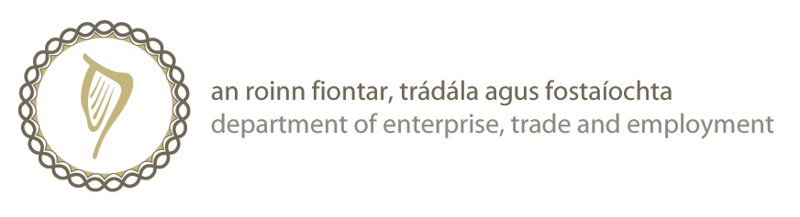

Statement on Behalf of Ireland at the WTO’s 7th Ministerial Conference

Address Delivered by Minister for Trade and Commerce, Mr. Billy Kelleher T.D.

Chairman, Director General, Excellencies,
The WTO provides the essential framework to manage the huge changes taking place in world trade. The agreements and obligations overseen by the WTO are essential to the fair regulation of trade. They give our enterprises confidence to develop new secure, open markets. Business gains from transparent, predictable and fair rules.

We believe in making the WTO adaptable to the needs of its members and responsive to global problems. This makes the organization vibrant, relevant and respected.

The WTO’s dispute settlement process is critical to keeping trade moving. The certainty of a fair hearing and the knowledge that trade disputes have international adjudication, with legal redress, is vital. Ireland would like to see more transparency in this process.
In these times of economic crisis the need for an effective and relevant trade referee could not be clearer. The WTO’s protection monitoring work is too important to overlook. Putting a spotlight on new rules that restrict trade prevents short term protectionism growing where trade rules might be abused. Widespread rolling back of what we have achieved to open markets and encourage more and freer trade must be avoided.

Trade is a tool that can be used to support so many policy goals, such as climate change. Trade policy should be deployed to address this threat. We need more products that are innovative, of a high standard and good value to help us create green policies. Opening channels for freer trade in environmental goods can contribute to a carbon free future.

On development, Ireland believes trade is one of the most important drivers. We are firmly committed to fulfilling the development dimension of Doha. The DDA was designed to ensure that the poorest and weakest countries are not marginalised, but could use trade to help deliver their individual development agendas. However, a lack of capacity and opportunity obstructs progress.

How a country benefits from liberalised trade depends on the strength and productivity of its domestic economy and its ability to access markets. By Aid for Trade, Ireland supports and funds a number of initiatives to help partner countries to reduce poverty through developing a trade capacity that also fosters economic growth. This technical assistance better equips developing countries to represent their interests internationally and gain more advantages from global trade.

Finally, the Doha outcome has to reflect key interests of all members. We will only have a successful agreement where everyone’s special interests are adequately catered for. The outcome has to fit coherently with all our objectives including the newer challenges of climate change and food security. We need to intensify our efforts to make this happen because the benefits are too great to ignore.

The huge decrease in global trade volumes already reported underlines the need to quickly resolve our differences and deliver an ambitious, balanced and comprehensive Doha agreement.

Go raibh mile maith agaibh go leir.
END

