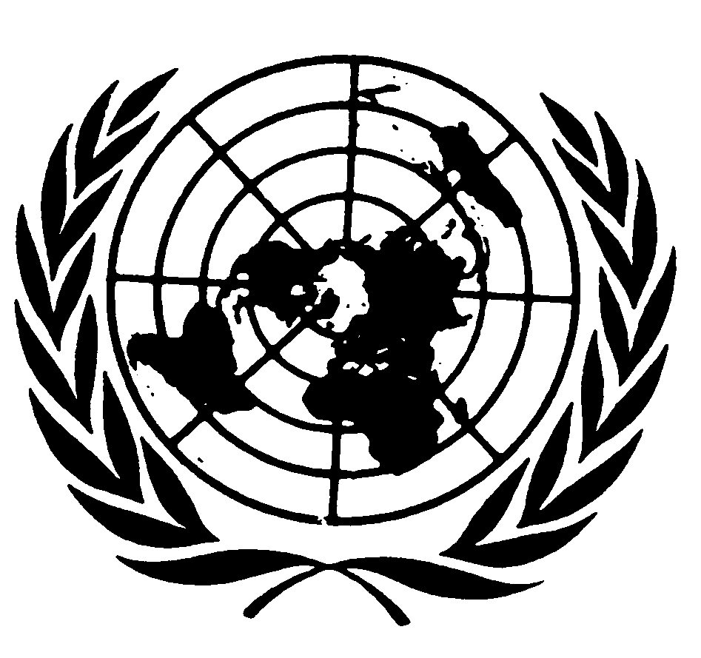
U N I T E D N A T I O N S N A T I O N S U N I E S

THE Secretary-General

MESSAGE TO Seventh Session
of the Ministerial Conference
of the world trade organization
Geneva, 30 November 2009

Delivered by Mr. Supachai Panitchpakdi, Secretary-General,
UN Conference on Trade and Development

It is a pleasure to greet the Ministers and others attending this important conference.

Over the past year, policy makers have made great efforts to mitigate the damage being inflicted by the global economic and financial crisis. Those efforts have reduced the threat of another Great Depression. The resilience of some emerging economies, particularly Brazil, China and India, has been particularly encouraging.

However, we are all aware of the toll that multiple global crises are having, especially on the most vulnerable communities. The number of unemployed in 2009 could reach 59 million, 70 per cent of them in developing countries. One billion people lack access to food. Global trade could fall by 11 per cent this year. Progress towards the Millennium Development Goals by 2015 could be compromised.

We must do better at managing the global economic system, and at ensuring open and stable markets and widely shared gains for all. That means we must carefully consider the recommendations of the UN Conference on the World Financial and Economic Crisis and Its Impact on Development, held last June. It means ambitious and concrete measures to combat climate change at the UN Conference in Copenhagen next week. And it means a strong and sustainable recovery that creates decent jobs.

Trade has a key role to play. Expanding international trade remains a key component of the development agenda of the United Nations. I urge this ministerial conference to reaffirm its commitment to the open multilateral trading system, and to the WTO as the forum for strengthening that system.

It is deeply troubling that, in response to the crisis, a number of countries have resorted to protectionist measures. Such actions disproportionately harm the development efforts of poorer countries, risk embedding a corrosive culture of protectionism, and, as history shows, likely to shrink global trade and injure all stakeholders. Such protectionist pressures need to be resisted, whichever lens they are viewed through: local, national or global. In the same vein, all forms of trade-distorting subsidies need to be eliminated as soon as possible.

Over the years, the WTO has been invaluable in advancing freer trade among nations. But there is room for improvement, in particular to make it more inclusive in responding to the needs of the weak and vulnerable countries. This requires a revival in trade and financial flows. But above all we need a speedy conclusion to the Doha Round, with strong and meaningful developmental content for developing countries, in particular the least developed. This is critical. So is aid for trade, a promising initiative that must complement any trade deal.

I look forward to working with you to achieve an open, equitable, rule-based, predictable and non-discriminatory multilateral trading and financial system that delivers tangible development gains to developing countries. In that spirit of partnership, I offer my best wishes for a successful conference.

