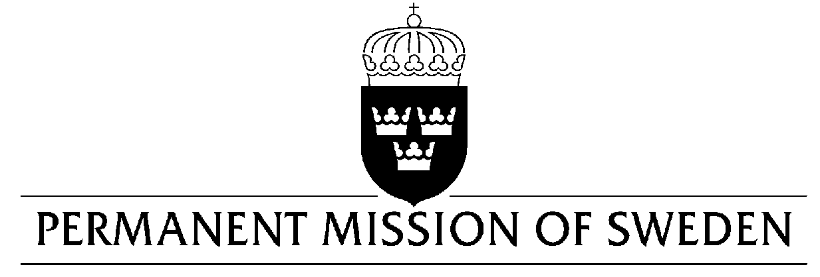
Geneva, 19 November 2007
CHECK UPON DELIVERY
Geneva

Statement by Mr Joakim Stymne, Sweden’s State Secretary for International Development Cooperation at the WTO Aid for Trade review, bilateral donors’ session on 20 November 2007

We are here today, a year after the adoption of the Aid for Trade Task Force recommendations, to speak about our vision, priorities and plans for Aid for Trade.

Clearly, things have happened in the past years, but the greatest challenge of delivering on our commitments lies ahead. Sweden’s vision is an international trading system that embraces all nations of the world, not only the ones that are already well-off. That is why free trade coupled with trade-related development cooperation is a priority for the Swedish government.
With this in mind, we are delighted that we have been able to contribute to the important Integrated Framework process. It is with great confidence that we look at the future work of the Enhanced Integrated Framework, given the successful outcome of the IF pledging conference, which was arranged in Stockholm in September. Sweden intends to commit 100 million Swedish kronor to the Enhanced Integrated Framework Trust Fund over the next three years.

Sweden’s own vision for Aid for Trade is bold since the adoption of the Aid for Trade recommendations. We have
increased our trade-related assistance by thirty per cent. We have scaled up, stepped up and will continue to do so. Our efforts will be carried out in concurrence with the ambitious Joint EU Aid for Trade strategy.
The Swedish International Development Cooperation Agency (Sida) is instrumental in transforming our ambitions on Aid for Trade into action. Their work is based on the demands and needs of partner countries and Sweden’s comparative advantage. Sub-Saharan Africa is our geographical focus. Sida works actively to integrate trade in our overall development cooperation.

Let me give you a few specific examples of our work:
- The Swedish International Development Cooperation Agency and the Swedish National Board for Trade are carrying out an International Training Program on rules of origin focused on officials from East and Southern Africa. As we all know, rules of origin are crucial for actually making use of formal market access.
- Another example of unconventional but promising cooperation, is a network bringing together the Swedish National Board of Trade, the Swedish Environmental Protection Agency, the Swedish Customs Service, the Swedish Patent and Registration Office, the Swedish Chemicals Agency and the Swedish Board for Accreditation, to exchange experiences and ideas for new forms of partnerships with developing countries.
- Sweden has also supported the establishment of a trade policy training centre – TRAPCA – in Arusha, Tanzania. The institute manages courses in trade policy at many levels and aims to educate already active servants within ministries, authorities, universities, business community as well as international, regional and non-governmental organizations, mainly from LDCs.
- This fall, the Swedish International Development Cooperation Agency, the United Kingdom’s Department for International Development and the World Bank, jointly developed the World Bank Multidonor Trust Fund for Trade and Development. The trust fund’s overall objective is to contribute to economic growth and poverty reduction by supporting countries to strengthen the role of international trade as part of their broader growth and poverty reduction agenda. Sweden has committed 90 million kronor to the Trust Fund over a period of three years.
These are just a few examples – but examples that illustrate how we think about and aspire to work with Aid for Trade in the future. Looking ahead, global efforts on Aid for Trade must of course also be efficiently monitored. We need an international consensus on how to report on Aid for Trade, including clear benchmarks and cursors. Swedish reporting on trade-related development cooperation primarily contains the two categories in the WTO/OECD database. As regards the wider Aid for Trade categories, trade-related components are extracted on a case-by-case basis. Sweden is currently working on improving our reporting methodology on Aid for Trade.

We also need to become better at linking our efforts to the reality on the ground – to the possibilities and constraints faced by poor women and men. Understanding the long and short term linkages between trade and poverty as well as the gender dynamics behind these linkages will help us address the challenge of making trade a powerful engine poverty reduction.
Again, important challenges lie ahead. The next step for Sweden is to further strengthen our work on Aid for Trade, bilaterally and within the EU. Input from our partner countries is crucial. We will continue to make every effort to ensure that Aid for Trade is a driving force for development.

Thank you!

