World Trade
Organization
World Trade  Organization | WT/COMTD/W/193  14 February 2013
 | (13-0844)
Committee on Trade and Development

electronic commerce, development
and Small, medium-SIZED enterprises

Background Note by the Secretariat

Table of Contents

I. INTRODUCTION 3
II. The Growth of the Internet 3
III. The Digital Divide: Still a Reality? 5
IV. THE GROWTH OF E-COMMERCE 6
1. What is e-commerce? 6
V. B2B, B2C or B2G? 7
1. Business-to-Business (B2B) 7
2. Business-to-Consumer (B2C) 8
3. Business-to-Government (B2G) 8
VI. Accessing the Worldwideweb through Mobile Telephony 8
VII. How do poorer countries benefit from mobile telephony? 10
1. What are the prospects of the global mobile market? 11
2. How do poorer countries benefit from mobile telephony? Agriculture, On-line supply and demand information, Fisheries and Labour mobilization 12
3. Agriculture 12
4. On-line data and information services 14
5. Market Access 14
6. Fisheries 15
7. Labour Mobilization 16
VIII. Mobile Money 18
1. Inherent Benefits 19
IX. E-COMMERCE AND SMALL, MEDIUM ENTERPRISES 21
X. Policy Issues - What restricts SMEs from more fully using E-Commerce? 23
XI. Conclusion 29
ANNEX 31

The number of mobile phones in use worldwide between 2000 and 2012 grew from less than 1 to more than 6 billion. The mobile revolution is transforming livelihoods, helping to create new businesses, and changing the way we communicate, work and earn and spend income. The mobile phone network is already "the biggest machine" the world has ever seen, and now that machine is being used to deliver development opportunities on a scale never before imagined. During this second decade of the new millennium, maximizing the potential of mobile phones is a challenge that will engage governments, the private sector, and the development community alike.
Source: World Bank, Information and Communications for Development 2012: Maximizing Mobile

INTRODUCTION
          - This background paper was prepared in response to a request for a workshop on Electronic Commerce, Development and SMEs made at the WTO's Committee for Trade and Development (CTD) in July 2012 (see Annex 1). The paper focuses on the relationship between electronic-commerce (e-commerce), development and small and medium-sized enterprises (SMEs) and on how some of the latter have used e-commerce to promote, market, service and sell their products nationally and internationally. Various types of e-commerce are discussed such as business-to-business, business-to-consumer and business-to-government. And the vast potential of mobile commerce is described given the key role it plays in developing and least-developed countries (LDCs). This paper by no means pretends to be an exhaustive study of the subject under discussion but does attempt to provide an overview of both the opportunities and challenges facing SMEs in least-developed and developing countries.
          - A key focus of the paper is on why some small and medium-sized enterprises have used the internet and realized significant increases in their exports and business activities overall, whereas others are barely making use of the huge potential offered by the internet and its various applications. Development-related issues are discussed such as how low levels of investment, inadequate infrastructure or a lack of appropriate legislation can negatively affect e-commerce or stifle its potential. The need to overcome infrastructural bottlenecks in telecommunications, transport, electricity grids and logistics are addressed alongside policy issues such as consumer protection, security of transactions, privacy of records, and intellectual property. The paper has a strong focus on mobile telephony and mobile-commerce (m-commerce) in general because of the key role both play in many low-income developing countries and because of the vast potential such technologies have for improving trade and business opportunities.

The Growth of the Internet
          - The first decade of the new millennium has witnessed a profound change and dramatic increase in the way business and trade takes place electronically. Each day more users in least- developed and developing countries are accessing the internet through terminals. A growing percentage of users are now also accessing the web through mobile technology. Predictions call for the internet and especially the use of mobile applications to expand exponentially in the decades ahead. There is enormous potential for using information and communication technologies (ICTs) to contribute to the social and economic progress of developing countries worldwide. A key role in this regard is played by small and medium-sized businesses.
          - UNCTAD's recent Information Economy Report 2010 shows how ICT use by micro- and small and medium-sized enterprises (SMEs) has improved not only business performance but has helped improve livelihoods in some of the world's poorest regions and communities. Many entrepreneurs in developing countries now have a real possibility to benefit from ICTs in their business activities. In many cases, this has resulted in gains in enhanced productivity. By improving communication channels, both domestically and internationally, the application of relevant ICTs can greatly enhance the competitiveness of business. Government efforts to further improve, upgrade and expand ICT use by the private sector should, therefore, be reinforced. UNCTAD's study finds that governments and their various partners, including the private sector, are far from taking full advantage of the opportunities that are emerging in the new ICT landscape. This is evident in part from the relatively limited attention that has been given to ICTs in strategies aimed at promoting private sector development (PSD).
          - The rapid technological advances in ICT and the steady increase in the number of users are changing the global economic landscape. From 1990 to early 2000, the estimated number of internet users grew more than tenfold to roughly 300 million. This had a direct effect on the way in which people communicate and do business. Today, however, these 300 million users represent barely two-thirds of the size of the subscribers active on "Facebook" alone. Today, there are more than five times as many internet users as there were in 2000. Growing from two billion at the start of this decade, there were an estimated 2.25 billion users in 2011. Chart 1 describes the increase in internet users over the past ten years.
Chart 1: Global numbers of individuals using the internet, 2001-2011

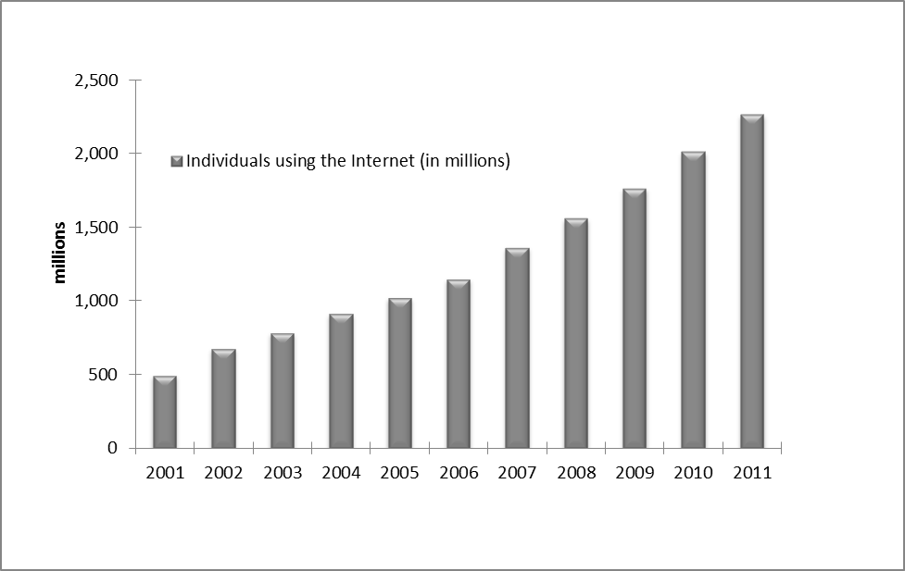Source: ITU

          - Of all the internet users in 2011, 1.3 billion were from the Asia-Pacific region, the Middle East, Africa or Latin and South America indicating a shift in the regions with the most people on line. However, in spite of this growing trend in internet use, developed countries still continue to surpass developing countries in terms of number of connections. Chart 2 highlights the number of individuals using the internet per 100 inhabitants. While the Africa region has a penetration rate of 12.4, Europe has the highest penetration rate with 68.4 out of every 100 Europeans having access.
Chart 2: Individuals using the internet per 100 inhabitants - 2011
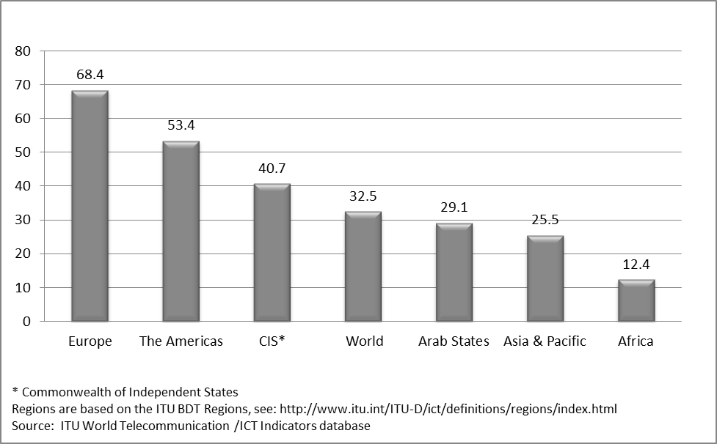Source: ITU

The Digital Divide: Still a Reality?
          - The term "digital divide" is commonly used to explain the gap between individuals, households, businesses and geographic areas at different socio-economic levels regarding opportunities to access information and communication technologies as well as the use of the internet for a wide variety of activities. The "digital divide" is used to denote differences both among and within countries. Since 2000, the phrase "digital divide" has come to symbolize the gap in ICT capabilities between developed and developing countries. However, civil society organizations such as the World Wide Web Foundation believe that the digital divide is more a symptom of other, more fundamental problems in a given country. These can include an education divide, a health divide and a governance divide. It is not always the cause of a lower level of development. Many examples have shown that narrowing the "digital divide" can assist in narrowing differences in other areas of developmental concern. The importance of prioritising the development of e-commerce lies in the fact that as the pace and scope of the technological revolution increases and expands, so does the potential digital divide. Governments can help to ensure, by a mix of investment incentives, competition policy and social policy, that users benefit not only from being connected to the internet but also from any technological evolutions which can increase the speed of data flows and reduce costs.
          - The internet plays a large role in e-commerce and has continued growing worldwide in terms of users and penetration. Although developed economies still accounted for the majority of internet users in 2006 and are still very much ahead in terms of internet penetration, developing economies have been catching up quickly. The number of users in developing countries actually surpassed that of developed countries sometime in 2010. Technological progress has indeed been thriving in both developing and developed countries and this trend is expected to continue as the sector attracts more research funds and investment.
Chart 3: Individuals using the internet by level of development
Source: ITU

THE GROWTH OF E-COMMERCE
          - There is no question that e-commerce has grown rapidly since the first users started to browse the worldwide web in search of goods and services. Today, sales realized over the internet represent a significant proportion of overall commercial sales. In 1991, the internet had less than three million users around the world and its application to e-commerce was non-existent. Almost a decade later, by 1999, an estimated 300 million users accessed the internet and approximately one quarter of them made purchases online from electronic commerce sites, worth approximately US$110 billion. This year global, business-to-consumer e-commerce sales are set to pass the US$1.25 trillion mark.

What is e-commerce?
          - For purposes of the trade focus of this paper, e-commerce is the sale or purchase of goods or services, conducted over computer networks by methods specifically designed for the purpose of receiving or placing of orders. Even though goods or services are ordered electronically, the payment and the ultimate delivery of the goods or services do not have to be conducted online. An e-commerce transaction can be between enterprises, households, individuals, governments, and other public or private organisations. Included in these electronic transactions are orders made over the web, extranet or electronic data interchange. The type of transaction made is defined by the method of placing the order. Normally excluded are orders made by telephone calls, facsimile or manually typed e-mails.
          - The United States (US) remains the world's biggest e-commerce market, followed by the United Kingdom and Japan. It is estimated that the growth rates for electronic transactions carried out over the net will be approximately ten to 15% in the coming years. China, however, saw e-commerce sales grow by more than 130% in 2011 and it is likely to be only a short matter of time before it becomes the world's single largest e-commerce market.

Chart 4: Mobile-cellular subscriptions by level of development
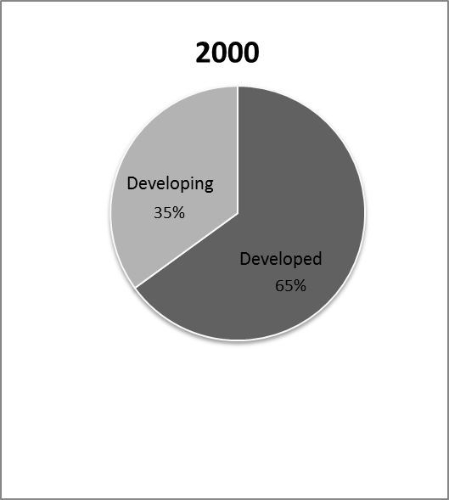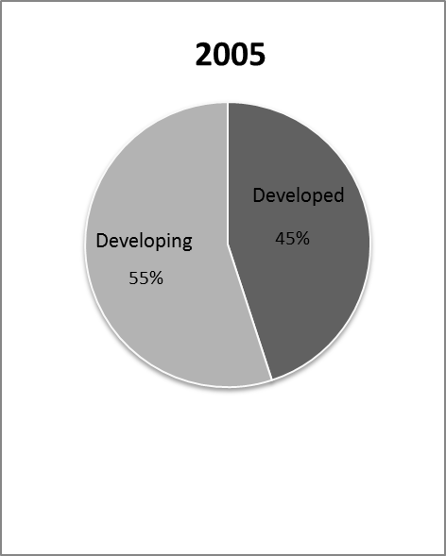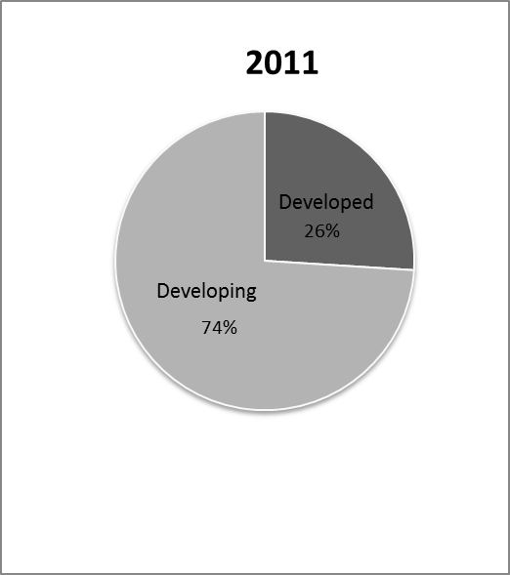
Source: ITU

B2B, B2C or B2G?
          - There are numerous types of commercial transactions that occur on line, from buying goods such as books or clothes to purchasing services such as airline tickets or making hotel or car rental reservations. Since the main focus of this paper is on how SMEs use the internet, the discussion here will concern only a few services which relate closely to SME economic activity. These include: electronic communications in the area of Business-to-Business (B2B), Business-to-Consumer (B2C), Business-to-Government (B2G) and mobile e-commerce.

Business-to-Business (B2B)
          - B2B is e-commerce between businesses such as between a manufacturer and a wholesaler, or between a wholesaler and a retailer. This is the exchange of products, services, or information between businesses rather than between businesses and consumers. Global B2B transactions comprise 90% of all e-commerce. According to research conducted by the US-based International Data Corporation (IDC), it is estimated that global B2B e-commerce, especially among wholesalers and distributors, amounted to US$12.4 trillion at the end of 2012. If the expansion in e-commerce continues at this rapid pace in developed markets as is expected, then B2B and B2C e-commerce transactions will account for about 5% of all inter-company transactions and retail sales by 2017.

Business-to-Consumer (B2C)
          - Although B2C e-commerce receives a lot of attention, B2B transactions far exceed B2C transactions. According to the IDC, global B2C transactions are estimated to reach US$1.2 trillion at the end of 2012, ten times less than B2B transactions. B2C e-commerce entails businesses selling to the general public typically through catalogues that make use of shopping cart software. Although B2C e-commerce only accounts for only a small share of e-commerce as a whole, it continues to grow. B2C e-commerce is highest in Norway, Denmark, Sweden, the United Kingdom and the US and covers mainly computer-related products, clothing and digitized products. Despite the low value of its transactions, B2C e-commerce has received the most attention, partly because issues such as consumer trust and data protection have received considerable concern from policy makers.

Business-to-Government (B2G)
          - Business-to-Government or B2G commerce is generally defined as e-commerce between companies and the public sector. It refers to the use of the internet for public procurement, licensing procedures, and other government-related operations. In B2G e-commerce, the public sector generally assumes the pilot role in establishing e-commerce in an effort to make its procurement system more efficient. The size of the B2G e-commerce market as a component of total e-commerce is still rather insignificant as government e-procurement systems still remain comparatively undeveloped.

Accessing the Worldwideweb through Mobile Telephony
          - The most popular ICT in developing countries and one which is progressing very rapidly in Africa and Asia, in particular India, is the mobile phone. Mobile phones are increasingly playing a larger role in the expansion of e-commerce in developing countries, especially amongst users without terminal connections. The chart below shows that in the past ten years, mobile-cellular subscriptions in developing countries have increased nearly tenfold. Not only have they helped to improve how businesses are run, they are also helping to close the poverty gap. Mobile phones are making it possible for rural farmers to engage in mobile money services, allowing them to open saving accounts, earn interest on their deposits and access a variety of credit and insurance products.
          - Mobile e-commerce is exactly the same as e-commerce except that the access mechanism is via a wireless phone or terminal. In recent years many developing countries have seen a surge in mobile commerce. Internet penetration across Africa, for example, remains low and computers are often too expensive to purchase. However, there are currently 695 million mobile phone subscribers in Africa. This has given Africans a simple and pervasive means of sharing information and conducting business, even in spite of the fact that online business transactions can be logistically complicated to execute.
Chart 5: Mobile-cellular subscriptions per 100 inhabitants, 2001-2011
Source: ITU

          - In many developing countries mobile phones are still mostly used for voice communication and texting. Recently, however, they are increasingly being used for data applications such as m-commerce and m-banking. In a number of African countries, notably Kenya, South Africa, Tanzania and Zambia, mobile telephones are being used to do personal banking services. And entrepreneurs are using calling and texting services to acquire locally relevant information and services. In the near future, internet-enabled phones may help to deliver the same services but more efficiently. Microenterprises and SMEs, many of which are in the informal sector in developing countries, appear to be the most positively affected by the adoption of mobile telephony. In the agriculture and fisheries sectors in Asia and Africa, for example, mobile phones are now frequently used to conduct sales and purchases, to establish delivery times and destinations and to negotiate prices. While these are classic transactions normally carried out over personal computers, they are being done on location using mobile technology. For fishermen, mobile phones are regularly used to check weather reports and to receive early warning announcements of severe weather conditions on land or at sea.
          - This fast growth of mobile e-commerce stems from the cost advantage of mobile infrastructure over fixed-line installation. Mobile network consumers can simply buy a prepaid card and a handset at an affordable price (usually subsidized by the operator) and start using their mobile phone as soon as the first base stations are in place. In recent years, a few innovative African companies have found ways to harness the potential of mobile commerce and information sharing, changing the way in which Africans communicate. This development has taken place in spite of the fact that online business transactions can still be logistically complicated to execute.
          - Mobile web adoption is growing at a faster rate today than the internet did in the 1990s and early 2000s. Emerging markets like India, China, Turkey and Brazil have seen an exponential growth in mobile web use with figures that have surpassed mature markets. Mobile 3G subscriptions in the US grew by 26% in 2011 whereas Brazil, Turkey, China and India saw growth of 79%, 104%, 172% and 1,050% respectively.
Table 1: Evolution of Mobile-cellular subscriptions per region
Mobile-cellular subscriptions | (millions) |  |  |  |  |  |  | (per 100 people)
 | 2005 | 2006 | 2007 | 2008 | 2009 | 2010 | 2011 | 2005 | 2006 | 2007 | 2008 | 2009 | 2010 | 2011
Developed | 992 | 1,127 | 1,243 | 1,325 | 1,384 | 1,413 | 1,514 | 82.1 | 92.9 | 102 | 108.3 | 112.6 | 114.5 | 122.3
Developing | 1,215 | 1,619 | 2,126 | 2,706 | 3,263 | 3,898 | 4,457 | 22.9 | 30.2 | 39.1 | 49.1 | 58.4 | 68.9 | 77.8
World | 2,207 | 2,747 | 3,369 | 4,031 | 4,647 | 5,311 | 5,972 | 33.9 | 41.7 | 50.6 | 59.9 | 68.2 | 77.1 | 85.7
Africa | 87 | 129 | 174 | 246 | 297 | 363 | 434 | 12.4 | 17.9 | 23.5 | 32.4 | 38.2 | 45.6 | 53.1
Arab States | 85 | 126 | 175 | 214 | 265 | 310 | 350 | 27.1 | 39.3 | 53 | 63.4 | 76.6 | 87.8 | 96.9
Asia and Pacific | 834 | 1,074 | 1,398 | 1,773 | 2,166 | 2,625 | 3,009 | 22.6 | 28.8 | 37.1 | 46.6 | 56.3 | 67.6 | 76.7
CIS | 166 | 227 | 267 | 312 | 356 | 377 | 408 | 59.7 | 81.8 | 96.1 | 112.2 | 127.7 | 135.1 | 146
Europe | 550 | 610 | 677 | 714 | 718 | 726 | 747 | 91.6 | 101.1 | 111.6 | 117.1 | 117.1 | 117.9 | 120.8
The Americas | 459 | 552 | 649 | 741 | 814 | 876 | 989 | 52.1 | 62 | 72.1 | 81.5 | 88.5 | 94.3 | 105.4
Source: ITU - Updated on June 2012

How do poorer countries benefit from mobile telephony?
          - Mobile telephony has transformed life for many consumers in developing countries. Mobile phones help improve the livelihood of the poor through better communications and greater access to information. Many poor farmers are now able to receive better prices for their crops because they have access to information on market prices, primarily via mobile phones. TradeNet, a Ghana-based trading platform, is one such example, allowing farmers to access prices and offers from traders by mobile phone.
          - Mobile phones have also spawned a wealth of micro-enterprises, offering work to people with little education and few resources, such as selling airtime and repairing or refurbishing handsets. In Bangladesh, for example, with micro-credit from the Grameen Bank, over 100,000 Bangladeshi women have set up mobile phone exchanges in villages where there are few if any landlines and are now earning their living as "Grameen phone ladies". Such village phone schemes have subsequently spread from Bangladesh to Uganda and Rwanda and to many other poor communities in LDCs.
          - Mobile phones have helped consumers to bridge the digital divide between regions in many developing countries. This is thanks to wireless technologies that enable the consumer to use mobile phones for communications and internet access without the need of a PC and cable connection. China and India are the two largest mobile phone markets amongst developing countries, and indeed in the world. However, similar to other developing countries, the mobile phone penetration rates in China and India remain relatively low, at 62.8% of the population and 51.6% respectively in 2010, leaving a significant potential for growth.
          - According to a 2010 International Telecommunications Union report on mobile phone penetration in developing countries, mobile cellular penetration in Africa stood at 45.2%. In Central and South America, it had grown to 94.5%. Meanwhile, across Asia and the Pacific in 2010, mobile cellular penetration stood at 69.2%, which was higher than mobile cellular penetration in Europe eight years earlier at 67%. In comparison, mobile phone use in Europe had grown to 117.7% by 2010.
          - The same report noted that internet user penetration in Africa grew over 20-fold in the decade to 2010, from 0.5 % to 10.8%, and that this gave Africa higher internet user penetration in 2010, than in the Commonwealth of Independent States (CIS) five years earlier. It noted that, in CIS, internet penetration grew from 10.2% in 2005 to 34% in 2010.
          - According to the report, LDCs forged ahead in mobile but still need to come on line. The ITU noted that in 2010, 833 million people were living in the 49 LDCs. In spite of these being the world's poorest countries, mobile phone services across the LDCs grew steadily throughout the first decade of the new millennium. It added that, in 2010, almost two thirds of people in LDCs, had mobile cellular coverage, with penetration reaching 34% up from just 5% only five years earlier, and close to the global figure for 2005. In just two of the 49 LDCs was mobile penetration still below 5% in 2010.

Village Phones:

The concept of Village Phone is an idea which caught people's imagination. Grameen Bank members have entered the age of information technology by leasing and purchasing cellular phones. The mobile phones not only create a new business opportunity for the poor, but also bring access to information, market, health and other services to the remote rural areas of Bangladesh. This was a major innovation: placing modern cell phones in the hand of the woman from poorest households in remote villages, something that no telecom operator had dared to do in the past. With Grameen Bank financing a Grameen Bank borrower buys a mobile phone to become the Telephone Lady of the village. She provides the telecommunication services to the village while earning profits for herself. By the end of 2007, there were more than two hundred ninety-five thousand village phone ladies.

Source: http://www.Grameen-info.org
          - Some governments are tackling the problem of low mobile phone penetration through specific actions to encourage investment and development. In Chile for example, the government allotted spectrum in multiple bands for mobile broadband in underserved rural areas. Chile offered subsidies through a reverse auction (resulting in a government subsidy of more than US$100 million) to develop mobile broadband in around 1,500 municipalities in rural areas, where no broadband service was available. Extending coverage to these areas could mean that 90% of Chile's population would have broadband coverage. Minimum service conditions for broadband access and a ceiling on prices was established. The winner of the auction, Entel Movil, started deploying mobile broadband in these areas in September 2010. The rapid expansion of mobile broadband services in the country, has permitted Entel Movil to achieve the largest share of mobile broadband connections in the country, surpassing its other two main competitors.

What are the prospects of the global mobile market?
          - Developing countries – particularly major emerging economies – will continue to drive growth of the global mobile phone market. This is due to their large population, low penetration rates and rising disposable incomes, although the true growth potential depends also on government policies to help liberalise the market and enhance competition among network providers. During 2011-2020, the number of mobile subscriptions in Africa and the Middle East is forecast to grow at an average rate of 5.6% per year, compared to the global average of 3.7%. However, the expected growth in Africa and the Middle East is from a relatively low base: in 2010, the mobile penetration rate in Africa stood at 56.5% of the population.
          - The Asia-Pacific region will continue to be the largest regional mobile phone market, with 3.9 billion subscriptions in 2020 (up from 2.4 billion in 2010). China will continue to be home to the world's largest number of mobile phone subscriptions, with 1.3 billion subscribers in 2020 (up from 839 million in 2010). However, India – currently the world's second largest mobile phone market – will have significant growth potential not only in the Asia-Pacific region but globally, with the number of mobile phone subscriptions forecast to grow at an average annual rate of 5.7% during 2011-2020, to reach 1.1 billion in 2020. From a luxury product used primarily in developed countries, mobile telephony has become universally available. It is now an integral part of life for many.
          - Meanwhile, in the developed world, the commercial deployment of next-generation technologies and devices will increase usage of advanced mobile services, which in turn will open up many new, e-commerce business opportunities and especially in developing countries. Meanwhile more data applications are now regularly being used in developing countries to conduct business (m-commerce), engage in retail or commercial banking activities (m-banking) and to find work (m-labour).
Low cost international capacity is probably one of the key 'tipping points' for improved internet access in developing countries and disadvantaged communities. In Kenya, for example, fixed and mobile broadband services exploded following the arrival of plentiful and cheap international bandwidth from competing submarine cables. International capacity in Kenya between 2002 and mid-2011 showed massive growth after submarine cables began to arrive in the country in mid-2009.

Source: World Wide Web Foundation 2011

How do poorer countries benefit from mobile telephony? Agriculture, On-line supply and demand information, Fisheries and Labour mobilization
          - Mobile technology can be utilized by small and medium-sized businesses operating in the agricultural and fisheries sectors. It also has uses for labour and transport mobilization, for micro-credit services and for mobile money. This section provides an overview as to how mobile technology is being used by SME business operators in various sectors in developing countries. Some examples are provided.

Agriculture
          - Greater productivity can help boost farmers' income, especially for small-scale farmers and fishermen, who have limited resources to grow and market their produce. Creating a more efficient value chain at local or national levels also requires engaging many stakeholders, from farmers growing crops and raising cattle to suppliers and distributors. The potential benefits of using mobile phones to connect these diverse stakeholders along the agricultural value chain are numerous. For rural populations, many of which are geographically dispersed and isolated from commercial activity, the information and communication capabilities offered by the mobile phone are invaluable. Of the 6 billion phones in use today, some 70% are accessible to the world’s poor and whose main source of income and employment comes from the agricultural sector. Mobile phones and other mobile devices have begun to change the way stakeholders in the agricultural sector make decisions regarding inputs, production, marketing, processing and distribution, all decisions that can potentially lead to greater efficiencies, reduced transaction costs and increased incomes.
As has already been discussed, access to market information services can significantly increase a poor farmer's revenue and help bring the farmer over the poverty threshold. Manobi Development Foundation in Dakar, Senegal, for example, is an organisation that has done substantial work with and for SMEs. Its experience has shown that a poor developing country farmer who is marginally literate or who has never even had a mobile phone can easily and quickly circumvent both the education and the technology divide.

          - Farmers in developing countries are increasingly utilizing mobile technology to increase their commercial potential. According to a World Bank study released in 2012, the benefits for farmers who use mobile phones includes access to agricultural information concerning stock piles and prices, data visibility for value chain efficiency and being able to tap into new and existing markets. When farmers have access to information about prices and stocks, it helps them to reduce the risk of under-selling and of either over or under-supplying their crops in a given market. The World Bank study shows that access to price information by farmers has helped to increase farming income by 24%. Sellers realized even greater gains of up to 57% with overall price reductions for consumers of around 4%. Information transmitted by mobile phone also includes access to early warning systems to mitigate the risk of losses due to extreme weather conditions or to the spread of disease.
Lack of traceability during the growing and procurement process is a major constraint for producers growing for high-value export markets, such as specialty coffee. For the cooperatives and companies that manage the exports, emerging mobile technology—smartphones and tablets—can play a major role in capturing, tracking, and accessing valuable information from growing practices to crop quality. Sustainable Harvest is a coffee importer that works with 200,000 farmers in Latin America and East Africa. Extending its relationship-based procurement model to the digital platform, the organization and its farmer training offices have introduced a new coffee traceability program called the Relationship Information Tracking System, or RITS, to help coffee growers become more efficient, reliable, and quality-focused through a new mobile or tablet-based information tracking system. RITS provides farmer cooperatives with the ability to trace each step of the value chain using a cloud-based application. The application also tracks the certification status of each delivery, processes farmer payment, and generates reports on farmer productivity, payments, and samples. Roaster clients can access videos, photos, quality, and lot information from their supplier cooperatives. The application has been designed for Apple's iPad and iPhone, but it can be used in any smartphone through the web browser. Devices with large touchscreens allow for easier input of a large variety of information. The application can record information offline, and then upload to the online database when connectivity is restored. In 2011 Sustainable Harvest also launched RITS Ed, an iPad app that delivers agricultural training videos on organic coffee production and quality control that co-op managers can use to assist their members.

Sources: "http://siteresources.worldbank.org/EXTINFORMATIONANDCOMMUNICATIONANDTECHNOLOGIES/Resources/IC4D-2012-Report.pdf"

          - Another benefit concerns sharing information and contacts over the mobile phone and setting up regional or national farmer organizations and even cooperatives. This helps to give farmers a collective voice and more visibility in agricultural value chains. Farmers or their respective cooperatives can establish links to large-scale suppliers and distributors, thereby obtaining key information on what and when to deliver. Through mobile phones, small-scale farmers are therefore able to leverage economies of scale by joining forces, pooling resources and increasing their bargaining power.

On-line data and information services
          - Mobile services can also enable better access to markets and other value-chain stakeholders. Sellers are increasingly using their websites to relay on-line information on transport and logistics, with some of these services being provided on mobile phones. For example, through the use of voice and short message service (SMS) in Morocco, farmers coordinate with local truckers to improve product transport and to identify where the best locations are for them to deliver their products. Some farmers also make use of two-way trade by bringing products back from larger, regional markets to sell in their own rural communities.
          - Product traceability has become increasingly relevant to those developing countries which want to gain or expand into new export markets. The use of ICT has led to improved consumer protection and food safety on the one hand and better livelihood outcomes for farmers on the other. Radio frequency identification (RFID) chips are also used to trace animal movement, enabling the monitoring of animals from cradle to grave. The use of the system in Namibia to replace traditional paper-based recording has increased the accuracy of the data and the speed in which it is disseminated, leading to higher monetary returns on livestock.
          - RFID has also been used for the prevention of animal poaching. Governments are now able to trace elephant and rhino herds and can take steps to mitigate illegal poaching activities. Such approaches are increasingly showing positive results in Africa and are contributing to sustainable development and to continued prospects for tourism.

Market Access
          - Mobile phones, although owned and used by individuals, can nevertheless have an important impact in linking markets and key stages of the value chain. A recent study of farmers conducted in Bangladesh, China, India, and Viet Nam found that 80% of farmers in these countries owned a mobile phone and used them to connect with agents and traders in business-to-business transactions to estimate market demand and selling prices. The study found that more than 50% of these farmers would make arrangements for sale over the phone. Another study found that as remote communities in Uganda were provided with access to a mobile network, the share of bananas sold rose from 50 to 69% of the crop.
"In June 2011, a grain trader arrived at my gate offering me 30 kwacha per kilo for my peanuts," Sara Maunda said. "My SMS from Esoko told me that the price was more than four times the trader's price. When I showed him, he said, 'These people are lying to you—you will go very far and find that you have lost money.'" Maunda trusted both her instincts and the text messages. She and four neighbors rented a pick-up truck in Madisi, the nearest town, and headed south to Lilongwe, 80 kilometers away, to sell their groundnut crop themselves. She said "the market price there was five times the vendor's offer. My share of the sale cleared 24,000 kwacha ($130) after all expenses. If I had sold to the vendor at my village I would have made only 4,500 kwacha ($27)."
Source: USAID Frontlines July/August 2012

          - As mobile service and applications providers in agriculture become more knowledgeable about the needs of the farmers as well as their behaviour, they are developing increasingly sophisticated applications. In 2000, the Indian Tobacco Company (ITC), a large conglomerate in India, broke new ground by establishing e-Choupal—kiosks with computers—in rural villages, where farmers are able to access information about prices, planting times and methods and weather conditions. Since then the company has been working to provide its services over mobile phones and has piloted a new virtual commodity exchange, Tradersnet. The latter enables the direct purchase and sale of coffee, for example, by producers and wholesale purchasers over an internet-based trading platform. SMS messages are sent to users' mobile phones every morning with the offers available for purchase that day. At the end of the day, users receive another message with details as to what actually transpired.
          - The company Esoko in Ghana was established by TradeNet to serve as a central repository for price information to be run by a centralized agency such as the government. The company is now a mobile and web-enabled repository of current market prices and a platform to enable buyers and sellers to make offers and connect to one another. Esoko has been able to offer differentiated services to a diverse customer base and, in a recent study of farmers with small land holdings in northern Ghana, it found that farmers had seen a 10% increase in revenue since they began receiving Esoko delivered market prices by SMS.

Fisheries
          - New ICT products are also being used across the fisheries sector, from resource assessment, capture or culture to processing and commercialization. Some are specialist applications such as sonar devices for locating or tracking fish. Others are general purpose applications such as Global Positioning Systems (GPS) used for navigation and location finding. Mobile phones are mainly used for trading, information exchange and emergency contact within fishing communities. They are also being used to relay web-based information and networking resources. A wide range of technologies can be adapted and introduced in all but the most remote communities and, once appropriated by users, can have positive impacts on their lives. In a study on the fisheries sector it was concluded that "mobile phones reduced price dispersion and waste and increased fishermen's profits and consumer welfare."
          - Like for agriculture, fishermen and merchants buying and selling fish communicate through voice calls, via SMS messages or by accessing specialist Wireless Application Protocol (WAP) services. The WAP is a technical standard for accessing information over a mobile wireless network. The WAP browser technology was created for older mobile devices. It allows users to access adapted web information and other data even if they do not have newer generation "smart" phones. New generation phones and higher bandwidth access are supplanting WAP in most developed countries. However, the need for low-cost mobile services and low penetration of newer phones has thus far kept WAP alive in many developing countries.
CASE STORY: MANOBI Senegal
In 2003, in collaboration with Sonatel (the Senegalese phone operator), Alcatel, IDRC and InfoDev, the Senegalese telecommunications company Manobi began to provide fishermen with real time weather reports and market prices using WAP and SMS technology via mobile phones. The interactive technology enabled fishermen to input fish stock information for marketing as well as departures and estimated times of return so that local fishing unions could be alerted in emergencies. The project successfully persuaded Sonatel to install a phone base station near the beach, ensuring network coverage up to 14km from the shore. In 2005, Manobi launched a Geographic Information System (GIS), using GPS and GSM technologies to increase protection at sea for fishermen and their boats, in partnership with insurance companies. It provides precise real-time localization up to 45 km offshore. Fishermen pay an insurance premium based on time spent at sea, with their mobile phones acting as security for both them and the insurance company.

          - Before the introduction of WAP, mobile service providers had limited opportunities to offer interactive data services. They needed interactivity to support internet and such web applications as email by mobile phone, tracking of stock-market prices, sports results and news headlines. By using WAP browsers, fishermen can actually sell their catch while still out at sea with buyers and processors knowing the details of the day's catch well before the boat returns to port.

Labour Mobilization
          - Labour pools in many developing economies are comprised predominantly of low to semi-skilled workers. While high-skilled workers regularly use the internet to look for jobs, there is a lack of a centralized platform for job information for the semi-skilled. Since many cannot afford to regularly buy newspapers or visit cyber cafes to look for jobs, they have to rely on word of mouth. On the other hand, those who are providing jobs, are inundated with thousands of applications from jobseekers whose qualifications are not suitable for the positions in question. Since recruiting procedures cost companies a lot of time and considerable resources, mobile technology is seen as a way to mobilize labour markets. In India, for example, the company Babajob was inspired by the concept that most people improved their livelihoods through finding better paying jobs. However, many of the ways used to finding such better paying jobs used platforms which catered mainly to the professional community and not to those with few job skills. Babajob's platform, however, allows workers in India to find jobs in their respective fields. Whilst Babajob uses SMS for user registration and information collection and distribution, new platforms using other protocols are being established in other developing countries. One of these is m-Kazi in Kenya which relies on Unstructured Supplementary Service Data (USSD), a protocol used by GSM cellular telephones to communicate with the service provider's computers.

What is GSM? The Global System for Mobile Communications (GSM) standard was developed as a replacement for first generation (1G) analog cellular networks, and originally described a digital, circuit switched network optimized for full duplex voice telephony. From its inception, GSM had basic text and data capabilities not possible on analogue phones and systems. This was expanded over time to include data communications, first by circuit switched transport, then packet data transport via GPRS (General Packet Radio Services) and EDGE (Enhanced Data rates for GSM Evolution or EGPRS). Further improvements were made when the 3GPP developed third generation (3G) universal mobile telecommunications system standards followed by fourth generation (4G) and more recently, so called LTE or Long Term Evolution advanced standards.

          - USSD can be used for WAP browsing, prepaid callback service, mobile-money services, location-based content services, menu-based information services, and as part of configuring the phone on the network.
          - USSD messages are up to 182 alphanumeric characters in length. Unlike SMS, USSD messages create a real-time connection during a USSD session. The connection remains open, allowing a two-way exchange of a sequence of data. This makes USSD more responsive than services that only use SMS. USSD is a menu system that allows m-Kazi, for example, to capture jobseeker qualifications, location, and personal information in order to more effectively match the right employers to the potential employee (see text box).

CASE STORY: M-KAZI, Kenya

m-KAZI is the first platform that serves the semi-skilled labour market in Sub-Saharan Africa. Its mobile recruitment tool efficiently connects jobseekers and employers. It allows jobseekers to register their qualifications using the most basic mobile phones and receive SMS alerts for jobs they qualify for. Employers can in turn target candidates on the m-KAZI database who meet their requirements. While the vast majority of Kenyans lack consistent access to the internet, over 65% of the population owns a mobile phone. The m-KAZI service can be used by anyone with access to a basic mobile phone and allows those with limited access to information to receive job opportunities anytime and anywhere. The use of mobile technology for recruitment results in more qualified candidates and ultimately higher quality employees, helping companies become more efficient.

m-Kazi services are accessible across the two major networks that hold 95% of the mobile market share in Kenya; Safaricom and Airtel.

m-KAZI's client base cuts across multinational companies, SMEs, NGOs and governmental or intergovernmental agencies. Due to the high turnover rate of semi-skilled labour, employers find this platform useful for rapid recruitment. SMEs, especially the ones who cannot afford to use other tools for job vacancy advertisement (i.e. newspaper) and/or do not have time and resources to sort through thousands of CVs benefit the most. m-KAZI currently has over 4000 subscribers and anticipated a very large media campaign and influx of registrants in November 2012.

          - M-Kazi is already a success in Kenya and it plans to increase its portfolio across Sub-Saharan Africa. Similar platforms are slowly emerging. The ability for such services to efficiently mobilize the labour market, create employment and increase efficiency while reducing costs for SMEs is now gaining momentum. Expectations are that such services will continue to grow in developing countries.

Mobile Money
          - Mobile money services are increasing in popularity. They have helped to improve how businesses operate and now they are also contributing to helping to close the poverty gap. One of the major barriers to poverty reduction is access to formal financial systems for the poor. The use of informal instruments means that the poor are limited in their ability to save, borrow, repay debt and manage risk responsibly. Mobile money services in developing countries are gaining in prominence mainly due to their effective way of conducting payments and providing access to finance, particularly in areas where access to physical bank branches or even ATM machines is minimal. They are helping to increase productivity and efficiency while at the same time reducing transaction costs.
          - Mobile financial services comprise mobile finance (including credit, insurance and savings), mobile banking (including transactional and informational) and mobile payments (including person-to-person, government-to-person and business-to-business).

What is a Communications Protocol? A communications protocol is a system of digital message formats and rules for exchanging those messages in or between computing systems and in telecommunications. A protocol may have a formal description. Protocols may include signalling, authentication and error detection and correction capabilities. A protocol definition defines the syntax, semantics, and synchronization of communication; the specified behaviour is typically independent of how it is to be implemented. A protocol can therefore be implemented as hardware or software or both. Communications protocols have to be agreed upon by the parties involved. To reach agreement a protocol may be developed into a technical standard. Communicating systems use well-defined formats for exchanging messages. Each message has an exact meaning intended to provoke a defined response of the receiver. A protocol therefore describes the syntax, semantics, and synchronization of communication. A programming language describes the same for computations, so there is a close analogy between protocols and programming languages: protocols are to communications what programming languages are to computations.

Source: http://en.wikipedia.org/wiki/Protocol
          - The graph below indicates that the use of mobile money in developing countries, especially in Sub-Saharan Africa is substantially more than other regions in the world. According to the World Bank, the potential advantages of the mobile money industry arise because of the inherent characteristics of the services on offer; the widespread usage and network effects and the purposeful and innovative applications which are being designed to provide users with more efficient and easier operating systems.
Chart 6: Number of Mobile Money Deployments by World Bank Region, March 2012
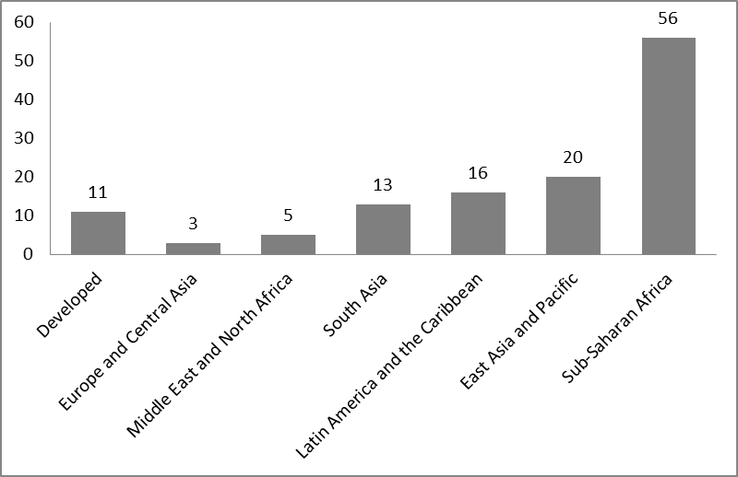

Source: GSMA Mobile Money Tracker 2012

Inherent Benefits
          - Mobile money is an accessible and convenient medium for the delivery of financial services and has already shown itself to be as, if not more reliable than traditional, informal methods of banking. In some countries, mobile banking services have been shown to be less expensive than average banking services. Lower costs therefore directly translate into extra income for the poor.
          - One of the most successful and fastest growing mobile banking services is M-Pesa, founded in April 2007 by Safaricom, a Kenyan telecommunications company. Safaricom launched the new mobile phone‐based payment and money transfer service to offer its customers an array of services ranging from depositing money into an account stored on a customer's cell phone, to sending balances using SMS technology to other users (including sellers of goods and services) and to redeem deposits for regular money. It also allows users to settle their bills. Users are charged a small fee for sending and withdrawing money using the service. M‐Pesa has spread quickly, and has become the most successful mobile phone‐based financial service in any developing country. By 2012, in less than five years' time, a stock of about 17 million M‐Pesa accounts had been registered in Kenya. M-Pesa is a branchless banking service, meaning that it is designed to enable users to complete basic banking transactions without the need to visit a bank branch. The continuing success of M-Pesa in Kenya has been due to the creation of a highly popular, affordable payment service with only limited involvement of a bank.
          - Services supplied by M-Pesa are considered to be much safer than carrying important sums of cash in person. In addition, there are other benefits such as privacy and autonomy. These are especially important aspects for example for marginalized groups of women who, through such mobile money services, now have direct access to their personal savings accounts.
What is Mobile payment? Also referred to as mobile money, mobile money transfer, and mobile wallet generally refer to payment services operated under financial regulation and performed from or via a mobile device.
Financial institutions and credit card companies as well as internet companies such as Google and a number of mobile communication companies, such as mobile network operators and major telecommunications infrastructure such as w-HA from Orange and handset multinationals such as Ericsson have implemented mobile payment solutions.
Mobile payment is an alternative payment method. Instead of paying with cash, check, or credit cards, a consumer can use a mobile phone to pay for a wide range of services and digital or hard goods such as music, videos, ringtones, online game subscription or items and other digital goods. Users can also settle payments for transportation fare (bus, subway or train), parking and to make purchases of books, magazines, tickets and other hard goods.
There are four primary models for mobile payments: Premium SMS based transactional payments, Direct Mobile Billing, Mobile web payments (WAP) and Contactless NFC (Near Field Communication)
Additionally there is a new emerging model from Haiti: direct carrier/bank cooperation. Mobile payment is being adopted all over the world in different ways. The mobile payment market for goods and services, excluding contactless NFC transactions and money transfers, is expected to exceed $300 billion globally by 2013, which would be double the figure as of February 2011. In developing countries mobile payment solutions have been deployed as a means of extending financial services to the community known as the unbanked or under-banked, which is estimated to be as much as 50% of the world's adult population, according to Financial Access' 2009 Report "Half the World is Unbanked". These payment networks are often used for micropayments. The use of mobile payments for Financial Inclusion has attracted the interest and funding of international aid foundations like the Bill and Melinda Gates Foundation, USAID and MercyCorps.
Source: www.en.wikipedia.org/wiki/Mobile_payment

          - Mobile money is to date mainly being used for sending money. Access and use of more sophisticated financial services such as savings, credit and insurance could prove far more beneficial to the poor. Services such as those provides by Kilimo Salama, a micro-insurance product that uses M-PESA to provide pay outs to smallholder farmers whose crops fail are now being developed. As individuals develop financial histories with mobile money, the ability to provide credit can expand because financial institutions will be able to assign credit scores.

Through Kilimo Salama, farmers can minimize risk by paying an extra 5% for a bag of seed, fertilizer or other inputs from participating local agro-dealers. That translates to about nine Kenyan shillings (Kshs) to insure a one-kilogram bag of improved, higher-yielding maize seed, and 25 Kshs to insure a 10-kilogram bag of fertilizer. The agro companies participating in the program, MEA Fertilizers and Syngenta East Africa Limited, match the farmers' investment to cover the full 10% premium it takes to cover the cost of the programme. The project partners hope to expand the programme to include other agribusiness companies in the upcoming years.

Agro-dealers registered and trained by Kilimo Salama have been equipped with a camera phone that scans a special bar code at the time of purchase, which immediately registers the policy with UAP Insurance over the Safaricom's mobile data network. This innovative mobile phone application, which was developed by the Syngenta Foundation, then sends a text (SMS) message confirming the insurance policy to the farmer's mobile phone. Some 30 weather stations in the targeted regions have been renovated with automated, solar-powered systems capable of broadcasting regular updates on weather conditions and rainfall quantities. When data transmitted over Safaricom's 3G data network from a particular station indicates that drought or other extreme conditions (including excessive rains) are destined to cripple crops, all farmers registered with that station automatically receive payouts directly via Safaricom's M-PESA mobile money transfer service.

"This is the first project to use mobile phones to set up insurance contracts and issue payouts to poor, smallholder farmers in Africa, deploying both our vast data infrastructure and globally acclaimed M-PESA service," said Betty Mwangi, Chief Officer, New Products Division at Safaricom. "We are happy to support a project that organizes a complex business administration over our expansive national 3G network. The close link to rural shops and farmers insures that thousands of farmers will have fast, efficient, and reliable service and shows that there is great potential for many other applications that link mobile technology with the needs of farmers and people in rural areas. This is the kind of innovation that underwrites our market leadership."

E-COMMERCE AND SMALL, MEDIUM ENTERPRISES
          - The term SME has a wide range of definitions varying from country to country and between the sources reporting SME statistics. Some of the commonly used criteria used to define an SME are net assets, number of employees and the levels of sales and investment. The most commonly used criterion used to define SMEs is, however, the total number of employees. Even the definition of an SME on the basis of a specific criterion is not uniform across countries. For instance, a specific country may define an SME to be an enterprise with less than 500 employees, while another country may define the cut-off to be 250 employees.
          - In both developed and developing countries, SMEs make up a majority of business and employ the majority of workers in both manufacturing and services sectors. SMEs cater mostly to their domestic market and their contribution to GDP, although normally very small, can vary greatly depending on the value of the goods or services they produce. While less than 6% of the formal work force is employed in manufacturing in SMEs in Azerbaijan, Belarus and Ukraine, this share is more than 50% in other developing countries such as Ghana, Turkey and Ecuador. Research has indicated that countries with large SME sectors also tend to benefit from the significant contribution which SMEs make to GDP.
          - An UNCTAD study has shown that SMEs, while generally lagging in ICT, have the most to gain from increases in productivity thanks to e-commerce. SMEs, however, actually run the risk of missing opportunities in both productivity and profitability by not engaging in e-business. SMEs also have a large role to play in the economies of developing countries because it is in these same countries that have the greatest potential to benefit from e-commerce. The extent of ICT use by SMEs is dependent on both sector and size of the business. Typically, those SMEs which are export or import-oriented as well those involved in the tourist sector have stronger incentives to invest in implementing ICTs in their respective businesses.
          - Global developments and other competitive forces are increasingly driving firms to engage in ICT-based strategies. The growing interaction that SMEs are having with foreign suppliers and clients is leading most firms in developing countries to connect to the internet for e-mail purposes. The adoption of ICT by SMEs in developing countries is largely a market-driven process and eventually it is expected that competition in ICTs will lead to greater affordability and allow SMEs to engage more in e-commerce. Global competition is a major driver in this process, particularly for export-oriented businesses. Many buyers in developed countries which would like to purchase agricultural goods or handicrafts in developing countries expect their suppliers, usually SMEs in developing countries, to be connected to the global online supply chain.
          - Although research has indicated that it is mostly large multinational companies that have benefitted the most from e-commerce, SMEs have been found to have the greatest potential for productivity gains through e-commerce. For most SMEs, however, the internet is mostly restricted to use by managers, for e-mail communication and for basic internet searches, particularly in developing countries with slow modes of access to the internet. Even in rare circumstances when SMEs have websites, the websites are generally limited to presenting goods and services on offer. It is unusual to see these same companies providing a means to purchase their products or services online. Despite several studies that have demonstrated the correlation between ICT adoption and a company's profitability, one of the major reasons many enterprises have not integrated ICT and e-commerce into their business strategies is the perceived limited impact on business profitability often coupled with the argument that few suppliers and customers are actually online. On the other hand, when SMEs are able to see the added benefits of using ICT, they are more willing to adapt their businesses strategies.
          - E-commerce presents a number of opportunities for SMEs. The main reason lies in that e-commerce has the ability to become a field-leveller providing as many opportunities for SMEs in developing countries as in developed countries. Since all internet sites co-exist, small businesses have access to just as much internet space as do large multinational companies.
          - SMEs in developing countries that are located in rural areas are usually more disadvantaged in terms of internet access. The rural-urban digital divide is created or exasperated by more expensive connection fees, an insufficient number of lines and unreliable internet connectivity. Mobile commerce, however, now provides more opportunities for SMEs, especially in rural areas. Statistics indicate that mobile technology is actually spreading into rural areas at a rapid pace. According to the ITU, the percentage of the world not covered by a mobile cellular signal was 39% in 2003. By 2010, that figure had dropped to 10%.
          - E-commerce has been hailed by many as an opportunity for developing countries to gain a stronger foothold in the multilateral trading system. E-commerce has the ability to play an instrumental role in helping economies benefit more from trade. Unlike the requirements necessary to run a business from a physical building, e–commerce does not require storage space, insurance, or infrastructure investment on the part of the retailer. The only pre-requisite is a well-designed web storefront to reach customers. Additionally, e-commerce allows for higher profit margins as the cost of running a business is markedly less.
          - Another added advantage provided by e-commerce is that it allows for better and quicker customer service. In some cases customers could have direct access to their own personal accounts online and can avoid calling companies on the phone. This can save both time and money. Adding customer online services such as overnight package delivery services can also have commercial benefits. These can be complemented by package tracking services which allow customers to check the whereabouts of their packages online. This helps provide good levels of customer satisfaction with very little effort from the side of the business.

Policy Issues - What restricts SMEs from more fully using E-Commerce?
          - E-Commerce is generally presented in very positive terms but, along with the potential benefits, come potential problems for developing countries. The adoption of e-commerce in developing countries differs greatly from one country to the other. But many face a number of similar obstacles to e-commerce. These mainly include a lack of financial, legal, and physical infrastructure for the development of e-commerce. The development of various types of e-commerce depends primarily on the existing structure of an industrial sector and how it fits into a given sectoral value chain. Additionally, the difference of cultures and business philosophies across developing countries has also been seen to limit the applicability and transferability of the e-commerce models designed by some developed countries.
Regulating Bottlenecks in the Broadband Supply Supplying broadband services involves a combination of network elements, processing, and business services that can be thought of as the broadband supply chain. This supply chain can be divided into four main components: (a) international connectivity; (b) domestic backbone; (c) metropolitan connectivity; and (d) local connectivity. Bottlenecks in any of the links of the chain will stifle competition and the development of broadband. Hence, effective regulatory frameworks must identify and address such instances of market failure in a timely and effective manner. As concerns domestic infrastructure or what some refer to as the national backbone infrastructure, a focus on networks is key. Constituting the second level of the network element supply chain, a country's high-capacity domestic backbone network is essential for broadband connectivity since it provides the link from international gateways to local markets as well as domestic connectivity between major cities and towns. However, backbone networks require extensive investments. A major impediment to reducing these costs, particularly in many developing countries, relates to vertical integration in which the backbone network providers are vertically integrated with the local access network operators. This results in a single end-to-end provider that can wield great market power. As such, other service providers may not have access to the backbone or may face high costs for interconnecting, a problem addressed in growing debates on open network access.

          - Although SMEs have numerous reasons for engaging in e-commerce, the security concerns of the customers remain an important impediment to expanding e-commerce services and business. Probably, the biggest drawback is the reluctance of customers to provide online information about their credit cards. Ensuring both trust and familiarity through a well-functioning website has proven to be one of the major e-commerce success-factors. In the same vein, the growth of broadband has created a greater need for users to protect their security and privacy in an "online" environment. Both individual users and businesses report that computer viruses are the "malware" they encounter the most. Security continues to be a problem for online businesses as customers have to feel confident about the integrity of the payment process before they commit to the purchase.
Business Development Department inviting SMEs to make use of e-commerce
BANGKOK, 6 July 2012 – The Department of Business Development (DBD) is encouraging SME operators to seek new opportunities via e-commerce while introducing the DBD Registered symbol to ensure security for online shoppers.
Deputy Minister of Commerce Siriwat Kajornprasart revealed that he has assigned the DBD to support Thai SMEs in doing business via e-commerce. Due to the huge growth and increasing popularity of e-commerce, he said Thai SMEs should consider expanding their businesses online in order to find new opportunities and reduce production costs at the same time. E-commerce can also help enhance the potentials of Thai companies to compete in the international market.
Source: The Thai Financial Post Published on August 6, 2012

          - The potential of e-commerce can only be achieved given adequate infrastructure. In most developing countries this constraint presents a major obstacle. Smaller, low-income internet markets in developing countries, particularly in Africa, have been unable to attract sufficient investment in infrastructure, which combined with lack of competition – results in bandwidth cost that can be up to 100 times higher than in developed countries. In most cases, these countries remain outside the reach of fibre optic cables and must turn to satellites for international – and sometimes even domestic – connectivity. This happens even in spite of significant improvements brought about by technology.
Peru enforces net neutrality, looks to roll out fibre backbone

25 July 2012 - The Peruvian government has announced that it will support the deployment of a national fibre-optic backbone for broadband access, Andina reports. The announcement followed the passing last week of the Law for the Promotion of Broadband and Construction of Optical Fibre Backbone. Telecoms regulator Osiptel will oversee the rollout, and ensure access is competitive, whilst the Agency for the Promotion of Private Investment (ProInversion) has been tasked with selecting a company to carry out the installation. Osiptel is understood to be drawing up technical criteria for the network, which will link all provincial capitals, and have connections to all districts. Further, the broadband bill ensures net neutrality, making it illegal for an internet service provider (ISP) to block, interfere with, discriminate against or restrict the right of any user to use an application, regardless of origin, destination or nature.

          - Many have noted that the most significant factor that would enable the necessary broadband growth in developing countries is the existence of alternative broadband infrastructures, in particular cable. Furthermore, a number of developing countries also face challenges such as an unreliable supply of power which is another major cause for concern. Many SMEs also lack the logistics for the prompt and reliable delivery of goods and services particularly in the case of B2C e-commerce. These obstacles put SMEs at a distinct disadvantage.
          - Another area of concern is the lack of technical skills which keeps SMEs from realizing their full e-commerce potential. Many developing countries do not have a workforce that has sufficient training in ICT and mobile technology. This greatly disadvantages many SMEs that may be seeking to diversify or to branch out into e-commerce. Making sure enterprises possess the required set of skills and capabilities to use relevant technologies productively is key to securing the economic benefits of e-commerce. Many entrepreneurs in developing countries, and especially in LDCs, lack the necessary capacity or awareness to take full advantage of ICTs. Even if they have access to mobile phones or the internet, they may not know how best to leverage them for their business operations. In some circumstances they may even fail to see the value of investing in the technology required so as to be able to take advantage of the opportunities of e-commerce.
Chart 7: Enterprises with their own website, latest year 2006-2009 (%)

Source: World Bank Enterprise Surveys
          - Slow internet diffusion in developing countries can be attributed to market and infrastructural factors controlling the availability of ICTs. In Tanzania, for instance, a lack of electrical supply, a low tele-density and a lack of purchasing power resulted in a low, rural internet usage. The cost of IT equipment can also discourage SME take up of e-commerce. The costs of computers, servers, parts etc. can be prohibitive for SMEs and can sometimes be subject to high tariffs or inconsistent tariff regimes. For example, providing incentives by lowering tariffs on computer terminals, but not on parts, can make buying lower cost replacement parts for simple repairs an unattractive option. Moreover, manufacturers of ICT products focus on large distributors often located in developed countries.
          - Financial infrastructure is also key. For example, the unavailability of credit cards can be a major hurdle. Past studies have found such problems for B2C e-commerce in Russia, India and Latin America. In Asia, 35–40% of transactions are cash-based. Other aspects of financial systems are also underdeveloped. In some countries and regions, local banks do not process online credit card transactions or other forms of electronic payment systems. Since mobile money targets the poor in developing countries and encompasses two very distinct industries (telecommunications and financial services), developing the necessary cross-sectoral partnerships - including bridging cultures and regulations - may therefore be difficult. Furthermore, in order to get the mobile money industry to be viable, agents and consumers have to be convinced at a large scale. Operators are faced with the trade-off between higher costs to recoup their investments or lower costs to reach scale and build a mass market.
Table 2: Business and consumer-level e-commerce barriers in the developing world
Barrier Type | Consumer Level |  | Business Level
Economic | Low credit card penetration.  Lack of electrical supply.  Low tele-density.  Lack of purchasing power. | Low commerce  Adoption rate among  businesses | Underdeveloped  financial systems.  Internet less attractive  for traditional economic sectors.  Lack of economies of scale.  Unavailability of ICT  and other supporting  infrastructure.
Sociopolitical | Inadequate legal  protection for  Internet  purchases |  | Preference to face-to face  communications  over e-mail.  Precedence of established  relationships.  Lack of DES laws.
Cognitive | General and  computer  illiteracy and lack  of English language skills  Lack of availability of  local language websites  Lack of awareness  and knowledge of  e-commerce benefits  Lack of confidence in  service providers. | Low ecommerce  adoption  rate among  consumers | Lack of knowledge to  use ICTs profitably.  High degrees of risk  aversion.  Lack of workforce with e-commerce expertise.
Source: Kshetri, Nir. Barriers to e-commerce and competitive business models in developing countries, 2007 Elsevier B.V.

          - The internet is also less attractive for traditional economic sectors (e.g., agriculture) that account for a significant proportion of developing countries' economies. For instance, a study indicated that cost savings from e-commerce – as a per cent of total input costs – is only 2% for firms in traditional sectors such as coal compared to 40% in electronic components. The rapid growth of e-commerce in the US, for example, can be attributed to infrastructure already in place and an easy availability of a physical delivery system. Such systems are rarer in developing countries. In the Caribbean region, for example, logistics challenges are among major barriers to e-commerce diffusion. It is difficult for small developing countries and especially island states to attract FedEx and UPS to provide delivery services. Finally, bandwidth availability is low in developing countries. A lower bandwidth means that a longer time is needed to transfer data and hence a lower relative advantage of the internet.
          - In a study published in 2008 on the adoption ICT by small hotel establishments in Southern Africa, some key factors were examined such as the role of government and government policy and attributes relating to the owners of the hotels, their organization and their ability to adopt more ICT in their commercial activities. Even though the study focused on small hotels using the internet, many of the study's findings are applicable to other industries in which SMEs operate, such as sales and distribution of products, manufacturing and services trade. The study found that internet, websites and fixed-line and mobile phone networks are the most common technologies adopted by SMEs to support their e-business operations. The results also suggest both formal and informal networks as important for ICT adoption. These include key sources of information, technology and social and business support. In addition, financial and owner manager support, including personal skills and experience are also crucial in the adoption of ICT. Power outage is identified as a major barrier.
          - Government intervention is largely indirect and crucial in areas such as setting up of national ICT policy, infrastructure, dissemination of information, facilitating public-private partnerships, capacity building and constructing and maintaining a power supply. While obviously not a course of action for all SMEs in developing countries, research has shown that there are things SMEs can do to take more advantage of the internet possibilities. While many of these "Key Policy Recommendations" in the chart below require both large investments in infrastructure, people and equipment, there are options which governments might wish to follow should they really wish to maximize use of e-commerce generally.
Key Policy Recommendations made by the OECD for SMEs
• Move beyond policies for basic connectivity and ICT readiness to facilitate more widespread uptake and use of complex ICT applications and e-business uptake by small firms. Target programmes where there are demonstrated market failures (e.g. R&D incentives, frameworks for standards, skill formation, information and demonstrations on best practice and benefits from adoption and use of ICT), taking into account that commercial considerations and returns drive business adoption of new technologies.
• Encourage rollout of affordable quality broadband networks to underpin the competitiveness and growth of SMEs. Continue to liberalise network infrastructure and promote broadband competition and liberalisation in network services and applications. Where the needs exist, and without pre-empting private initiative or inhibiting competition, complement private investment with public financial assistance to expand coverage for under-served groups and remote areas.
• Strengthen the infrastructure for trust, security (including spam and viruses), privacy and consumer protection. Intellectual property protection of ICT innovations and digital products is necessary to build the confidence among SMEs that is essential if such firms are to take full advantage of the potential of domestic and cross-border on-line activities.
• Expand, in conjunction with business and consumer groups, SMEs' use of low-cost on-line dispute resolution mechanisms. Strengthen cross-border co-operation between stakeholders and the development of rules with cross-border application.
• Develop and distribute digital content, including by expanding the commercial use of information about the public sector, education and health care. E-government services to enterprises should be used as a tool to improve efficiency of government interactions and operations with SMEs.
• Reduce ICT skill impediments to the growth of SMEs. Strengthen government and private roles to improve basic ICT skills and developing frameworks to encourage higher level ICT and e-business skill formation (including marketing, organisational, security, trust and management skills in addition to ICT skills) in conjunction with education institutions, business and individuals.
Source: OECD, ICT, E-Business and SMEs, 2004

Conclusion
          - This background note has examined different ways of using e-commerce and has looked at some specific sectors where SMEs are using the internet to sell their wares directly to customers through online transactions. As noted, a growing number of such transactions are now also taking place via mobile applications. This trend is to expand exponentially in the decades ahead. As has been seen, there is enormous potential for using information and communication technologies to contribute to the social and economic progress of developing countries worldwide.
          - Many entrepreneurs in developing countries and certainly many owners and managers of SMEs have a real possibility to benefit from ICTs in their day to day business activities. This has already resulted in gains in enhanced productivity, be it in the area of B2B, B2C or B2G e-commerce. However, as this paper shows, SMEs in many developing and LDCs are not always maximizing the use of the internet. In this regard, the role of governments and their various partners, including the private sector, need to take more advantage of the opportunities that are emerging in the new ICT landscape. And governments need to ensure that users benefit not only from being connected to the internet but also from any technological evolutions which can increase the speed of data flows and which can help reduce costs to consumers.
          - The paper has focused on how mobile telephony has transformed life for many in developing countries. Mobile phones help improve the livelihood of the poor through better communications and greater access to information. Many poor farmers are now able to receive better prices for their crops because they have access to information on market prices, primarily via mobile phones. The African company TradeNet, a Ghana-based trading platform, was provided as a key example.
          - Mobile phones have also spawned a wealth of micro-enterprises, offering work to people with little education and few resources, such as selling airtime and repairing or refurbishing handsets. When farmers have access to information about prices and stocks, it helps them to reduce the risk of under-selling and of either over or under-supplying their crops in a given market. Information transmitted by mobile phone also includes access to early warning systems to mitigate the risk of losses due to extreme weather conditions or to the spread of disease.
          - This background note has examined different ways of using e-commerce and has looked at some specific sectors where SMEs tap into vital market information on which their businesses depend. Others still are involved with the development or the dissemination of mobile services such as mobile banking, credit and insurance services.
          - It is important to remember, however, that SMEs are not alone in their involvement with e-commerce. The government and the private sector have vital roles to play not only in allowing e-commerce to take place but to ensure that it grows and benefits not only SMEs but also consumers. Much of the support to e-commerce depends on having or providing the right infrastructure, regulations and the policy mix allowing e-commerce to thrive.
          - High-quality and reliable transactions over the internet need advanced telecommunications systems and ones that offer broadband and mobile broadband services at affordable prices to both companies and private users. This requires an enabling environment where competition between telecommunications providers is robust. Also required is a workforce with solid ICT skills. Such skills are crucial for the further development of e-commerce and other mobile applications. The latter are critical in the quest to produce relevant and high-quality applications. Here too governments can play a vital role in ensuring that secondary and vocational schools teach the necessary skills to help build a viable digital economy and one that is capable of adapting to the needs of its users.

ANNEX
Work on Electronic Commerce in the WTO's General Council and
the Committee on Trade and Development

          - Following the Declaration on Global Electronic Commerce by the Geneva Ministerial Conference in 1998, the General Council adopted the same year a Work Programme on electronic commerce defining e-commerce as the production, distribution, marketing, sale or delivery of goods and services by electronic means. The Work Programme foresaw a broad spectrum of issues related to electronic commerce that was to be examined by the Council for Trade in Services, the Council for Trade in Goods, the Council for Trade-Related Aspects of Intellectual Property Rights (TRIPS) and the Committee on Trade and Development (CTD), with the General Council exercising an oversight function and considering any issue of a cross-cutting nature in Dedicated Discussions held under the auspices of that body.
Dedicated discussions under the auspices of the General Council

          - Since the inception of the Doha Round in 2001, seven dedicated discussions on electronic commerce have been held under the auspices of the General Council. A main issue throughout the discussions has been on the extensions of the moratorium on customs duties on e-commerce. While to date no agreement has been reached to make the moratorium permanent and binding, it was decided in December 2011 to maintain the moratorium in place until the Ninth Ministerial Conference in 2013. Other issues discussed throughout the period concerned such cross-cutting issues as questions related to the classification of the content of certain electronic transmissions, development-related issues, fiscal implications of e-commerce, the relationship (and possible substitution effects) between e-commerce and traditional forms of commerce, the imposition of customs duties on electronic transmissions, competition policies and the jurisdiction and applicable law and other legal issues. Most of these discussions, however, remained inconclusive with Members realizing that more work would be required to further clarify the various issues.
Work undertaken in the CTD

          - The Work Programme on electronic commerce requested the CTD to examine issues such as (i) the effects of e-commerce on the trade and economic prospects of developing countries and their SMEs in particular; (ii) the challenges and ways to enhance the participation of developing countries in e-commerce and the role of improved access to infrastructure and transfer of technology, and of movement of natural persons; (iii) the use of information technology in the integration of developing countries in the multilateral trading system; (iv) the impact on the traditional means of distribution of physical goods; and (v) the financial implications for developing countries.
          - In the years following the adoption of the Work Programme, the CTD addressed certain issues by inviting speakers from other international organisations, by discussing country experiences and by holding two seminars, i.e. on E-commerce and Development in 1999 and on Government Facilitation of E-commerce for Development in 2001. After the Doha Ministerial Conference in 2001, a seminar on the Revenue Implications of e-commerce was held in 2002. In 2003, the Secretariat and the CTD produced a background note and a report on the work that had been undertaken in the CTD on e-commerce.
          - In 2011, a communication from Cuba, Ecuador, Nicaragua, the Pluri-national State of Bolivia and the Bolivarian Republic of Venezuela titled "Effective participation of developing countries in electronic commerce as a means to combat poverty" provided new impetus to the CTD's work on e-commerce. In particular, Ministers decided at the Geneva Ministerial Conference on 17 December 2011 to instruct the General Council to emphasize and reinvigorate the development dimension in the Work Programme. This was to be done through the CTD which would examine and monitor development-related issues linked to e-commerce such as the need for technical assistance and capacity building and the facilitation of access to e-commerce by micro, SMEs, including small producers and suppliers, of developing countries and particularly of least-developed country Members.
          - At the CTD's 85th Session held on 16 July 2012, Cuba and Ecuador proposed the idea of holding a Workshop on E-Commerce, Development and SMEs (WT/COMTD/W/189) and suggested that the Secretariat prepare a background paper on the subject and organize a workshop which would involve public and private sector representatives as well as individual experts.
          - At the CTD's 86th Session on 19 November 2012, it was agreed that the workshop on Electronic Commerce, Development and SMEs would be held on 8 and 9 April 2013. The two-day workshop would focus on the private sector, inter-governmental organizations and also non-governmental actors and would seek the active participation from SMEs from least-developed and developing countries located in Asia, Africa and the Latin American and Caribbean regions.

__________

This document has been prepared under the responsibility of the WTO Secretariat and is without prejudice to the positions of Members and to their rights and obligations under the WTO.
UNCTAD's Information Economy Report 2010.
Goldstein, Andrea and O'Connor, David. "E-Commerce for Development: Prospects and Policy Issues." Organization for Economic Cooperation and Development, September 2000. Available at: http://unpan1.in.org/intradoc/groups/public/documents/apcity/unpan004061.pdf
http://www.pwc.com/gx/en/technology/publications/assets/the-new-digital-economy.pdf
http://www.bbc.com/news/technology-11576486
Understanding the Digital Divide. http://www.oecd.org/internet/interneteconomy/1888451.pdf
George Sadowsky, ed. "Accelerating Development. Using the Web: Empowering Poor and Marginalized Populations." World Wide Web Foundation.
ITU.
http://www.oecd.org/eco/economicoutlookanalysisandforecasts/2087433.pdf
http://www.internetretailer.com/2012/06/14/global-e-commerce-sales-will-top-125-trillion-2013
"http://www.oecd-ilibrary.org/sites/sti_scoreboard-2011-en/06/10/index.html;jsessionid=v04de9q27yt1.delta?contentType=&itemId=/content/chapter/sti_scoreboard-2011-64-en&containerItemId=/content/serial/20725345&accessItemIds=/content/book/sti_scoreboard-2011-en&mimeType=text/html"
http://www.internetretailer.com/2012/06/14/global-e-commerce-sales-will-top-125-trillion-2013
http://searchcio.techtarget.com/definition/B2B
OECD Economic Outlook 67 and International Data Corporation (IDC). IDC is the premier global provider of market intelligence, advisory services, and events for the information technology, telecommunications and consumer technology markets. IDC helps IT professionals, business executives, and the investment community make fact-based decisions on technology purchases and business strategy.
UNCTAD IER 2004
E-commerce and E-Business, Zorayda Ruth Andam, UNDP-APDIP
http://www.bbc.co.uk/news/10156667
UNCTAD IER 2002.
UNCTAD IER 2009.
UNCTAD IER 2002.
See http://news.rusbiz.com/newslist/290954.html
http://www.mobify.com/about/
"http://www.i-policy.org/2011/09/mobile-penetration-leaps-as-internet-access-still-wobbles-in-97-economies-.htm"
World Bank, Information and Communications for Development 2012.
http://blog.euromonitor.com/2011/05/qa-the-importance-and-prospects-of-mobile-telephony.html
Halewood, Naomi J. and Surya, Priya, Mobilizing the Agricultural Value Chain, "http://siteresources.worldbank.org/EXTINFORMATIONANDCOMMUNICATIONANDTECHNOLOGIES/Resources/IC4D-2012-Chapter-2.pdf"
World Bank 2012 Information and communications for developing countries; Maximizing Mobile", 2012.
http://news.mongabay.com/2012/0808-hance-ivory-forensics.html
Minten B., T. Reardon, and K. Chen. n.d. “The Quiet Revolution of‘Traditional’ Agricultural Value Chains in Asia Evidence from Staple Food Value to Four Mega-cities.” Unpublished draft, International Food Policy Research Institute, Washington, DC.
Muto, M., and T. Yamano. 2009. "The Impact of Mobile Phone Coverage Expansion on Market Participation: Panel Data Evidence from Uganda." World Development 37 (12): 1887–96. http://www.sciencedirect.com/science/article/pii/S0305750X09000965
Naomi Halewood and Priya Surya, Mobilizing the Agricultural Value Chain, World Bank 2012 Information and Communications for Development.
Halewood and Surya, Mobilizing the Agricultural Value Chain, World Bank 2012, Information and Communications for Development.
Robert Jensen, "The Digital Provide: Information (Technology), Market Performance, and Welfare in the South Indian Fisheries Sector", The Quarterly Journal of Economics (2007) 122(3): 879-924, p. 919.
New Directions in Fisheries, ICTs benefit Fishing Communities, FAO, 2007.
http://mobileactive.org/case-studies/babajob-bringing-jobs-bottom-pyramid
http://en.wikipedia.org/wiki/GSM
WB, Maximizing Mobile, p. 63.
http://en.wikipedia.org/wiki/M-Pesa
www.sciencecodex.com/first_microinsurance_plan_uses_mobile
http://siteresources.worldbank.org/DEC/Resources/84797-1114437274304/SME_globe.pdf
http://siteresources.worldbank.org/DEC/Resources/84797-1114437274304/SME_globe.pdf
UNCTAD IER 2004.
UNCTAD IER 2004.
UNCTAD IER 2011.
UNCTAD IER 2004.
UNCTAD Report 2005.
UNCTAD IER 2004.
UNCTAD IER 2004.
E-Commerce: The next global frontier for small businesses. The Journal of Applied Business Research. Volume 17, Number 1.
UNCTAD IER 2004.
http://www.itu.int/ITU-D/ict/statistics/index.html
UNCTAD IER 2004.
http://www.manjeetss.com/articles/advantagesdisadvantagesecommerce.html
See at: http://www.sciencedirect.com/science/article/pii/S0378720607000298 .Business-to-business adoption of eCommerce in China.
Broadband Strategies Toolkit at: http://broadbandtoolkit.org/3.5
E-commerce: the role of familiarity and trust David Gefen, OMEGA, The International Journal of Management Science.
OECD, "http://www.oecd-ilibrary.org/sites/sti_scoreboard-2011-en/06/10/index.html;jsessionid=v04de9q27yt1.delta?contentType=&itemId=/content/chapter/sti_scoreboard-2011-64-en&containerItemId=/content/serial/20725345&accessItemIds=/content/book/sti_scoreboard-2011-en&mimeType=text/html"
UNCTAD IER 2004.
"www.telegeography.com/products/commsupdate/articles/2012/07/25/peru-enforces-net-neutrality-looks-to-roll-out-fibre-backbone/"
UNCTAD IER 2004.
UNCTAD IER 2011.
Kshetri, Nir. Barriers to e-commerce and competitive business models in developing countries, 2007 Elsevier B.V.
ICT Adoption and Development of E-business among SMEs in South Africa Knowledge Chinyanyu Mpofu: http://www.isbe.org.uk/Mpofu09
WT/MIN(98)/DEC/2.
WT/L/274.
WT/COMTD/W/110.
WT/COMTD/47.
WT/GC/W/635-G/C/W/650-WT/COMTD/W/179, and its addendum.
WT/L/843.

