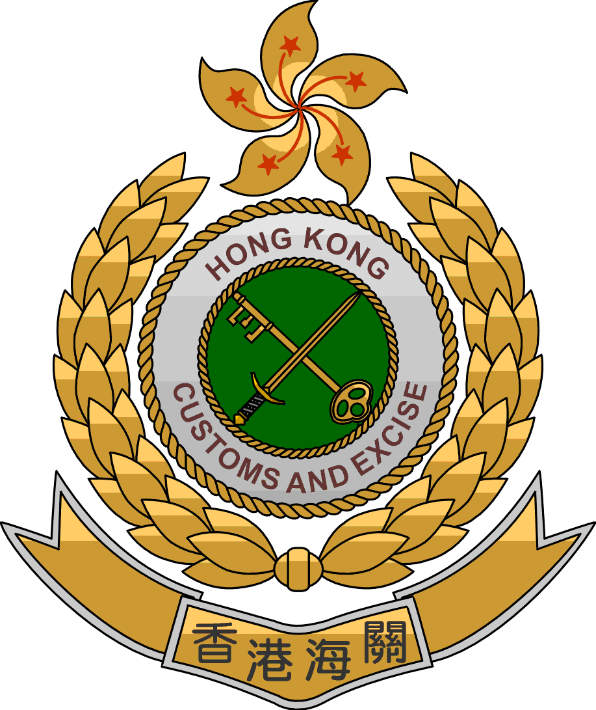

Implementation of Hong Kong
Authorized Economic Operator Programme

A Partnership Approach to
Secure International Supply Chain and
Facilitate Legitimate Trade

Prepared by the Office of Supply Chain Security Management
Customs and Excise Department
Hong Kong, China
Implementation of Hong Kong
Authorized Economic Operator Programme

A Partnership Approach to
Secure International Supply Chain and Facilitate Legitimate Trade

I. General Overview:

- How long has this measure been put in place?
After the successful conclusion of the pilot scheme last year, Hong Kong Customs (HKC) has formally launched the Hong Kong Authorized Economic Operator Programme in April 2012.

- What are the benefits of applying this measure? (for both governments and traders)
For traders:

The Programme is basically a free accreditation scheme for local companies that satisfy certain pre-determined security requirements. A company accredited by HKC, known as Authorized Economic Operator (AEO), will enjoy extra trade facilitation and other benefits, including:

- less cargo inspections as AEOs are acknowledged to be trusted partners of Customs and their goods are considered of lower risk;

- prioritized Customs clearance if their goods are selected for inspection;

- enhanced goodwill as a secure trader with industry “kitemark” as the AEO certification demonstrates commitment in safeguarding the global supply chain;

- strengthened competitiveness and marketability as a result of the enhanced customer confidence, improved cooperation with partners in the global supply chain;

- reduced stock loss, theft and pilferage as a result of improved security and safety of their supply chains; and

- benefits granted by other Customs administrations under mutual recognition arrangements (MRAs), such as reduced Customs inspections, expedited clearance, deferred payment or priority treatment.

For Government:

Implementation of the Programme also brings reciprocal benefits to the Hong Kong Special Administrative Region Government (HKSARG). These benefits include:

- exemplifying HKSARG’s commitment in the pursuit of a more secure and efficient trading environment which would help consolidate Hong Kong’s position as an international trading centre and a regional logistics hub, thereby sustaining Hong Kong’s long-term economic development;

- strengthening Customs-Business partnership to help ensure global supply chain security;

- allowing HKC to do more with less through the efficient use of resources to identify high-risk shipments while conducting less inspections on AEOs’ goods; and

- maximizing the advantages of Hong Kong AEO programme through MRAs characterized by global connectivity between other Customs administrations and their trade partners.

- How does the use of this measure impact the revenue?

HKC has formed a dedicated team (i.e. Office of Supply Chain Security Management) to take forward the Programme through internal restructuring and redistribution of business. Manpower of this dedicated team is acquired through internal reshuffling rather than from new resources. Hence, no additional government expenditures were incurred in implementing the Programme.

Participation is open and voluntary. Any local companies engaging in business principally related to the international supply chain are welcome to apply, without having to pay any charge to HKC.

Though the Programme has neither direct nor immediate impact on revenue, it would definitely help enhance the clearance efficiency in the long run, taking into account the considerable savings in time and manpower resource resulted from reduced inspection.

- What are key provisions that should be included in laws or regulations?

The Programme is not an enforcement regime which necessitates legislative basis. Instead, it is a voluntary Customs-to-Business partnership initiative. Any local companies that engaging in business principally related to the international supply chain are welcome to apply. Accreditation of AEO applicants does not involve the measurement of a company’s adherence to Customs legislation through constant compliance checks. Instead, the validation process prior to accreditation focuses on the verification of supply chain security procedures that a company voluntarily agrees to perform under the auspices of the Programme.

- What are the administrative and staffing requirements (how many people and what skills are needed)?

A 13-member team is set up to implement the Programme. This dedicated team will work hand in hand with applicants throughout the accreditation process. They will help applicants to review their security profiles, and share best practices.

Officers of this dedicated team are knowledgeable in auditing supply chain security processes and procedures with acquaintance in the application of international security standards such as ISO.

HKC will conduct timely review on the staffing situation and requirement of this dedicated team with a view to ensuring that manpower resource is effectively and efficiently deployed.
- What type of training is provided to teach the use of this measure? Who is trained (what level of government officials, private sector, etc.)?

For Government officers:

Taking into account the professional nature of work, officers responsible for accrediting AEO applicants are provided with training on ISO security management concepts and audit inspection.

For industry stakeholders:

HKC has devised a self-assessment questionnaire with guidance notes to assist applicants in evaluating their readiness for the AEO accreditation. Through the self-assessment, they will know whether their internal policies and operational procedures meet the laid down security criteria.

Briefing sessions are also regularly conducted to the industries in an attempt to ensure their understanding of the Programme details.

- What type of equipment, structures, software, etc. is needed?

The operation of the Programme rides mainly on existing systems. However, appropriate IT configurations are required for access to different confidential database for purpose of background vetting of applicants. During on-site inspection in the validation process, HKC officers may bring along special devices and equipment including dummy contraband to test the security standard of an applicant’s operation premises.

- Lessons learned: what were the biggest problems/issues you have faced in applying this measure and how were they overcome?

Over 98% of the local industries are small and medium enterprises. HKC is mindful of introducing a programme that could provide a level playing field for all stakeholders. The accreditation criteria are thus prudently worked out to ensure their applicability to local companies.

With this concern in mind, HKC formulated a 2-tier free and voluntary accreditation programme which is open to local companies engaging in business principally related to the international supply chain. Companies applying for a lower tier are required to meet certain basic criteria whereas additional criteria are required for a higher tier.

The AEOs recognized so far, including SMEs, could meet the accreditation criteria without having to make major changes or investment. Recognizing that the extent of compliance depends on the size, nature and model of the business, etc., HKC exercises flexibility in the accreditation process as appropriate.

Success of the Programme hinges on the active participation of local traders. Provision of tangible incentives for participants is thus another issue that HKC has to address when implementing the Programme. Taking into account that Hong Kong is a free port, Customs facilitation to traders in terms of reduced or prioritized inspection may not be great incentives for wide participation in the Programme. As such, HKC focuses on identifying the long-term substantial benefits to local traders through the enhanced export competitiveness and marketability upon their accreditation as AEOs. More importantly, the AEO status is a symbol of trusted traders. They will enjoy more privileged benefits at international level under MRAs.
- What were the factors crucial to success/ best practices? (What can you recommend to other countries that might undertake implementation of this measure?)

The HKSARG’s decision not requiring legislative amendments, not necessitating significant changes to the existing business operation and Customs clearance procedures, as well as not charging any accreditation fee helps gain acceptance from the industry stakeholders. They are the crucial factors for the successful development and implementation of the Programme.

Conducting a pilot scheme to test the applicability of the Programme in Hong Kong also contributes to the successful formal launch of the Programme. The pilot scheme proved that the Programme fits the local trading environment and that the accreditation mechanism is effective. Valuable comments from the industries are collected to fine-tune the Programme.

To complement the formal launch of the Programme, HKC conducted a series of briefing sessions to different trade associations and outreaching visits to some potential applicants. An E-corner has also been set up on the departmental homepage for the public to obtain details of the Programme and make enquires or comments. The Programme is well received so far while HKC has been in close contact with the industries through various established channels, such as customer liaison groups. All these help ensure industry stakeholders are fully aware of the Programme framework and detailed operational arrangements.

- If possible please provide other useful information such as copies of laws, regulations, standard operating procedures/instructions, etc. (you can attach as an annex)

(Attachment 1 - Guidelines on Hong Kong Authorized Economic Operator Programme)

(Attachment 2 - Leaflet summarizing the framework of the Programme)

******

