Trade Facilitation Implementation in

TANZANIA

Prepared by: James John Mbunda,
Manager Modernisation and Quality Assurance,
5th September 2011

ACRONYMS
ASYCUDA - Automated System for Customs Data
ASY-SCAN - Web applications in ASYCUDA++ to facilitate e-documents
ASY-BANK - Web applications in ASYCUDA++ to facilitate e-banking
ASY-REPORT - Web applications in ASYCUDA++ to facilitate e-report
CED - Customs and Excise Department
CMA - Customs Management Act
CRMS - Computerised Risk Management System
DB - Doing Business
DFID - Directorate for International Development-UK
DIS - Destination Inspection Scheme
DTI - Direct Trader Input
EAC - East African Community
ICF - Investment Climate Facility
ICD - Internal Containers Depot
IMF - International Monetary Fund
ISO - International Organisation for Standards
NSGRP - National Strategies for Growth and Reduction of Poverty
OGA - Other Government Departments
PCA - Post Clearance Audit
PMO - Prime Minister’s Office
PSDS - Private Sector Development Strategy
PSI - Pre-Shipment Inspection
TAFFA - Tanzania Freight Forwarders Association
TASAA - Tanzania Shipping Agencies Associations
TBS - Tanzania Bureau of Standards
TFDA - Tanzania Foods and Drugs Authority
TICTS - Tanzania International Container Terminal Services
TISS - Tanzania Inter-Bank Settlement payment System
TPA - Tanzania Port Authority
TPD - Transactions Price Data base
TRA - Tanzania Revenue Authority
TRS - Time Release Study
SUMATRA - Tanzania Government Chemist and Laboratory Services
WB - World Bank
WCO - World Customs Organisation
WCO SAFE Framework - World Customs Organisation‘s Framework of Standards to Secure and Facilitate Global Trade
WTO - World Trade Organisation.

EXECUTIVE SUMMARY

This report provides an overview of implementation of Trade Facilitation in Tanzania, objectives and its alignment to the World Customs Organization Framework of Standards, and WTO Trade Facilitation initiatives as well as the link with Government broad policies. Further, it explains the baseline and its contribution to the preparation of overall Customs Modernization Strategies and Action Plan, source of finance, status of its implementation and the impact on revenue and Trade Facilitation realized so far. The report concludes with the summary of benefits and challenges experienced in the course of implementation and, finally, draws main factors critical to success that can be recommended on similar reforms implemented by other countries.

The implementation of Trade Facilitation in Tanzania is part of the initiatives on which the Tanzania Revenue Authority has been implementing since its establishment in July 1996 following the integration of the Customs and Excise, Sales Tax and Income Tax Departments with a view of transforming the departments into a modern Tax Administration. Formerly these departments were under the Ministry of Finance.
In July 2009, TRA prepared and adopted the Customs Modernization strategies and Action Plan 2009/10-2012/13 which were subsequently incorporated in the TRA Third Corporate Plan 2008/8-2012/13. The strategies were built on successes and challenges on the previous Customs reforms implemented since 2004; the World Customs Organization (WCO) Framework of Standards and WTO Trade Facilitation initiatives. The main financial supporters are the Government of United Republic of Tanzania, The Republic of Korean, the UK Department for International Development (DFID) and ICF.
The broad strategic objectives aim to provide a roadmap of transforming the Customs administration to meet challenges of 21st Century as well as support the broad Government’s Economic and Social policies particularly the National Strategy for Growth and Reduction of Poverty (NSCRP), The Tanzania Development Vision 2025, The Private Sector Development Strategy (PSDS), and the Private Sector Competitiveness Project. These objectives are: facilitation of trade and reduction of cargo clearance times across ports; automation of Customs processes and procedures; enhancement of human resource capacity and organization; strengthening enforcement capacity; and strengthening relations with stakeholders.
The results and recommendations of the Time Release Study conducted in 2009 and The Tanzania Doing Business Report, 2010, prepared by the World Bank provided the inputs and baseline for the implementation of Customs Modernization Strategies and Action Plan 2009/10-2012/13. All major stakeholders, the Government institutions and Business community in the cargo clearance industry, were involved in the preparation and administration of the Time Release Study which was coordinated by TRA.
The scope of both the Time Release study and Customs modernization strategies go beyond Customs operations and therefore as they incorporate the improvement on procedures administered by Other Government Agencies (OGAs), Customs licensed operators (Agents, Transporters, Internal Containers Depot(ICDs), Manufacturers Under Bond; Customs Bonded Warehouse), Banks and Landing contractors. To date, 50% of the planned initiatives have been accomplished and the remaining 50% have been commenced, and it is our expectation that by June 2013 they will be completed.

There are benefits which have accrued to both the Government and business community in the course of implementing Customs reforms in Tanzania, including; revenue growth and facilitation of foreign and local investments; enhanced transparency and predictability; improved cargo clearance time across ports; improved staff integrity and increased traders’ compliance level. The automation of Customs process through ASYCUDA++ with DTI facility, the implementation of e-payment system and roll out plan to all Customs stations resulted in a dramatic impact on revenue growth - 212%, and improved cargo clearance time from 15days in 2009 to 12 days in June 2011.
The implementation of Customs reforms has significant contributions to the implementation of the EAC Customs Union Protocols including a new EAC Customs Management Act, 2009. National and regional sstakeholders were represented in the consultative process before changes were proposed and submitted to EAC Secretariat for consideration and approval. The main changes on administrative policies which resulted from these reforms were; - TRA administrative structure was reviewed to incorporate a Project and Modernisation programme unit whereas in the Customs administration, units such as Modernisation and Quality assurance, Risk Management, Trade Facilitation and Post Clearance Audit (PCA) were introduced to enhance coordination of reforms and efficiency. With regard to the monitoring of the improvement in Doing Business in Tanzania, a Task Force coordinated by the Prime Minister’s Office (PMO) was formed.
There are lessons learned in the course of implementing Customs reforms. Change of mindset among officers and the business community to accept and adopt new ways of conducting business was a challenge which was resolved by conducting awareness programmes and feedback forums on reforms for all staff and business community across the country.
The main factors crucial to success which can also be recommended to other countries that might carry out similar reforms are summarized as follows:
- Readiness by the Government to support reform;
- Committed Management leadership;
- Effective Internal and External monitoring mechanisms:
- Sharing experiences with other countries
- Iimplementation of Change Management programmes for both officials and the business community.
In conclusion, the interfacing of Customs processes within and outside the TRA, particularly with the processes administered by other stakeholders in the cargo clearance system, poses some challenges. Therefore, for Customs processes to be efficient and effective they need to be adapted to changing trade practices and modern approaches as well as reflect Government policy objectives. A baseline study, on which each stakeholder is on board, provides inputs to the formulation of Trade Facilitation initiatives that are accepted by all. The support and commitment by the Government, the business community and development partners as well as a day to day TRA Management leadership essentially underpin the success of Trade Facilitation implementation in Tanzania.

I. General Overview/Reasons for Reform

- Please provide a general overview of the reforms that were undertaken:

A. Was it part of an overall reform program (and therefore co-financed)? Was it linked to WTO trade Facilitation or was it broader? Did it build on recent reforms?

The Customs Modernisation Strategy and Action Plan 2009/10-2012/13 is part of the Tanzania Revenue Authority’s Third Corporate Plan 2008/9-2012/13 implemented since 1st July 2009 with the following broad strategic objective;-
- Provides a roadmap to modernizing and automating processes and procedures and bringing the practices of the Tanzania Customs to the level of international best practice, the WCO SAFE Framework of Standards to Secure and facilitate Global Trade.
- To create an environment conducive to investment and business, promote broad-based participation in production and trade and facilitate trade in international markets and therefore supporting broad Government economic and social policies, particularly the National Strategy for Growth and Reduction of Poverty (NSGRP), the Private Sector Development Strategy (PSDS), and the Private Sector Competitiveness Project.
Specifically, the following are strategic objectives:-
- Facilitate trade and reduce clearance times on imports
- automation of Customs processes and procedures
- Enhance Human Resource Capacity and Organization
- Strengthen Enforcement Capacity
- Strengthen Relations with Stakeholders

The Customs Modernization Strategy and Action Plan 2009/10-2012/13 financed by The Government of United Republic of Tanzania and others Donors including DFID, ICF and the Government of the Republic of Korea. ICF is financing the procurement of New Customs automated system while Korean Government is financing Cargo and Risk Management systems.

The strategies are prepared in line to both the World Customs Organization (WCO) Frame work of Standards and WTO Trade Facilitation initiatives. With regard to WCO Frame work of Standards, Customs modernisation strategies built on the following areas;- Globally networked Customs; Better coordinated border management; Intelligence-driven risk management; Customs-Trade partnership; Post Clearance audit based controls; Enabling technology and tools(Use of x-ray scanners and Computerized Risk Management System; A professional, knowledge-based service culture(Implementation quality management system-ISO 9001:2008); Capacity building(Training, succession plan, payment based performance); Integrity (implementation of The WCO Arusha Declaration and National anti-corruption strategies); Anti-smuggling; and Stakeholders(formalised meetings with stakeholders on TRA and Customs administration calendar). With regard to WTO Trade Facilitation, the strategies are focusing to reduce the cost of doing business for traders in Tanzania particularly on simplification and harmonisation of Customs procedures; access of information and transparency; and appeal mechanism.

The implementation of Customs Modernisation Strategy and Action Plan 2009/10-2012/13 was built on from previous reforms implemented since 2004. These reforms included;-
- Introduction of the EAC-Customs Union legislation in January 2005 which Tanzania, Kenya and Uganda has been operating under the provisions of the EAC Customs Management Act, Common External Tariff and the EAC Customs Protocol. Rwanda and Burundi joined the regional framework in July 2009.
- Implementation of ASYCUDA++ with DTI system in 14 stations.
- Initial steps have been taken to introduce Asy-Scan, Asy-Bank and Asy-Report to support the ASYCUDA++ system in viewing supporting documents, introducing electronic payment and enhancing reports available from the automated system.
- An oil product monitoring system was introduced in September 2008 to enable tracking and monitoring of oil imports and the payment of taxes on them.
- An exemption tracking system was introduced in September 2008 to track the use of exemptions from payment of duty and tax and reduce possible abuse in that area.
- An automated system for monitoring and recording the management of offences and enquires is in the process of being introduced.
- A Destination Inspection Scheme (DIS) has been contracted out and replaces a Pre-Shipment Inspection (PSI) arrangement. This has accelerated clearance times as it provides for pre-arrival lodgement of cargo documents, container scanning, a Transaction Price Database (TPD) and Computerized Risk Management System (CRMS).
- The Destination Inspection Scheme (DIS) provider, TISCAN is in the process of providing training and skills transfer to accommodate the transfer of their functions to CED in December 2010.
- The organization was restructured in 2005 to introduce a functional based structure.
- A compliant trader scheme became operational in July 2007 and now includes 52 traders who account for 60% of the revenue collected.

B. What was your baseline (i.e. did you already partially implement many of the measures)? What was the scope- what procedures did it encompass? Which government agencies were involved/affected? etc.

Time Release Studies conducted in 2009 as well as Tanzania Doing Business Report 2010 prepared by the World Bank provide baseline for the implementation of Customs Modernization Strategies and Action 2009/10 -2012/13.

The Time Release study conducted in 2009, was coordinated by the TRA through Customs and Excise Department with the participation of all major institutions in the cargo clearance system. These institutions include;- The Tanzania Ports Authority (TPA), Tanzania International Container Terminal Services (TICTS), Tanzania Food and Drugs Authority (TFDA), Tanzania Bureau of Standards (TBS), Tanzania Freight Forwarders Association (TAFFA), Tanzania shipping Agency Association(TASAA), Surface and Marine Transport Regulatory Authority(SUMATRA), Tanzania Government Chemist and Laboratory Services(GCLS).

The scope of the Time Release Study cover all processes from the time cargo arrived at the border/port to the point where all processes accomplished and cargo handled to the agent or owner. Action Plan prepared based on results and recommendation and institutions responsible were assigned with time frame. Quarterly review report on its implementation is prepared and presented to the Port improvement Committee chaired by Permanent Secretary –Ministry of Infrastructure Development on behalf of Prime Minister.

With regard to the scope of Customs modernisation strategies it goes beyond Customs procedures. Strategies incorporate the improvement on procedures administered by Other Government Agencies (OGDs) and Customs licensed operators (Agents, Transporters, Internal Containers Depot(ICDs), Manufacture Under Bonds; Customs Bonded Warehouse), Banks and Landing contractors.

Todate, 50% of the planned initiatives have been accomplished and the remaining 50% commenced their implementation and it is our expectation that by June 2013 will be accomplished.

- Why did your country decide to undertake these reforms? (E.g. input from traders, studies showed trade barriers, Kyoto Convention Compliance, etc.)

The following are key reasons for undertaking these reforms
- Time Release Study conducted in 2009 showed that there is persistent increase on cargo clearance time across seaports, airports and land border stations as well across the individual institutions involved in the cargo clearance system. Other reports including “Optimizing Port capacity in Dar-es-salaam, Improving Dwell Times” published by TPA/TICTS in 2007, The World Bank Doing Business, 2008, 2009 and 2010; and The World bank’s Logistics Performance Index, 2007 indicated deterioration of trade Facilitation in Tanzania.
- Provides a roadmap to modernizing and automating processes and procedures and bringing the practices of the Tanzania Customs to the level of international best practice, the WCO SAFE Framework of Standards to Secure and facilitate Global Trade.
- To create an environment conducive to investment and business, promote broad-based participation in production and trade and facilitate trade in international markets and therefore supporting broad Government economic and social policies, particularly the National Strategy for Growth and Reduction of Poverty (NSGRP), the Private Sector Development Strategy (PSDS), and the Private Sector Competitiveness Project.

- What benefits have been realized as a result of this reform? (Benefits for the government and/or traders, what problems did it solve?)

- The preparation and subsequently approval of the Customs Modernization Strategies and Action Plan 2009/10-2012/13 by TRA Management and Board made it possible to sell it to the Government and various Development Partners for technical and financial support.
- Revenue growth and Facilitation of investments inflow.
- Relationship between Government and Business community enhanced- Management meet with TAFFA on quarterly and annual basis as a results it has created a sense of ownership among business community on services provided by Customs administration.
- Agents and importers can now lodge declarations with attachments and submitted to Customs electronically wherever they are
- Prelodgment processes formally administered by the contracted service provider M/s TISCAN are now integrated into Customs systems and administered under one roof through Central Data Processing system.
- Payment on taxes and duties are paid on line through ASY-BANK and Tanzania Inter-Bank Settlement payment system
- Compliant trader scheme established and currently 53 traders are registered and facilitated.
- Cargo clearance times improved and hence increased business turn around.
- Transparency among officers and business community enhanced
- Through the implementation of quality management system ISO 9001:2008, Customs operation are more customers oriented.

- What were the revenue implications? Did any particular measures have a strong impact on revenue either positive or negative?

Since the implementation of Customs Reforms in 2004 and subsequently Customs modernization strategies and action plan 2009/10 -2012/13 the Department has been recorded a revenue growth. In 2010/11 the Department collected revenue of Tshs 2,336,366.10 million being a growth of 212% from Tshs 749,407.04 million in 2004/5 .

The introduction of ASYCUDA++ with Direct Trader Input(DTI) and rolled to all major station, use of ASY-bank and Tanzania Inter-bank Settlement payment System(TISS) to facilitate on-line taxes and duties payment and implementation of Destination Inspection Scheme that provided pre-arrival lodgement of cargo documents, container scanning, a Transaction Price Database (TPD) and Computerized Risk Management System (CRMS) on which for the first seven years administered by TISCAN until 31st December 2010 and since 1st January 2011 it is administered by Customs administration provided a significant impact on revenue growth.

Impact on Trade Facilitation – Improved cargo clearance time across the ports
The results for the quarter ending June 2011, show that there is significant improvement on cargo clearance time across seaports, airports and land border station as compared to the baseline Time study release’s results of 2009.

- Cargo clearance time – Arrival to removal
The clearance time from arrival to removal of goods is referred to as a time taken on administration of cargo clearing processes from the date and time of arrival of the vessels/flights to the date and time the goods leave the area under Customs control.

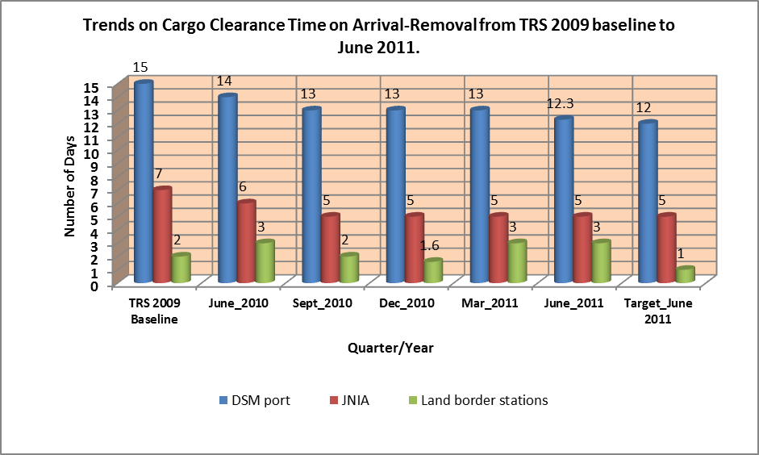

- Cargo clearance time – Lodgment to Release

The clearance time from Lodgment to Release of goods is referred to a time taken on administration of cargo clearing processes from the date and time of lodgment of the goods declaration at Customs to the time a Release Order is issued.

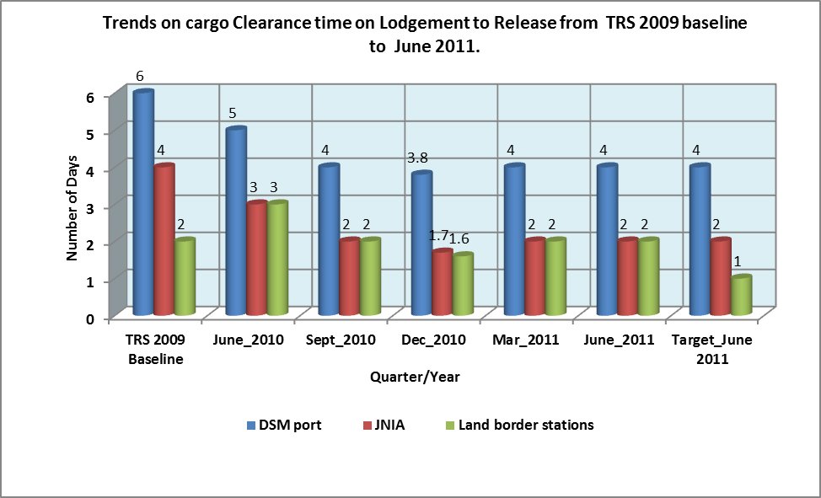

II. Framework:

- Describe any amendments to laws and regulations that were required. (Did you consult with stake holders on this?)

Section 24(1) of the EAC CMA, 2004 that call for submission of sea cargo manifests within 24 hours after arrival is amended to within 24 hours before arrival. Stakeholders were consulted before changes were submitted to EAC Secretariat for consideration and approval.

- Did reform require major changes in administrative policy or organization? Please describe.

TRA administrative structure of reviewed to incorporate unit/department such as Project and Modernisation programme, Information and Communication Technology and Internal Affairs whereas in Customs administration, units such as Modernization and Quality assurance, Risk Management, Trade Facilitation and Post Clearance Audit (PCA) were introduced to enhance coordination of reforms and efficiency. With regard to the monitoring of the improvement of Doing Business in Tanzania, a Task Force was formed and it is coordinated by the Prime Minister’s Office (PMO).

Following the report on Tanzania Doing Business 2010 published by the World bank in 2009, the President of the United Republic of Tanzania convened a meeting with the Chief Secretary, selected Permanent Secretaries and the Governor of the Bank of Tanzania (BOT on 18th September 2009to discuss the business environment / investment climate in Tanzania in view of Tanzania’s deteriorating ranking on the Ease of Doing Business index. Tanzania’s aggregate “Ease of Doing Business” index ranked 124th in Doing Business report for 2008 (DB2008), 127th in (DB 2009), and 131st in (DB 2010). The President directed the Prime Minister’s Office (PMO) to coordinate a process of reviewing the status of the regulatory framework and procedures involved in all indicators where Tanzania achieved the three-digit performance ranking and identification of measures that will enable the nation to improve this ranking to double-digit level. Terms of reference and Roadmap were prepared. The list of indicators and the corresponding lead Ministry are as follows;-
- Starting and Closing Business indicators: Ministry of Industry, Trade and Marketing ;
- Dealing with Construction Permits: Prime Minister’s Office, Regional Administration and Local Government;
- Registering Property: Ministry of Lands, Housing and Human Settlements Development;
- Employing Workers: Ministry of Labour, Employment and Youth Development;
- Trading Across Borders: Ministry of Home Affairs;
- Paying Taxes and Protecting Investors: Ministry of Finance and Economic Affairs;
- Getting Credit: Bank of Tanzania; and
- Enforcing Contract indicators: Ministry of Constitutional Affairs and
Justice (responsible for two indicators).

III. Implementation information:

- What was the approximate time frame for implementation? Why?

Time frame for Customs Modernization Strategies and Action Plan 2009/10-2012/13 is four year plan since at a time the document was completed and approved by TRA Management and Board already TRA Third Corporate Plan 2008/9-2012/13 has a life of one year of implementation. Essentially, the idea was to incorporate the Customs modernization strategies into TRA Third Corporate Plan 2008/9-2012/13.

- Lessons learned: what were the biggest problems/issues and how were they overcome?

Change of mind set among officers and business community to accept and adopt new way of conducting business was a challenge and was resolved by conducting awareness program on New reforms to all staff and business communities across the country.

Implementation of major reform e.g Roll out of ASYCUDA++ at early stages normally affect both the revenue collection and trade Facilitation performance but as time goes on all of them improve. Strong leadership commitment and accountability across the institution is key contributing factor.

- Describe any training or capacity building programs for government officials and/or, private sector that were conducted.

Various programs on awareness implementation of TRA Third Corporate Plan and Customs modernization Strategies were implemented across the institution country wide. Specific program on Change management was conducted to all managers and senior officers with a view to prepare them on how cope and administer the ongoing reforms. With regard to business community regular forums including TRA Stakeholders, Port Improvement Committee and Customs/TAFFA forums were used to keep them abreast with ongoing reform and some specific project such procurement of New Customs automated system, all stakeholders are members of of the Project Steering Committee.

- What equipment, structures, software, etc. was required for implementation?

SNO. | System Name | Description | Technology Used
1. | ASYCUDA | Automated System for Customs Data | 1.Database:  a. Oracle 10g  b. Sever Linux  c. Front End - Pascal
2. | ASYSCAN | Enhanced ASYCUDA application used to scan documents, | 1.Database:  a. Oracle 10g  b. Sever Linux  c. Front end  Web based
3. | ASY-BANK | Online payment system | Database :  ASYCUDA.  Web Server –Apache Tomcat
4. | TPD | Transaction Price Database | Database:  MS SQL Server
5. | Oil Monitoring System | The system is used for oil monitoring system. | 1. Database:  a. Oracle 9i  2. Platform:  a. Windows XP  b. Windows 2000 Professional  c. Windows Server 2000  d. Windows Server 2003  3. Front-end:  a. PowerBuilder
6. | Exemption System | The system is used for exemption. | 1. Database:  a. Oracle 9i  2. Platform:  a. Windows XP  b. Windows 2000 Professional  c. Windows 2000 Server  d. Windows Server 2003  3. Front-end:  a. Oracle Forms
7. | Customs Licensing Application System ( CULAS). | Customs Licensing Application System. The system is used for online Customs license applications | 1. Database:  a. SQL Server 2005  2. Platform:  a. Windows XP  b. Windows 2000 Professional  c. Windows 2000 Server  d. Windows Server 2003  3. Front-end:  a. Visual Basic.Net
8. | Fast – Case Tracking System | This system is used to capture and store all cases to be handled by the Fast section, of Customs Department. | 1. Database:  a. MySQL  2. Platform:  a. Windows XP  b. Windows 2000 Professional  c. Windows 2000 Server  d. Windows Server 2003  3. Front-end:  a. MS Access 2003 Forms and Reports

- Did you require technical assistance? If so what kind?

Both financial and technical assistance have been provided but with manner that it enhance internal capacity building. Teams of officers were appointed to understudy the contracted consultants to ensure continuity of service provision.

- What were the factors crucial to success/ best practices? (What can you recommend to other countries that might undergo similar reform?)

The following are factors crucial to success and can be recommended to other countries undertaking simalr reform;-

- Readiness by the Government to support reform
- Committed leadership
- External monitoring: Regular Effective monitoring system by the Government, Development Partners and IMF/WB Missions.
- Internal Monitoring system: On monthly, Quarterly, midyear and annual review of the implementation of reforms
- EAC regional forums of Tax administrations on which experiences are shared on implementation of various reforms at national and regional levels.
- Conduct Program on change management as part of the preparedness for the implementation of reforms.

- Costs of implementation. If possible please provide a break-out of the costs. Be as specific as possible. (you can attach as an annex)

The costing for Customs Modernization strategies and Action Plan:2009/10-2012/13 is attached in annex 1

- If possible please provide other useful information such as copies of laws, regulations, standard operating procedures/instructions, implementation plan with benchmarks, etc. (you can attach as an annex)

Documents attached:-
- EAC Customs Management Act, 2004(2009) - Annex 2
- EAC Customs Management Regulations 2010 – Annex 3
- Status of implementing Customs Modernization Strategies by September 2011-Annex 4
- Customs Standard Operating procedures- major procedures – Procedures and Flow charts – Annex 5

