Trade Facilitation Implementation Case Study
Overall Trade Facilitation Reform

Trade Facilitation Implementation in ZAMBIA

Prepared For TradeMark Southern Africa
By Gilbert Nkamba
28th September 2011

EXECUTIVE SUMMARY

This summary covers highlights on Zambia’s response to the Trade Facilitation Implementation Case Study. It focuses on the overall trade facilitation reform program, in particular reforms related to customs modernisation initiatives that have been implemented since 1994.

Following the dramatic changes in the global trading landscape in the last decade and considering that trade has continued to flourish despite the current difficulties in concluding the Doha Development Agenda particularly on trade issues; the Trade Facilitation dimension appears to have remained relevant in the multilateral context.

It is generally accepted that trade is the engine of globalisation and that a larger component of trade facilitation is based on customs modernisation. It is in recognition of the central role that customs procedures play as part of a trade facilitation programme that the Government of the Republic of Zambia took a bold decision to embrace Customs in the overall national reform program and supported its visibility in various activities including that of National Working Group on Trade Facilitation.

Overall, major trade and customs reforms can be traced from as far back as 1993 when the Government of the Republic of Zambia establishment the Zambia Revenue Authority (ZRA) as a corporate body (through Act No. 23 of 1993). Effectively, ZRA became operational in April 1994 following the amalgamation of the then Income Tax and Customs and Excise Departments of the Ministry of Finance.

Consolidating on modernization efforts that have been pursued since then, the Authority has incrementally continued with multiple pronged interventions aimed at enhancing operational efficiency and effectiveness with particular emphasis on trade facilitation mainly from a customs perspective. Customs reforms gained momentum in 2006 after Zambia acceded to the WCO revised Kyoto Convention, which espouses the simplification and harmonization of customs legislation and procedures that regulate international trade.

Key customs reforms have been;

- Automation of customs offices with ASYCUDA system;
- Introduction and implementation of the OSBP at the Chirundu border post;
- Enhancing freedom of transit by piloting the implementation of a web based transit data transfer module under COMESA;
- Elimination of pre-shipment inspection, replacing it with destination inspection;
- Benchmarking of procedures with the best practices regionally and internationally
- Strengthening inter and intra-institutional agency linkages and partnerships with business and other stakeholders;
- The review and modernization of business processes on a continuous basis. This includes staff capacity building;
- Application of risk management in daily operations.

The reforms have accrued benefits to the government, to the trade, to customs and to citizens. Some of the benefits derived from reforms in combination with other measures include:

- Improved investor confidence;
- Improved trade and economic environment;
- Attraction of technical assistance and capacity building;
- Increased revenue yield ( trade taxes contributed K3,912bilion in 2010, 4.1% above target);
- Reduced cost of doing business. For instance, a truck that would take six days to go through customs formalities before the introduction of reforms, now takes only one day. This effectively means that there will be no demurrage charges to be incurred by the importer;
- Improved work environment, staff morale and productivity;
- Enhanced public-private sector collaboration;
- Enhanced compliance;
- Improved processing efficiency and service delivery. From an average of two and half days processing time (2006 TRS) to 0.7 days currently. This is against ZRA’s standard benchmark of 1.5 days; and
- Enhanced transparency.

For the reforms to be enforceable, they have been incorporated in the national legislative framework. All customs reforms have been incorporated in the national law. Formulation of tax policy and legislation in Zambia is subject to an open and all-inclusive process. This process allows for an elaborate consultation process with stakeholders.

Implementation of the reforms has, however, not been smooth throughout, and for that reason, there are lessons learned in the process. The lessons inform policy and help government and customs authorities to shape their procedures and make some adjustments to the reforms and to the legislation enforcing them. If done strategically, such adjustments do not compromise gains attained in terms of trade facilitation and do not jeopardize international efforts.

Introduction

This report analyses the reforms that were pursued by government and the customs authorities, with the aim of facilitating trade. It has looked at the measures separately, but has pointed out that the different measures have contributed to the one broad benefit of facilitating the flow of trade. The report has highlighted some of the issues that limited the effectiveness of the reforms and pointed out lessons learned.

With the benefits that have resulted from the reforms so far, there is great hope for more measures to be undertaken in order to consolidate the reforms and further modernize customs processes. In the wider global village, it is very important to be competitive and dynamic. The will of the stakeholders to take bolder steps in embracing modern trade developments in the spirit of transparency and international best practices have been, are and will be a catalyst to trade facilitation.

I. General Overview/Reasons for Reform
- Please provide a general overview of the reforms that were undertaken:

- Was it part of an overall reform program (and therefore co-financed)? Was it linked to WTO trade facilitation or was it broader? Did it build on recent reforms?
Overall major trade and customs reforms can be traced from as far back as 1993 when the Government of the Republic of Zambia established the Zambia Revenue Authority (ZRA) as a corporate body (through Act No. 23 of 1993). Effectively, ZRA became operational in April 1994 following the amalgamation of the then Income Tax and Customs and Excise Departments of the Ministry of Finance.

Consolidating on modernization efforts that have been pursued since then, the Authority has incrementally continued with multiple pronged interventions aimed at enhancing operational efficiency and effectiveness with particular emphasis on trade facilitation mainly from a customs perspective. The road map has therefore been defined and continued to be refined through medium to long term corporate plans which provide strategic framework for developing, implementing and monitoring initiatives and projects in priority areas. The current Customs modernization strategy and Action plans are therefore distilled from the Corporate Plan 2011 - 2013. This plan is premised on broader strategic objectives including:

- To optimize revenue collection
- To improve service delivery
- To enhance operational efficiency
- Enhance professionalism and workforce productivity
- Improve infrastructure
Consistent with the above, the Customs Services Division embraces specific objectives including:

- Review and modernize business processes on a continuous basis
- Enhance risk management in daily operations
- Reduce the cost of doing business and improving service delivery
- Benchmark procedures with the best practices regionally and internationally
- Strengthening inter and intra-institutional linkages and partnerships
In relation to WTO Trade Facilitation initiatives, the reform program embraced a broader approach with some of the elements being co-financed. Building on the broader WCO driven initiatives and programs for customs reforms and modernization ( Revised Kyoto Convention, SAFE Framework of Standards, Twenty First Century Customs and Coordinated Border Management among others), specific interventions impacting facilitation of legitimate international trade include:

- Implementation of One Stop Border Post program
- Time Release Study to provide baseline for procedure simplification and streamlining of Customs processes. Whereas ZRA’s current service standard benchmark is 1.5days, the Service is averaging 0.7 days from above 3 days in 2006 in some cases
- Border Infrastructure Development to respond to increasing volumes
- Systems upgrade from ASYCUDA version 1.18b to version 1.18e
- System centralization to deal with changing business dynamics
- Procurement of equipment and tools e.g. None intrusive cargo Scanners (NII)
- Automation of customs offices formerly operating without ASYCUDA system (currently at 30% coverage, Zambia is currently on ASYCUDA++ version 1.18e. This system has an RDBMS database on Oracle 10g with a SUSE LINUX 10 operating system.
- ICT communication infrastructure enhancement (VSAT to Fibre connectivity)
- Client Accreditation Customs Program
- Customs e-payment
- Integrated cashiering which allows for payment of liabilities anywhere ZRA facilities exist.
Generally the above reforms were built on recent and on-going reforms which transcend Customs.

- What was your baseline (i.e. did you already partially implement many of the measures)? What was the scope- what procedures did it encompass? Which government agencies were involved/affected? etc.

Pre-ZRA performance and the need to continually improve trade and investment climate in Zambia led to a combination of interventions and programs as means for achieving a freer trade environment which would spur economic development. This included implementation of recommendations from the Private Sector Development Programs (PSDP), WCO based Time Release Study (2006), Millennium Challenge Corporation Project, WTO/World Bank Needs Assessment (2007) and the various World Bank Doing Business reports.

Regarding the Time Release Study, the broad objective was to determine where, in the customs process of clearing goods, problems exist, the type of problems, the reasons for these problems, who is involved and to recommend possible solutions to any such challenges. Accordingly the study results identified areas and functions that hindered the effective attainment of Customs’ mandate. In particular, the study focused on establishing the following:
- the time taken between arrival and release of goods;
- the mean time required for the clearance of goods by Customs clearance points, type of traffic ( rail, road and air) and type of customs declaration;
- the mean time taken for release of goods requiring the intervention by other government agencies.
Fig. 1: Geographical Spread – 38 Customs Services Division offices (26 border offices, 8 inland offices and International airports)
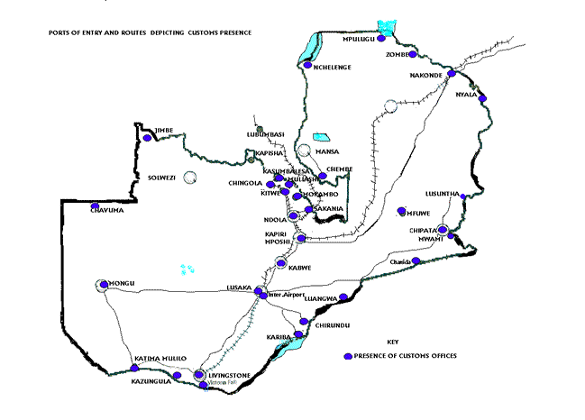

Under given assumptions therefore, the table below shows average time it took for certain aspects of the clearance process at selected border ports, inland ports and the airport. Indeed undertaking subsequent Studies would provide a good basis for comparison.

Fig.2: Mean time by Clearing Process and Port Type*
TIME RELEASE STUDY 2006 - ARRIVAL TO RELEASE (DAYS)
 | Border | Inland | Airport
Arrival to DTI | 1.8 | 1.29 | 3.2
Surveyor to Release | 0.37 | 1.7 | 2.25
Release to Gate | 0.41 | 0.66 | 0.7
 | 2.58 | 3.65 | 6.15

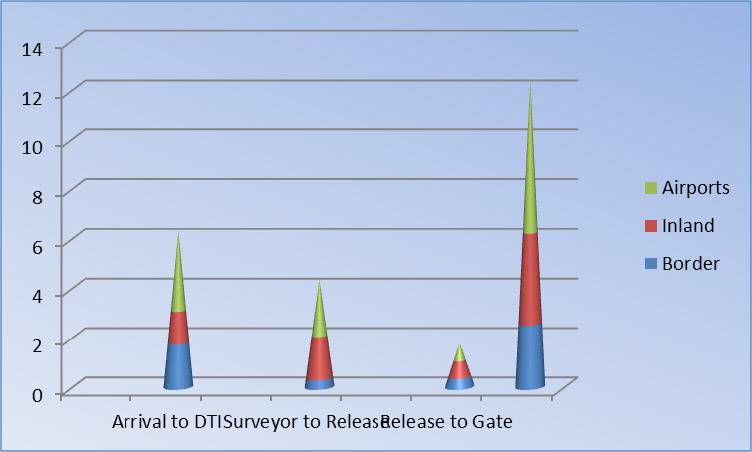

As depicted above, at the time of the study (2006), it took an average of 2.58, 3.65 and 6.15 days from arrival of goods to release from customs control for border port, inland port and airport respectively.

Notwithstanding the above, Customs has continued to exploit the time tracking system inherent in the Asycuda system to provide the basis for performance monitoring, evaluation and appropriate interventions.

Fig.3: Average clearance days from registration to assessment
Year | Jan | Feb | Mar | Apr | May | Jun | Jul | Aug | Sep | Oct | Nov | Dec | AV Days
2005 | 4 | 4 | 5 | 7 | 4 | 3 | 3 | 4 | 5 | 4 | 4 | 6 | 4
2006 | 6 | 3 | 8 | 9 | 5 | 5 | 4 | 5 | 4 | 3 | 3 | 3 | 5
2007 | 3 | 3 | 3 | 4 | 4 | 4 | 4 | 4 | 3 | 4 | 3 | 3 | 4
2008 | 4 | 4 | 3 | 3 | 3 | 2 | 2 | 2 | 2 | 2 | 2 | 3 | 3
2009 | 3 | 3 | 2 | 2 | 3 | 2 | 2 | 3 | 2 | 2 | 2 | 2 | 2
2010 | 2 | 2 | 2 | 1 | 2 | 2 | 2 | 1 | 2 | 2 | 2 | 2 | 2
2011 | 2 | 2 | 2 | 2 | 1 | 1 | 1 | 1 | 1 |  |  |  | 1
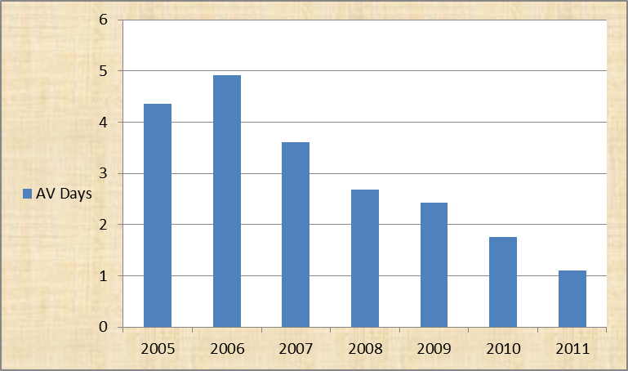

The chart above shows a significant improvement in customs processing efficiency in terms of time taken from registration to assessment, which is from about 5 days in 2006 to less than a day in 2011.

In responding to the need for effective Trade Facilitation therefore, the scope of modernization transcends customs procedures and embraces all relevant stakeholders in the trade supply chain. An all-embracing and inclusive consultative process was utilized in bringing together stakeholders.

Notable players in the program included the Ministries of Commerce, Trade and Industry, Finance and National Planning, Works and Supply, Home Affairs, Agriculture and Cooperatives, Health and Transport and Communication. Others stakeholders were Zambia Development Agency, Immigration, Zambia Environmental Agency, Zambia Bureau of Standards, Central Statistical Office, Zambia Freight Forwarders Association (ZAFFA), Zambia Clearing and Forwarding Association (ZCFA), Road Development Agency, and the Market Access and Enabling Policies Project (MATEP).

The outcome of 2006 WCO Diagnosis mission in the context of WCO Framework of Standards also provided a significant impetus to the overall reform program

- Why did your country decide to undertake these reforms? (E.g. input from traders, studies showed trade barriers, Kyoto Convention Compliance, etc.)
In the context of the broader economic liberalization, the Government’s desire to reform tax and customs administration coupled with the adoption of the Kyoto Convention and subsequently the Revised Kyoto Convention in 2006 necessitated most of the reforms that have continued to be undertaken.

Related to this is a complementary drive from the ever-changing landscape in international trade which demands responsive trade and customs related policies.

Given the strategic location as a transit traffic hub, Zambia has endeavored to continually improve its socioeconomic environment in order to realize her potential for meaningful growth. Trade and investment therefore present an opportunity for sustainable growth, economic development and wealth creation. Hence Zambia endeavors to effectively participate and promote implementation of commitments made under regional and multilateral trade arrangements.

- What benefits have been realized as a result of this reform? (Benefits for the government and/or traders, what problems did it solve?)
Benefit derived from this reform in combination with other measures include:

- Improved investor confidence
- Improved trade and economic environment
- Attraction of technical assistance and capacity building
- Increased revenue yield ( trade taxes contributed K3,912bilion in 2010, 4.1% above target)
- Reduced cost of doing business. For instance, a truck that would take six days to go through customs formalities before the introduction of reforms, now takes one day. This effectively means that the there will be no demurrage charges to be incurred by the importer.
- Improved work environment, staff morale and productivity
- Enhanced public-private sector collaboration
- Enhanced compliance
- Improved processing efficiency and service delivery. From an average of two and half days processing time (2006 TRS) to 0.7 days currently. This is against ZRA’s standard benchmark of 1.5 days
- Enhanced transparency

Fig.4: The matrix below summarizes additional benefits:
 | Area | Benefits
1 | Post Clearance Audit | - Client education  - Risk based targeting  - Legislative simplification  - Reduced intervention at the border
2 | Accredited Clients Program: 15 clients. Not extended to SMEs because of weak internal control environment | - Increased transactions to green channel  - Client education  - Priority attention through dedicated contacts  - Reduced cost related to customs processing  - Voluntary compliance
3 | Risk Management | - Applied as work culture  - Applied at planning stage  - Applied in audits  - Applied at pre-entry processing  - Applied during processing through ASYCUDA selectivity
4 | Modernization  - E-payment  - Systems interface between customs administrations  - ASYCUDA upgrade and Centralization | - Electronic payment of taxes including through mobile phones from anywhere at any time, 24/7  - Paperless and Seamless movement between borders to reduce re-input of data  - 24hrs operation  - Better access to improve voluntary compliance and timely processing

- What were the revenue implications? Did any particular measures have a strong impact on revenue either positive or negative?
Since inception of ZRA, revenue yield has been on an upward trend. Specifically trade taxes collected in the last five years are as follows:

Year | 2005 | 2006 | 2007 | 2008 | 2009 | 2010
Revenue (Kbln) | 1,666 | 1,977 | 3,121 | 4,034 | 3,257 | 3,912

The slump performance in 2009 could be attributed to the global economic and financial crisis.

The centralization of the customs processing system (ASYCUDA) coupled with improved payment system and enhanced customs-public collaboration greatly contributed to the overall improved performance.

II. Framework:

- Describe any amendments to laws and regulations that were required. (Did you consult with stake holders on this?)
The Customs legislative framework received a major and fundamental overhaul in 1999 in order to align it with international best practice particularly on the basis of the Kyoto Convention. Since then, incremental improvements have consistently been made so as to keep it relevant to all stakeholders. This has continued to be done to take account of new developments and trends both in the domestic and global world.

Formulation of tax policy and legislation in Zambia is subject to an open and all inclusive process which allows for contributions and elaborate consultations with stakeholders.

The introduction of OSBPs resulted in the enactment of new Acts. Zambia enacted the OSBP Act No 8 of 2009 and in Zimbabwe the OSBP Act No 21 of 2007 was introduced to make the Chirundu OSBP operational. This was complemented by a bilateral agreement between the two governments that established the OSBP and gave authority to officers to implement the OSBP and Chirundu and perform their respective mandates in the common control zone.

- Did reform require major changes in administrative policy or organization? Please describe.
Comprehensive reforms need to be supported by a realignment of both organizational structure and administrative arrangements. Some of the notable changes in ZRA included creation of new support units such as Audit and Business Risk (ABR), the Data Management and Intelligence (DMI), Investigations and International and Policy. Other notable offshoots of these changes include the following:

- Establishment of Integrity Committee
- Code of conduct for employees
- Establishment of Internal Affairs Unit
- Internal Audit Unit
- Continuous Tax payer education
- Establishment of Customs Business Forum to enhance collaboration
- Competitive conditions of service including remuneration for staff
- Streamlined appeal process
- Pre-arrival registration and clearance
- Improved coordination among border agencies
- Adoption of Risk management
- Post Clearance Audit and Control
- Enhanced appeal process (establishment of the Revenue Appeals Tribunal in addition to internal administrative processes and the Courts of law)
Authority levels at various operating ports and operating procedures have continued to be adapted in response to legitimate demand from the trading community.

More and more information on the activities of the Authority has been made available on the ZRA website. Other publications are distributed through the print and electronic media to reach the wider public as much as possible. Information on ZRA commitments and clients obligations (Clients Charter and other publications) is also readily available.

Inter-agency collaboration has continued to be enhanced with ZRA playing a critical role in almost all government inter-agency committees and subcommittees, working groups or indeed any such other structures established to support and promote legitimate trade.

III. Implementation information:

- What was the approximate time frame for implementation? Why?
Overall the Authority has employed a three-year cycle Corporate Plan coupled with corresponding tactical annual plans with specific strategic interventions and Action plans which are subject to peer review mechanism. Some of the milestones are highlighted below:

- One Stop Border Post at CHR (Began in 2007 and launched officially on 5th December 2009).
- Time Release Study to provide baseline for procedure simplification and streamlining of Customs processes [Done in 2006 ]
- Border Infrastructure Development. [Infrastructure development at other major customs ports are at different levels of completion. Ongoing and depending on availability of funds as such infrastructure is developed by Government.]
- Automation. Initiated around 1995, the program has seen a number of enhancements including System Centralization [From 2006 to mid-2007]
- Equipment procurement e.g. Cargo Scanners (NII) [ on going]
- Automation of customs offices formerly operating without ASYCUDA system [Chanida 2 weeks, Mpulungu 2 weeks ]
- ICT communication infrastructure enhancement (VSAT to Fibre connectivity) From 2009 but ongoing]
- Client Accreditation Customs Program [Started in late 2007, ongoing]
- Customs e-payment [Approximately two years from March 2009. Collaborative project with Commercial banks. Technology and skill variances]
- Integrated cashiering allowing taxpayers to make tax payment from any station convenient to them (effective Oct 2011 )

- Lessons learned: what were the biggest problems/issues and how were they overcome?
One of the challenges to carry out such overarching reforms is availability of resources (financial and human capital constraints), local capacity to implement reform projects, sustainability (running costs of newly implemented projects) and change management among stakeholders, especially employees.

Considering that some of the projects were co-financed, appeals were made for more funding from the Government and Cooperating Partners, Capacity building (training of officers), Public Private Partnerships financing arrangements and alternative financing arrangements where employed

- Describe any training or capacity building programs for government officials and/or, private sector that were conducted.
ASYCUDA Training (Functional and Technical), WCO Fellowship Programme (Columbus Program), Project Management, Risk Management, InWent program, GRIPS, Senior Management Development Programme, Customer Care, Integrity etc

- What equipment, structures, software, etc. was required for implementation?
New computers, Operating system upgrade and changes Linus to Oracle g, ASYCUDA system upgrade, ASYCUDA system centralization, Non Intrusive Scanners, Oracle discover licenses (data mining), border support facilities including buildings or general infrastructure i.e. Chirundu (One stop Border Post infrastructure), Kasumbalesa, Katima Mulilo and Nakonde.

- Did you require technical assistance? If so what kind?
Yes substantial support was received from Cooperating Partners in the form of technical assistance and capacity building (for sustainability) particularly in ICT equipment and expertise.

- What were the factors crucial to success/ best practices? (What can you recommend to other countries that might undergo similar reform?)

- Clearly defined objectives and strategies
- Effective leadership
- Ownership
- Political will from the critical mass especially Government
- Effective Change management program.
- Comprehensive peer review mechanism

- Costs of implementation. If possible please provide a break-out of the costs. Be as specific as possible. (you can attach as an annex)
The total cost of implementation of the ASYCUDA program was USD278,324.00. This is broken down as:

- ASYCUDA 2.7, version 1.18b USD104,440;

- ASYCUDA ++, version 1.18e USD173,884;

- The cost of the envisaged COMESA implementation of ASYCUDA ++ in its member states would cost USD399,629. Out of the 21 member countries, 14 are using the system;

- ZRA customs’ further reforms are in the direction of migrating to ASYCUDA World, and the cost is estimated at USD1,500,000.

- Funding for the ASYCUDA implementation came from the European Union and Technical assistance from UNCTAD.

- Implementation of the Customs Master Degree capacity building project by InWent Germany did not cost Zambia any amount, but the project budget by the Germany Federal Ministry of International Cooperation was estimated at USD134,000 per student including tuitions, field tours, research, accommodation and attachments in Germany

The Chirundu OSBP was financed by DFID and JICA and activities are still on going and total cost will be ascertained at a later stage. The Governments of Zambia and Zimbabwe also contributed to the costs of establishing the OSBP.

- If possible please provide other useful information such as copies of laws, regulations, standard operating procedures/instructions, implementation plan with benchmarks, etc. (you can attach as an annex)

- Customs and Excise Act (2010)
- Customs and Excise (General) Regulations (2010)
- Time Release Study Recommendations
- ZRA Corporate Plan 2011-2013

