Case Study on Publication and Information

Submitted by Norway for the November Symposium

Article 1 (Publication and Availability of Information) and Article 2 (Prior Publication and Consultation)
Norwegian Customs has a number of different solutions for efficient communication with our users, over the Internet. These provisions cover both our unilateral communication, in addition to our users’ possibility to contact Norwegian Customs. Some of these provisions will be presented below.

- Provisions under articles 1 and 2
  - Publication and types of Information Available Through the Internet
The main information source to the public is the internet. Technically this is a “hotel” solution with an external provider of the servers and technical infrastructure. The internet sites are mostly not interactive. For the moment there is no use of social media such as Facebook and Twitter. All pages are edited at national level, by The Directorate of Customs and Excise (TAD). The Communication Unit is responsible for the overall structure and the respective departments are responsible for the content.

The main web page www.toll.no offers three main menus – one for individuals, one for business and one general. There is also an English menu, with a limited service. The pages have approximately 1 million page views per month.

For customs legislation the web pages are linked directly to the Lawdata Foundation (www.lovdata.no) where i.a. all Norwegian laws and regulations are published.

It is possible to subscribe by e-mail for all news related to selected items, like “Importation”.

Examples of features:

Electronic Customs Tariff – searchable by national tariff number, HS position or selected words. Approximately 10 % of all visits on the web page are related to the Norwegian Customs Tariff.

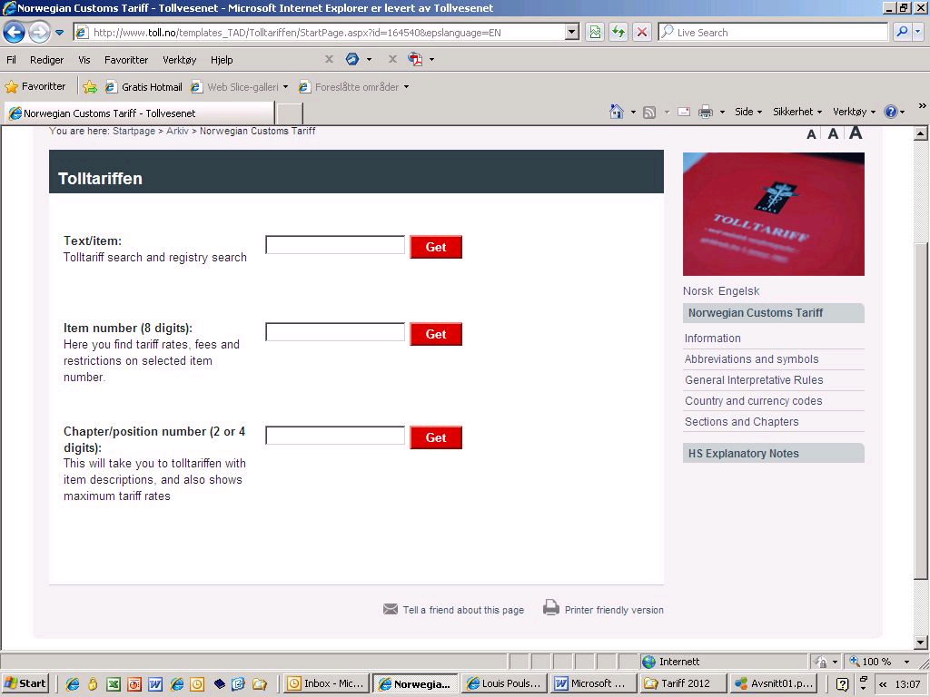

For each classification number the user has access to all duty rates, import taxes and restrictions. This information is the same as in the electronical declaration system:

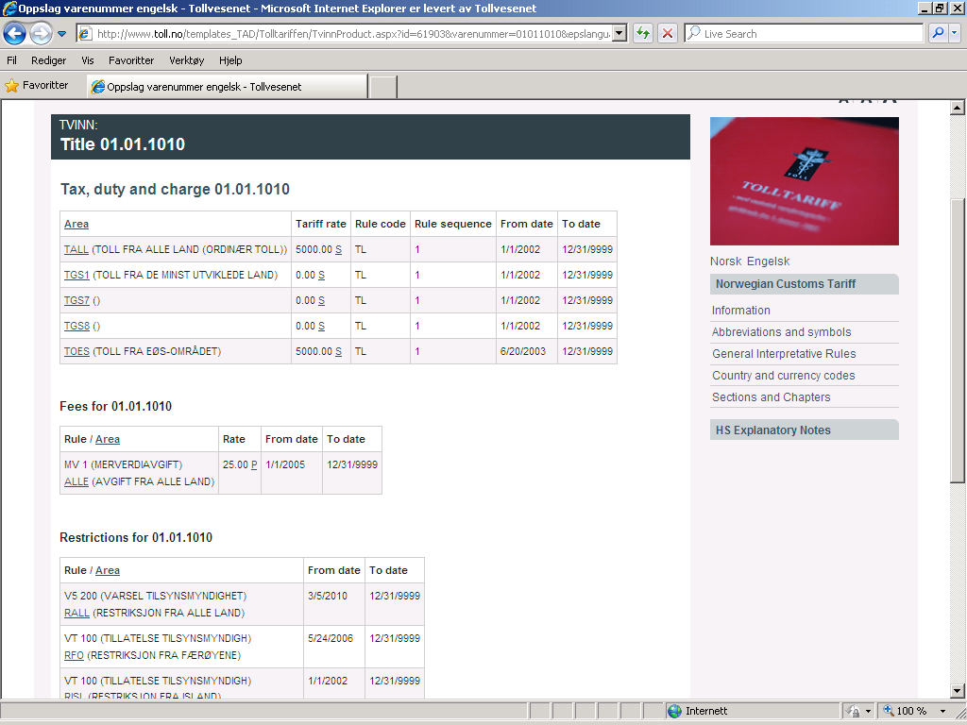

The range of information covers the Norwegian Customs Act and its regulations, as well as the Norwegian Customs Tariff and various forms.

As a helpful provision for our users the customs web pages have different calculators measuring the amount to be paid when importing cars or other goods. The calculator for cars is separated from the one for other goods.

The car tax calculator has about 116 000 page views, whilst the other importation calculator has about 26 000 page views per month.

  - Enquiry Points
Norwegian Customs is divided into six different geographical regions. Each region has its own enquiry point, organized to answer questions from the public. Significant resources have been given to these enquiry points, and they work well as a primary contact point between customs and its users. A total of approximately 120 000 enquiries are being processed every year. The six enquiry points are staffed with around 20 officers.

  - Notification and Opportunity to Comment on New and Amended Rules
All new regulations must, as a main rule, be notified publicly, to make it possible for all interested parties to comment on them. Most draft acts are also notified, according to the Government’s Instructions for Official Studies and Reports Chapter 5.

  - Interval between Publication and Entry into Force
Today Norway has no such provisions, in addition to the above mentioned requirements for public notification.

  - Consultations
The Directorate has regular meetings with the main business interest organisations.

- Costs
The costs of implementation are not available, since this has been a process over some 15 years. For system maintenance the costs amount to approximately 400.000 Euros. Maintenance and updating of the content is a part of the ordinary work.

- Challenges
The requirements for translation differ somewhat between our different international agreements. Translating and publishing all relevant documents in English have to a certain extent been a challenge. As far as Norwegian Customs is concerned, this challenge is bigger for Norwegian Agricultural Authorities, but as the legislation in question is somewhat interwoven this is challenging for Customs as well. As well as the translation of relevant documents, keeping information available and updated in English requires a lot of resources.

- Conclusions
Norwegian Customs has a well functioning system for information and publication. There are some obvious challenges when it comes to availability in English, as well as potential for improvement in certain areas, such as social media, and the possibility for different online applications. All in all the current solutions work well.

