Case Study on Single Window implementation

Korea

Prepared by: So Young Yang, Deputy Director, Korea Customs Service, Oct. 15th 2011
KCS’ experiences on Single Window implementation

- Background
In line with revised Kyoto Convention and recommendation by international organizations including WCO and UN, Korea Government launched Single Window project as one of the major seven tasks of 「Roadmap for Logistics Hub of Northeast Asia」 initiated by the presidency in 2003. Korea Customs Service(KCS) accordingly embarked on Clearance Single Window Project. Prior to building up Single Window system, KCS performed BPR/ISP for 7 months, and came up with strategies and concrete action plans for implementing a Single Window. Single Window system had been completed through three phases from 2004 to 2007, in which a total of 5.7 billion won(approx. $6 million) was invested by government budget.

- Phased Implementation
As of 2011, 23 government agencies relating to trade requirement verification are connected through internet-based clearance portal of KCS(http://portal.customs.go.kr). Single Window has been established through three steps as follows.
- Phase 1 (Aug. 2004~Mar.2006): Building the Single Window System
Standardized marine/air conveyance report and passenger/crew list with the participation of 5 agencies related to customs, immigration and quarantine. Established internet-based Single Window system connecting 8 governmental agencies. 2.6 million won was invested in this phase.
- Phase 2 (Mar. 2006~Feb.2007): Extending the Single Window System
Expanded Single Window, Connecting 4 more agencies. 1.4 million won invested.
- Phase 3 (Jan. 2008~Jul. 2008): Improving the Single Window System
Focused on improving the quality of the system and upgrading to provide user-friendly environment. 1.7 million won invested.
- Phase 4 (Jul.2009~) : Increasing connected agencies (23 agencies connected by 2011)
- Major challenges & lessons learned

- Use rate of SW by declarants
At the end of phase 1, the use rate of Single Window by general declarants was only 1.0%. The major causes of low rate included incompleteness of some system functions(e.g. electronic fee payment), adjusting period of small businesses or need for P.R. and training for SW use. Upon learning these hindering factors, KCS tried to improve the use rate by clearing these negative factors. At first, collecting both user’s and non-user’s opinion by PCRM or meetings was carried out. Based on the opinions collected, the Single Window system has been upgraded step by step. (e.g. loading the e-payment function, lump sum transfer of EDI declaration to Internet SW portal, etc) P.R. was also continued through various means such as information session for companies and distribution of SW user’s guide. In addition, focusing on key stakeholders such as customs broker was very important to increase the use rate. Both strategy of persuasion and incentive(e.g. exemption of inspection) were used to promote key people in logistics chain to use Single Window.

- Coordination among related agencies
Data Harmonization among trade related government agencies is critical for successful implementation of Customs Clearance Single Window. Task Force team was formed in Phase 1, consisting of KCS and 8 import/export related government agencies including the Korea Food and Drug Administration(22 officials). Data harmonization process conducted by this TF team is as follows.

『Selection of government agencies participating in data harmonization & Identifying laws and regulations engaged in the confirmation of import/export requirements. →Identification and classification of data elements to be harmonized → Analysis and reconciliation for data harmonization(based on comparison among Customs import declaration, requirement confirmation documents, and WCO DM) → Revision of relevant laws and regulations and establishment of integrated declaration system(e.g. By the TF team in phase 1, 10 forms related to 8 relevant agencies were analyzed for harmonization, and 7 Acts including Food Sanitation Act were revised.) 』
To promote coordination and participation of various agencies, strong political support and sufficient allocation of government budget were identified as one of major success factors. In case of Korea, the president directed vitalization of Clearance Single Window(2007), and Prime Minister’s office accordingly prioritized this as Special National Project(2008). The National e-Trade Committee was chaired by the Prime Minister and included 10 ministers, the commissioner of KCS and the chairs & presidents of leading private industry associations, including those for small and medium-size businesses. This strong political will and following budget allocation supported KCS to well-function as a coordinator in SW implementation.

- Technical issue: ASP system
Some of requirement verification agencies did not have there own computerized verification system. In order to encompass these agencies in the Single Window, KCS developed a verification system of ASP format so the agencies without their own system could electronically manage verification work through the Single Window. This means that the number of connected agencies can be extended more easily, without having to develop a new individual system. Now, 10 agencies have their own verification systems, which are directly linked to the SW, and 13 agencies are using the ASP requirement verification system developed by KCS.

- Performance Evaluation

- Financial aspects: Cost / Benefit comparison
- B/C ratio(accumulated 2006~2010): 9.73 (775.9/79.7)
- Cost: annual government budget invested
- Benefit: logistics cost saving by reduction of data processing time
Formula) logistics cost saving = annual number of SW declarations
x cost saving per one SW declaration
e.g.) 2010: 43 billion won ≒ 864,366 declarations x 49,766 won/declaration

- Use rate and Participating agencies
High rate of use by declarants and expanded connection to related agencies are critical factors for successful implementation of SW and maximization of B/C ratio. The expansion of Single Window has been accomplished as follows:

- Yearly use rate
 | 2006 | 2007 | 2008 | 2009 | 2010
Number of Single Window uses | 24,320 | 50,115 | 132,418 | 488,934 | 864,366
Total Number of requirement confirmation | 567,211 | 729,909 | 685,419 | 728,000 | 943,747
Yearly use rate | 4.3% | 6.9% | 19.3% | 67.2% | 91.6%

- Connection with related government agencies
 | 2006 | 2007 | 2008 | 2009 | 2010 | 2011
Accumulated number of connected agencies | 8 | 12 | 15 | 17 | 20 | 23

- Other outcomes
- Time saving
Before SW implementation, it took approximately one day between requirement confirmation by related agencies and import declaration to Customs. After SW system has been launched, at the same time as requirement confirmation number is reported to the SW system, the number is automatically input to import declaration form by a key variable of cargo management number, so that declarants do not have to file in duplicatively.

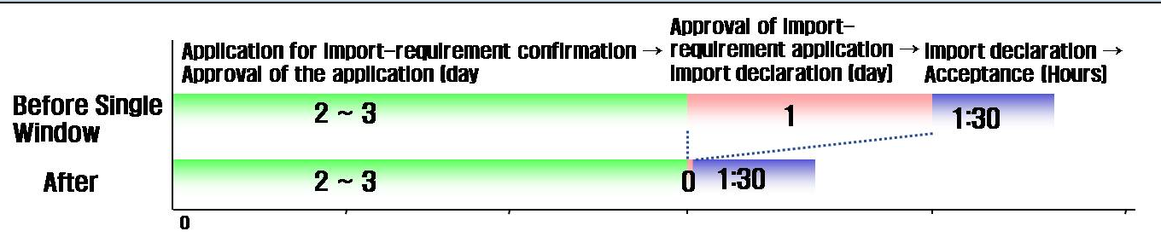
- Comprehensive saving of Firms’ costs (calculated by World Bank, 2010)

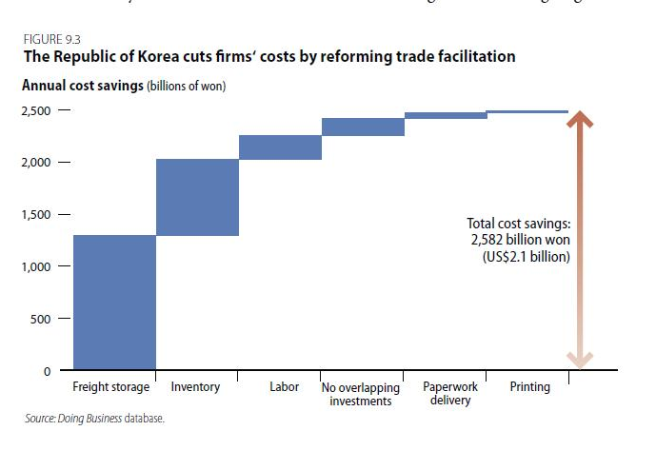

- Future Plan
By conducting the Single Window project at the national level for trade facilitation and seamless logistics flow, KCS established Single Window for the customs clearance and conveyance report participated by 23 relevant agencies as of 2011. In addition, inter-agency harmonization of similar forms and data elements and simplification of declaration procedures have enhanced user convenience and reduced logistics costs, which in return helped to boost use rate of Single Window and resulting financial benefits.
However, in order to build an international trade Single Window which enables advance information exchange among nations and contributes to the trade facilitation as well as the cargo security, it is prerequisite to standardize data elements to be declared to governmental agencies around the world. Therefore, KCS actively joins WCO’s efforts to design Data Model and adopt it to data elements in Korean declaration documents. At the same time, KCS is trying to communicate the significance of the harmonization of coding & data and the standardization of procedures at domestic and international level.

Business Process Reengineering/Information Strategy Planning
KCS, Immigration Office, National Quarantine Station, Ministry of Marine Affairs and Fisheries, Aviation Administration
Korea Food and Drug Administration, National Plant Quarantine Service, National Fisheries Products Quality Inspection Service, National Veterinary and Quarantine Service, Korea Medical Devices Industry Association, Korea Dental Trade Association, Korea Pharmaceutical Traders Association, Korea Animal Health Products Association
Korea Environment & Merchandise Testing Institute, Korea Toy Industry Cooperative, Republic of Korea, Korea Testing & Research Institute, Korea Testing Laboratory
Public Customer Relationship Management
Korea Food and Drug Administration, National Fisheries Products Quality Inspection Service, National Plant Quarantine Service, National Veterinary and Quarantine Service, Korea Pharmaceutical Traders Association, Korea Animal Health Products Association, Korea Medical Devices Industry Association, Korea Dental Trade Association
Food Sanitation Act, Plant Protection Act, processing of Livestock Products Act, Act on the Prevention of Livestock Epidemics, Pharmaceutical Affairs Act, Cosmetics Act, Medical Device Act
Application Service Provider
Doing Business Report, The World Bank & International Finance Corporation, 2010
As of 2011, a total of 145 documents related to conveyance and customs clearance has been designed applying WCO v.3.0

