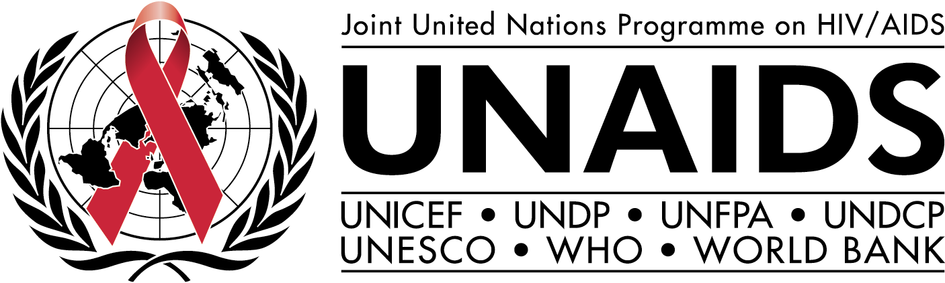

Check against delivery

Speech at the WHO-WTO workshop on
differential pricing and financing of essential drugs,
Norway, 8-11 April 2001,

by Peter Piot,

Executive Director

If you were a Martian monitoring earth through the editorials of leading newspapers, you could be forgiven for thinking that AIDS in Africa is a new issue. You would conclude that the only reason millions of Africans are dying of AIDS is that the cost of antiretrovirals is too high. And you would also conclude that a six-month campaign by these newspapers has miraculously solved the problem – bringing pharmaceutical giants to their knees.

Those of us who are not from Mars (or Venus) know that recent breakthroughs in the prices of antiretroviral drugs are the product of years of painstaking work, in turn building on a long history of tackling AIDS, and an even longer history of agitation for affordable medicines, contraceptives, and vaccines, led by WHO, UNICEF, UNFPA, non-governmental organisations and activists. Let me also be clear: confronting the AIDS epidemic requires much more than providing antiretroviral therapy to those infected. We will only halt this terrible epidemic if we do not compromise on a strictly balanced approach with much increased attention for prevention of new infections.

By 1996 it had become clear that the face of AIDS treatment had changed in high-income countries. At UNAIDS, we were acutely aware that it would be morally unsustainable for these life-transforming treatments to be out of reach of the great majority of the world’s population living with HIV, those in the developing world. But the global consensus at the time was that extending antiretroviral access to the developing world was simply unfeasible – the cost of the drugs would break the budgets of all but the richest countries, and health infrastructures would be unable to cope. And there are still real and unresolved issues.

Swimming against the tide of this consensus, we decided to put some of these assumptions to the test. In 1997 the Drug Access Initiative began on a small scale to study the feasibility of extending antiretroviral access in Uganda, Cote d’Ivoire and then Chile. Around the same time the Government of Brazil decided to offer such therapy in the public sector.

By 1999 we were starting to get a picture of what was feasible and where the major barriers lay. The evidence showed it was possible to gain therapeutic benefits from antiretrovirals in developing countries provided sufficient attention was paid to human resources, infrastructure, financing and drug management.

However, we quickly realised that offering HIV treatment at the scale of millions of patients, instead of a few thousands, is altogether a very different enterprise. We have known this for decades when trying to take a research or demonstration project to scale – but we seem to forget some basic lessons from good development practice.

Over the last year and a half, we concentrated on two major issues: firstly, on affordability, and secondly, on comprehensive care plans for HIV in low-income countries. On the first issue, the initiative had achieved prices around half those in the US, but seemed unable to get lower than that.

Therefore, in May 2000 dialogue began between on the one hand 5 major pharmaceutical companies and on the other hand UNAIDS - including cosponsors WHO, UNICEF, UNFPA and the World Bank. This initiative has resulted in a reduction of up to 90% of the price of antiretroviral drugs – all still under patent.

At the same time, UNICEF, WHO and UNFPA, called for expressions of interest by drug and diagnostics manufactures to help map and extend drug supply.

On the second issue, an essential care package for people with HIV was defined, and systematic collaboration with countries on access to HIV care was began by the UNAIDS Secretariat and WHO – with 31 countries so far indicating they would like to participate.

There are at least three major lessons to draw from our experience with treatment access. These should be key for our work on scaling up current efforts.

First, while pricing is not the only issue, price does make a difference. Analysis conducted by McKinsey and Company on increasing access to antiretrovirals in Uganda underlined the extent to which the price to patients is a major limiting factor in Uganda’s capacity to scale-up treatment provision. At an annual charge of around $2,400, about 5,000 patients could be reached. When the annual cost of drugs to the patient fell to six hundred dollars, fifty thousand people could be reached.

Second, the preferential pricing for developing countries on HIV-related medicines has become an accepted reality by many in the industry. But we should not restrict ourselves to only one model for delivering affordable prices – there are at least five ways that affordability can be increased:

- the negotiated agreements between governments or regional bodies, and research-based and generic manufacturers (as in Uganda, Rwanda, Senegal, Cameroon, Mali and Cote d’Ivoire to date, with others coming on board rapidly);
- donation programmes, such as Boehringer-Ingleheim’s nevirapine offer in relation to mother-to-child transmission, and Pfizer’s agreement with the Government of South Africa;
- pursuit of voluntary licensing offers and local manufacture - compulsory licensing theoretically would also lead to lower prices, but is unproven as an instrument;
- generic competition (or the threat of it) drives down the price, as now well-documented in Brazil and Côte d’Ivoire; and
- abolition of taxes on essential drugs and commodities such as condoms.

And lastly, a third lesson. In most urban areas in the developing world, there are systems in place which should enable the provision of quality HIV care and treatment, including in major private companies - so “quick wins” are possible. However, the sobering reality is that concerns of equity are not addressed in this way, and that, at least in most of Africa, provision of antiretroviral therapy will require a major boost for the health system.

So, what are the key challenges that remain?

First, we need to be clear that no one wins if we set up intellectual property and public health to be in conflict. This is fundamental to the integrity of the TRIPS agreement, and the intent of its safeguards to allow sovereign governments to protect public health.

Second, and probably most formidably, we need to strengthen the capacity of the health systems needed to deliver these medicines safely and effectively. Success depends on whether the momentum built up around the affordability of antiretrovirals can be used to drive the wider agenda.

Third, resources are needed, on a new scale – this is billions of dollars per year - and with a new level of coherence. The issue of resources is rapidly becoming a test of the international community’s credibility. Now is the time for all the fine words about the AIDS crisis to translate into real dollars. The UN General Assembly Special Session on HIV/AIDS in June provides us with a unique momentum to achieve this.

Fourth, we cannot avoid the issue of increasing drug affordability for middle-income countries. The fact is that these are the countries where deep discounts on antiretroviral costs will make the biggest difference, because they already have the health infrastructures needed to deliver the drugs. Our progress on this issue will be measured very clearly in the next few years – in trends in mortality in Latin America, the Caribbean and Asia.

Fifth, support for innovation must be maintained. Preferential pricing for developing countries is part of a deal where drug prices in high-income countries continue to include a component that compensates for the investments and risks associated with innovation.

But innovation needs to be extended beyond therapeutics. Vaccines and microbicides are desperately needed prevention tools. Their development is long-term and high-risk. That is why we need to plan now to guarantee the resources for their eventual use at high-volume along the lines proposed by IAVI.

We can achieve all these, if we know what our real assets are. The politics of AIDS is unlike other diseases – it is a disease with a constituency, and people living with HIV are its most vocal core. Their demands are driving much of the agenda and without AIDS activism we would not be where we are today. Therefore, they must be fully involved in all steps of our endeavour.

With them it is not too much to demand a radical, new way of doing business in times of an extraordinary epidemic (which will be with us for a long time). As I stated of the European Commission Round Table on Accelerated Action against Communicable Disease in September in Brussels, we need nothing less than a “new deal” between the pharmaceutical industry and society. A contract which is based on the ethical imperative to find a way to ensure that the fruits of science benefit all, including the poorest; and that the costs of new development fall on those who have the means to pay.

In essence, I see this new global deal as having a coherent package with at least three components:

- Continuing the current successful paradigm in high-income countries. This market continues to drive research and development for the majority of illnesses, and to pay for much needed innovation.
- For newer essential medicines (e.g., still under patent) in the low-income countries, development of a new paradigm based on preferential pricing, licensing out, and geographic restrictions.
- Expanded public funding for research and development for treatment and prevention of neglected diseases.

This coherent package must have the full endorsement of the global community – politically and commercially.

Thank you.

