Health and Pharmacy Systems in Developing Countries

Richard Laing

Associate Professor

Dept. of International Health
Boston University School of Public Health

Paper presented Hosbjor Norway
April 9th 2001

Introduction

In developing countries there is a multiplicity of health service provision and payment mechanisms. As a percentage, pharmaceuticals are a major portion of health expenditure BUT in absolute terms are still very low. While concerns about the infrastructural capacity of many of these poor countries to effectively use drugs which require monitoring and laboratory support, price remains the major factor in determining access. Only when the price of these new or existing drugs has been reduced to the marginal cost of production can a realistic assessment be made of what health system developments would be necessary to treat the range of diseases affecting developing and in some cases transitional countries.

The Global Burden of Disease

The World Health Organization has undertaken a massive effort to quantify the global burdaen of diseases. They have calculated this burden in Disability Adjusted Life years (DALYS) and in deaths.
Disease | DALY’s (000s) | Deaths (000s)
HIV/AIDS | 89,819 | 2,673
Tuberculosis | 33,287 | 1,669
Malaria | 44,998 | 1,086
Depression and Suicide | 59,030 | 894
Source World Health report 2000 quoting 1999 data

All of these diseases or conditions affect developing and transitional countries. Effective drugs exist to treat them but primarily due to the cost of the drugs are not available to be used.

HIV and AIDS
The HIV/AIDS epidemic progresses in Africa and in Asia causing millions of infections with HIV and eventual AIDS deaths. It is important to recognize that the AIDS epidemic lags about eight years behind the HIV epidemic. This means that the AIDS cases being seen today in a country reflects the HIV situation of 1993. For many African countries, the rates have increased by a limited extent in this period and the annual number of cases of and deaths from AIDS may be close to stabilizing, but for South Africa and some Asian countries the rate of HIV infection has increased dramatically between 1993 and 2001. For these countries, rapid increase in the numbers of AIDS cases is inevitable.
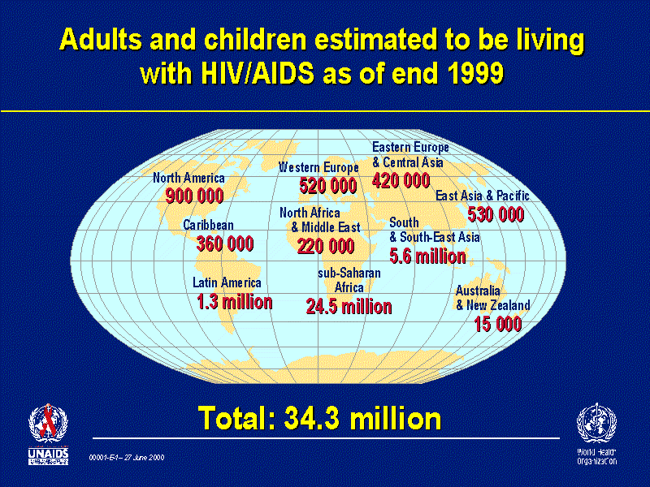

The UNAIDS and WHO map of HIV and AIDS reflects the devastating concentration of the disease in the poorest continent in the world, Africa. Such a serious public health disaster is affecting the continent least able to respond effectively to this threat.

Demographic and Social Effect of HIV/AIDS on Populations
The effect of this epidemic is to reverse the gains of the last fifty years and to reduce life expectancies substantially. For example the male and female life expectancy in Zimbabwe would be about 65 years without HIV/AIDS. In 2000, the US Census Bureau International Health Office estimated the life expectancy for men to be 39 years and for women to be 36 years. As the fertility rate in Zimbabwe had fallen prior to the epidemic these high young deaths means that the population is close to Zero population growth now and will inevitably change to negative population growth.

The social effects on a country can also be seen in many different ways with Ministers, Deans, businessmen and leaders being lost to their countries at the most productive times of their lives. A recent news item from a South African newspaper caught my attention:

Natural prison deaths climb by 584% in SA
The number of “natural” deaths in prison has escalated by 584% in the past five years, prisons inspector Judge Johannes Fagan said in his annual report on prisons. In his report for 2000, Fagan said “natural” deaths had increased from 186 in 1995 to 1087 in 2000, mostly due to HIV/AIDS. Fagan said unless an AIDS cure was found, prison deaths due to AIDS would rise to 7,000 prisoners annually in five years and 45,000 in 10 years.
The Star Johannesburg April 6 2001

Tuberculosis
Combining with the HIV/TB epidemic is the explosive increase of tuberculosis cases in the world again primarily in Africa though Asian countries particularly in India and China and in the Former Soviet Union countries are experiencing significant increases. In Africa, a partial explanation for the increase is HIV infections causing the reactivation of latent infections, but the increases in poverty, urbanization, overcrowding and poor ventilation have all contributed to this increase. The rapid rise in Africa is unprecedented in the history of tuberculosis.

TB/HIV and TB epidemics in a historical context

To place the HIV/AIDS and TB in context, the present HIV/AIDS and TB epidemic in Africa is the worst public health disaster since the Great Plague of 1347-1351 in Europe! In that epidemic, about 25% of the population of Europe died in four years. After the epidemic ended, major social changes occurred in Europe. Similar changes are likely in Africa as the people of these societies struggle to cope with the effects of the epidemic particularly the increase in the number of orphans who will require care.

Health and Pharmacy Systems in Developing Countries

The first characteristic of these systems is to note the multiplicity of Health and Pharmacy systems which exist. Patients frequently access each of the different systems simultaneously or sequentially. These systems include the traditional systems, the public sector and the private sector. The public sector often provides some preventive services and attempts to be a curative service to those too poor to access private services. This “leaking safety net” has come under increasing pressure over the last decade as governments have undertaken structural adjustment programs which have shifted resources away from social sectors. Often these savings have been spent on defence items!
Public sector health expenditures as percentages and as absolute amounts vary greatly between countries. Public health expenditures as a percentage of GNP varies from 0.6% to over 4% in some countries. When drug expenditure is compared to the health budget, the amount also varies from under 5% to over 25%. In absolute terms however, this may amount to a few cents per capita per year. For many years, WHO has estimated that a country needs to spend at least $2 per head per year to meet the basic drug needs of their populations. Clearly many countries fail to achieve this target.

 | Total Public Health Expenditures |  | Total Public Drug Expenditures
 | As % GNP | Per capita  (US$) | As % health budget | Per capita  (US$)
Colombia | 1.6% | 20.03 | 18.0% | 3.61
Thailand | 2.0% | 33.65 | 5.6% | 1.89
Sri Lanka | 1.5% | 8.58 | 15.6% | 1.34
Philippines | 0.5% | 4.53 | 13.3% | 0.60
Vietnam | 1.1% | 2.32 | 20.0% | 0.46
Guinea | 0.4% | 1.73 | 15.8% | 0.27
Mali | 0.4% | 0.74 | 18.8% | 0.14
India (Andhra Pradesh) | 3.2% | 1.93 | 6.8% | 0.13
Chad | 0.6% | 1.06 | 4.5% | 0.05
Data Source WHO-EDM

The Private and NGO sectors

The private sector is often the major health service provider. Both high end and low end services may coexist providing a range of services to clients. The private medical sector includes high tech “centers of excellence” hospitals to shop front dispensing doctors and “quacks.” All of these providers are likely to use modern allopathic medicines. Private pharmaceutical sellers range from “quality” pharmacies employing professional pharmacists to drug stores selling “on demand.” In addition to these two well recognized sectors a third often forgotten sector exists. The Not for profit sector (NGO’s) may be major provider in rural areas. This includes “Mission” organizations and employers. These NGOs often cover 20-30% of health expenditures in low-income Asian countries and Sub-Saharan Africa. They often provide up to 50% of curative services in some countries esp in rural areas. In addition Employer-provided health services can provide services which improve access to drugs.

In most developing countries, WHO/EDM reports that 50 to 90% of drugs are obtained in the private sector.
Even in up market pharmacies in South Africa, AIDS drugs are too expensive to be fully stocked. On a recent visit to such a pharmacy, I discovered that only four anti retroviral were in stock and then only one bottle of each. The pharmacy did stock expensive items such as statins and Cox-2 inhibitors but as the owner said "“Even our clients cannot afford the monthly cost of these AIDS drugs!"

Within poor households in developing countries, drugs are the largest health expenditures amounting to between 60 to 80% of spending.

Prices of Drugs
Drug prices vary widely between countries and whether drugs are generic or brand name products. During 2000, I examined the prices of TB drugs (mostly generics) and AIDS Anti Retroviral drugs. The data collection methods required respondents to provide information on actual prices paid and while this includes the manufacturers prices it also has taxes, markups etc. Others have also undertaken similar work looking at AIDS drugs. Branded AIDS drug price vary greatly (2000 prices)Error: Reference source not found
Prices of Zidovudine (AZT) in public and private sectors
in different countries May 2000

When these prices are compared with tuberculosis drug prices it is clear that in developing and transitional countries prices are very similar. Dramatic differences exist between these and developed countries.

When examined over time, it is interesting to note that in the US, generic TB drug prices have increased by about 10% per year for 20 years while the international prices have decreased at about 2% per year for a shorter period. Despite these major differences in prices, there have been no attempts to import low cost generics into the US or Japan because of regulatory barriers and an unwillingness of purchasing authorities to deal with the complexities of international purchases.

The details of TB drug prices have been published elsewhere and are available on request.

Based on these observations the question can be asked “Could the major pharmaceutical companies afford to provide drugs using an equity pricing model in which lower prices are charged to the poor whose needs may be greatest but who are least able to pay?”

Global Pharmaceutical Market
The global pharmaceutical market has been estimated by the IMS service to be $406 billion in 2002.
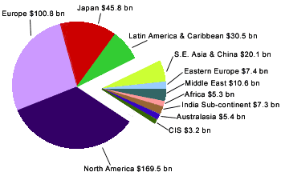

Of this global market, Africa amounts to only 1.3% while the US, Europe and Japan accounts for 78%. These figures should also be put in context of the size of the pharmaceutical companies, the percentage of revenue actually spent on research and executive remuneration. As can be seen from the table below the 10 largest pharmaceutical companies have revenues in excess of the Gross National Products of all African countries except South Africa and Nigeria. In addition, it would appear possible for these companies to absorb 1.3% of costs into either their profit or marketing and administration budget lines.

1999 Pharmaceutical Company Reports
for 10 largest Pharmaceutical Companies

Conclusions

Because poor people pay for their drugs, prices matters!

The multiplicity of providers and payers in developing countries means that any equity pricing scheme must accommodate all sectors

For TB drugs, generic competition has achieved low prices. Can voluntary licensed competition achieve the same for AIDS and other drugs?

In the face of the worst public health emergency since 1347 extraordinary measures are needed!

References

http://filestore.who.int/~who/whr/2000/en/pdf/Overview.pdf
Report of the Global HIV/AIDS epidmeic June 2000 http://www.unaids.org/epidemic_update/report/Epi_report.htm
Global Tuberculosis Control WHO Report 2000 page 22 http://www.who.int/gtb/publications/globrep00/PDF/GTBR2000full.pdf
WHO Public-Private Roles in the Pharmaceutical Sector - Implications for Equitable Access and Rational Drug Use Health Economics and Drugs. DAP Series WHO/DAP/97.12 1997
Perez-Casa C, Berman D Kasper T HIV/AIDS medicines pricing report. Setting objectives: is there a political will? Access to Medicines Project MSF July 2000 Geneva
Laing RO, McGoldrick K Tuberculosis Drug Issues: Prices, Fixed Dose Combination Products and Second Line Drugs Int J Tuberc Lung Dis 4(12):S194-207
www.ims-global.com/insight/report/global/report.htm
http://dcc2.bumc.bu.edu/richardl/ARV_Drug_Prices/AIDSv3.0c.ppt
O’Reilly B Death of a Continent Fortune November 20 2000 p 259- 274

